Person A is a 19-year-old boy with Cerebral Palsy and ASD. He’s been attending MYA Choices Knowsley sessions since he was 16 years old and has always brought a big smile with him to Bluebell Park.

During lockdown, person A’s parent was contacted by phone and encouraged to check our social media for helpful content. His Mum said her preferred platform is Facebook. Since this call, Person A and his Mum have frequently engaged with much of the online content. Despite Person A no longer accessing our sessions because of his age, their support and communication across Facebook proves how they valuable the time he spent at MYA Choices Knowsley sessions was to them.

Having attended for so long, person A has appeared in many of the recent ‘Throwback Thursday’ posts which feature photographs from sessions gone by. The themes of these posts have been varied across activity types which has really evidenced the range of things Person A has enjoyed over the years.

Person A’s Mum entered him into two of our online competitions. Both required person A to be photographed doing something they were enjoying during lockdown influenced by videos posted by staff. Despite attending school during lockdown, Person A was able to take on board our suggestions and enjoyed getting out for walks and taking some ‘me time’ to wind down with his favourite screen time activities; a relax and a chill much welcomed by his Mum.

It was the photograph of him out on a walk with his ‘high value’ items that won him the prize of a £10 gift voucher for Amazon. Linda revealed him as the winner on a video post on which many other parents/ carers commenting their congratulations to Person A which I am sure made him very pleased. Person A’s Mum communicated that he would make good use of it and that it would likely be spent on hoover related items.

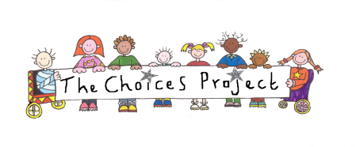
Person A also received a rescue pack collated and send out by our Project Coordinator, containing various sensory toys, a keyring, a stress ball, a fidget toy and a greetings card from the MYA Choices Knowsley staff team. Person A’s Mum even sent a message on Facebook to say how much she and Person A appreciated the personalised pack.

Nicola McDiarmid (Team Leader)

