Person B is an 8-year-old boy with multiple difficulties. He has been accessing MYA Choices Knowsley sessions since September 2019. At his meet and greet session, he settled into child led play straight away, actively engaging with other young people and staff. Watching from a distance, Mum was overwhelmed with emotion as she had never seen him so happy in an unfamiliar setting. On his second session when his parents left, the only person not smiling was his little sister who was desperate to stay and play!

Since then, person B has been thoroughly enjoying every session he’s attended, consistency thanking staff for the brilliant time he’s had and greatly looks forward to more of the same the following week. He leads other young people in play with enthusiasm and confidence and very rarely spends time alone. Given his sociable tendencies, Person B was definitely somebody we wanted to reach out to during lockdown in order to support him through the changes by offering interesting content from familiar faces.

Under the supervision of his Mum, Person B has been able to benefit from our Covid-19 response in more ways than one. Firstly, the effort to reach out to our service users by way of rescue packs delivered to their home was very well received by Person B. His Mum got in touch to say that he had waited at the window every morning for the postman once he got wind of a parcel addressed to him. She added that Person B was struggling with being stuck in and that the pack would ‘go down a treat’. On Facebook we received photo evidence of person B grinning from ear to ear once it was received and a further message from Mum to say, “Thank you again, you are all very caring people. He was made up and misses his short breaks”.

Person B also used social media to share some things he had been up to during lockdown, thus entering himself into our weekly competitions. His winning photograph was him in a homemade reading den, an activity we had promoted on Instagram in the weeks prior. He was overjoyed to find out he had won and was filmed jumping up and down shouting “Thankyou” on hearing the news. Mum asked if she could share the post with family so they could see him “going mad. He was made up”. Following his win, Person B continued to post photographs with the request of not being entered into the competition but simply to share with pride his cardboard box creations of a ‘boxicorn’ and a go kart. It was great to have a young person willing to engage so actively without the prompt of winning a prize.

Finally, Person B has engaged with our response in a way less common due to the ages of some of our children. Again, supervised by Mum, he has taken the time to browse other children’s photographs and comment on what they’ve been up to. Together, they have congratulated other competition winners and really taken every opportunity to communicate with other parents and carers as well as staff on the page.
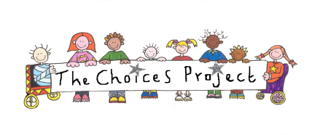
Nicola McDiarmid (Team Leader)

