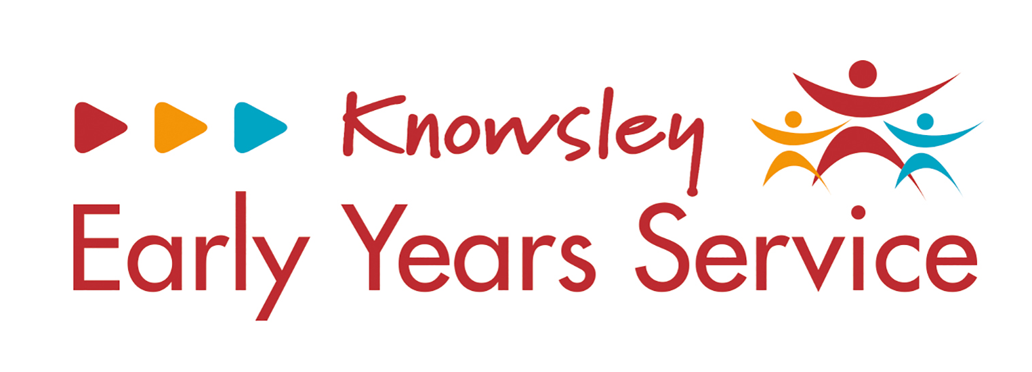
Childcare providers will need to use this DAF Audit form from April 2023. This form will need to be available when being audited by the LA in the future.
To be completed by childcare provider:  ‘Resources purchased’ | Invoice reference, as stated by nursery | Price (total) | Cross-check outcome, completed by Local Authority SEND Officer
i.e., Clay / Sensory Fabrics | i.e., Amazon / Early Years Direct

Please reference parent/carer consultation that took place regarding the DAF expenditure and evidence impact:

