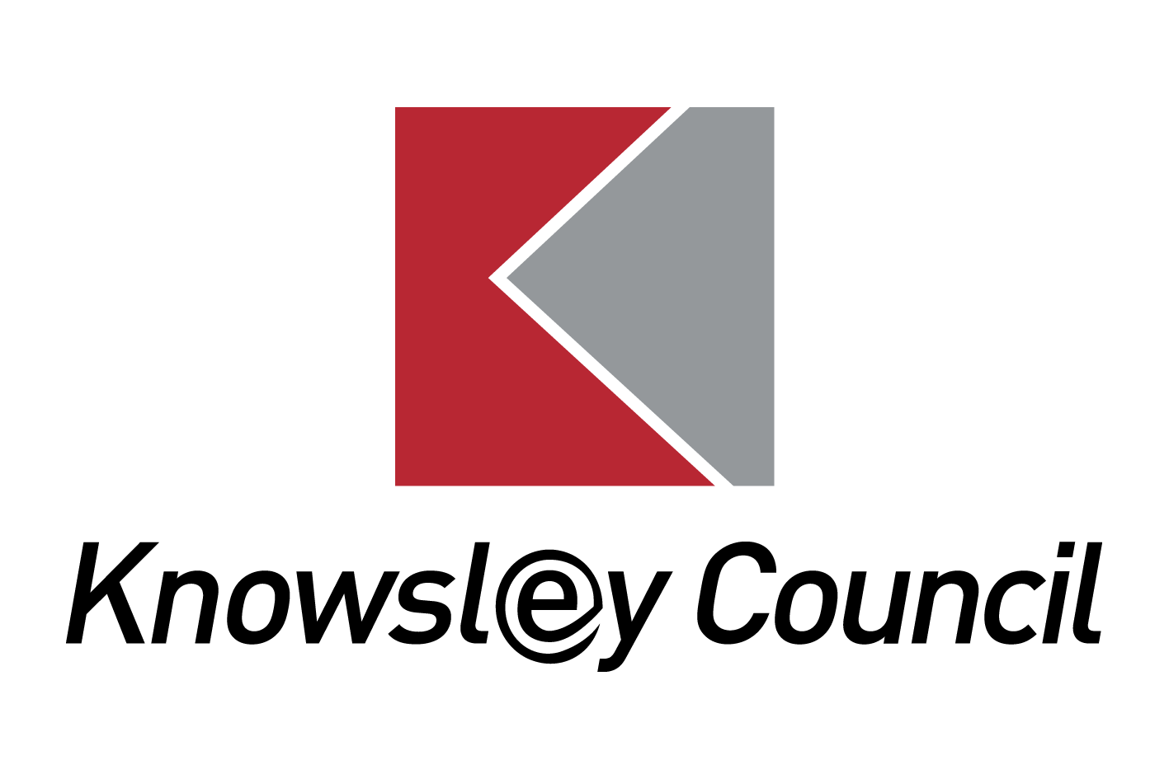
Knowsley Metropolitan Borough Council.

Annual/Interim Review form for Education, Health and Care Plan.
Name of Child |  |  |  |  |  |  | Date of Birth
School |  |  |  |  |  |  | Year Group
Address
Postcode |  |  |  |  |  |  | Telephone
Date of Admission |  |  |  |  |  |  | Date of EHCP
Date of Last Review |  |  |  |  |  |  | Attendance |  |  | %
Looked After Child? | YES |  | NO |  | Name of Social Worker
Date of this Review |  |  |  | Annual |  |  |  | Interim

Name | Role | Provided written advice? | Attended review meeting?

 |  | Signed |  | Print name | Date
 | Head Teacher/Principal
 | SENCO
 | Parent(s) / Carer(s)
 | Child or young person:
Summary of Annual Review discussion.

What people like and admire about the young person.

What’s working? |  |  | What’s not working or could be better?
Child’s/pupil views |  |  | Child’s/pupil views
Parent/carer’s views |  |  | Parent/carer’s views
Others views  (Education/Health/Social Care) |  |  | Others views  (Education/Health/Social Care)
Progress and achievement - please comment on progress across the three areas (Education/Health/Social Care) over last 12 months.
OUTCOMES from EHCP – Please consider whether or not they are still appropriate and what steps of progress has been made towards achieving the outcome.

Outcome 1.

Strategies Implemented to meet Outcome:

Progress Made:

Is this outcome still needed (if no longer appropriate is there another Outcome that should be included?)

Outcome 2.

Strategies Implemented to meet Outcome:

Progress Made:

Is this outcome still needed (if no longer appropriate is there another Outcome that should be included?)

Outcome 3.

Strategies Implemented to meet Outcome:

Progress Made:

Is this outcome still needed (if no longer appropriate is there another Outcome that should be included?)

Outcome 4.

Strategies Implemented to meet Outcome:

Progress Made:

Is this outcome still needed (if no longer appropriate is there another Outcome that should be included?)

Priorities for the coming year.

Action | By Who | By When
Recommendations for amendments to the EHCP
Please detail amendments/additions to be made including section/page number or annotate and attach supporting evidence.

Summary of recommendations – delete as appropriate
Maintain EHC Plan | YES/NO
Amend EHC Plan | YES/NO
Amend placement (Section I) | YES/NO
Cease EHC Plan | YES/NO

PLEASE RETURN COMPLETED FORM TO:

Education Improvement Team
Assessment and Commissioning (Special Educational Needs Team], Knowsley Metropolitan Borough Council, Huyton Municipal Buildings, P/O Box 21, Archway Road, Huyton, Knowsley, Merseyside, L36 9YU
0151 443 5146

REPORT for ANNUAL REVIEW OF EHC Plan Parent/Carer Comments

Child’s Name ……………………………………………………...............…..
Each year there is an Annual Review of your child’s special educational needs to review how his /her progress and how their needs are being met. Your views are important. You can use this form to record your views, or you can send your own report to the school. Please try to attend the meeting.

What people like and admire about my child or young person?
This could be in relation to relationships in school, at home and the wider community, character and/or personality.

What is important to my child or young person?
This could include hobbies and interests, social activities, health and wellbeing, communication, academic achievement, relationships, future prospects.

The progress my child has made since the last annual review (i.e. over the last year)

What is working well about my child’s education and their Education, Health and Care Plan?

What is not working well about my child’s education and their Education, Health and Care Plan?

Any changes that I feel are needed to the way my child is supported.

What else would you like to say?

Signed: | Print Name: | Relationship to child | Date:

Thank you for your time. Please return this to the head teacher / SENCO of your child’s school two weeks before the Annual Review meeting.

REPORT for ANNUAL REVIEW OF EHC Plan
Pupil Comments (if this information is already gathered by other means please attach the document)

Dear ___________________________________________________

You are invited to attend the annual review of your progress on __________________

This meeting is a chance for you to say what you feel about your school and learning. An adult or a friend can help you if you like and/ or come with you to the meeting. Please answer as many questions as you can, there are no right or wrong answers.

If you are adult helping to fill in this form, please write each answer in the child’s words.

Important people…

My favourite things…

Name:
___________________________

I am good at...

- Since my last review (in the last year)

The things I like about school...

The things I don’t like about school...

This year I have done well with....

Sometimes I find these things hard to do....

These things have helped me to learn or get on better...

- Next year at school (including secondary transfer for year 5 & 6 pupils)

I would like to get better at...

Sometimes I get worried about/ need help with...

Do you want to continue having the same sort of help, or would you like something to change, e.g. more/ less support or a new school?

When I am older I would like to... (e.g. new things you want to learn, going to a new school or college, the job you would like when you are older)

Questions I want to ask at my review meeting...

Pupil signature:_________________________________ Date:__________________
With help from____________________ Role:____________________

