EHM User Guide – Partner Agencies

Contents

Overview and Getting Support (p.2)

Starting a Level 2 Early Help Episode (p.3)

Completion of Consent (p.5)

Episode Details (p.7)

Starting an Assessment (p.8)

Meetings – please only use one of the following sections:
Adding a Case Note Meeting (p.13)
Or
Starting a Team Around Family Meeting (p.15)
- Completing the Meeting Outcomes (p.16)

Episode Closure (p.19)
- Retention (p.21)

Overview and Getting Support
This guide will show you how to start, complete and close a Level 2 Early Help Episode.
If you have any questions relating to the process, please speak with your Episode Coordinator.
If you need to log an IT support call, please e-mail servicedesk@knowsley.gov.uk – make sure to include the following information:
- Your name and contact telephone number
- The client case reference number and initials of the record name (if available). For example, for a record relating to John Smith, it should look like 123456 JS. Note – never type the full name of a record in an e-mail for data protection purposes
- A description of the query / issue you have – you can also include screenshots if applicable, but make sure not to include any identifiable information on the screenshot other than the case reference number (no names, photographs, addresses, etc.)

Starting a Level 2 Early Help Episode

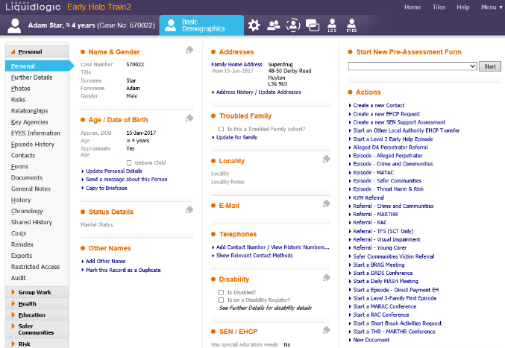
On the Personal tab located on the client’s basic demographics, click on the Start a Level 2 Early Help Episode link found under the Actions bullet point on the right side of the screen.

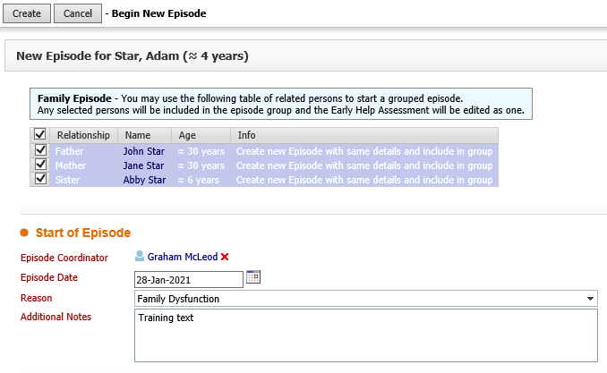
Before continuing, you will need to make sure that the tick box next to each family member is checked if they are to be included in the episode.
Note - mandatory questions on the system have red text - the system will not allow you to move forward until these questions have been answered.

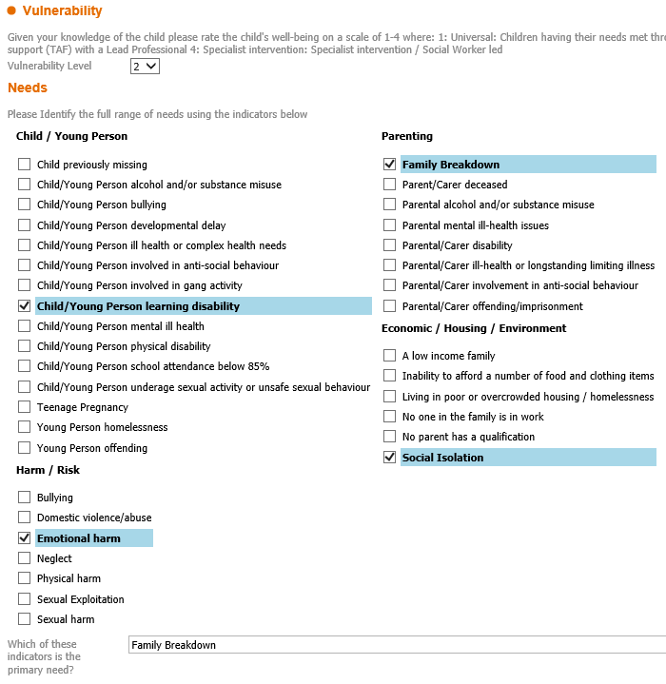
The Vulnerability Level will need to be set to 2.
You will need to tick the boxes of the needs that have been identified, in the following areas: Child/Young Person, Harm/Risk, Parenting and Economic/Housing/Environment.
Then select which of the indicators is the primary need.
Then click the Create button at the top of the page.

Note - once you have done this, a flag showing L2EH will appear under the person’s name at the top left of the screen – when viewing a record you can click on this flag to open Episode Details, and from there can click on Episode Pathway to return to the pathway.

Completion of Consent

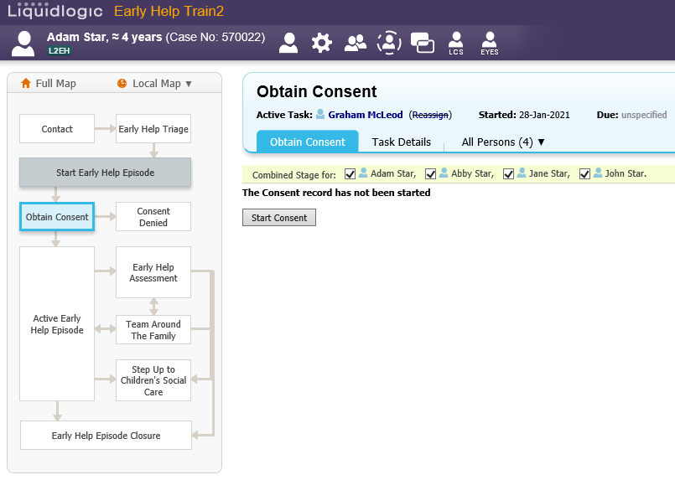
Check that you have all the correct people ticked in the Combined Stage for section, and then click Start Consent.

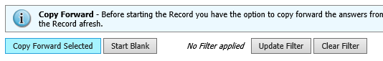
Then click Start Blank.

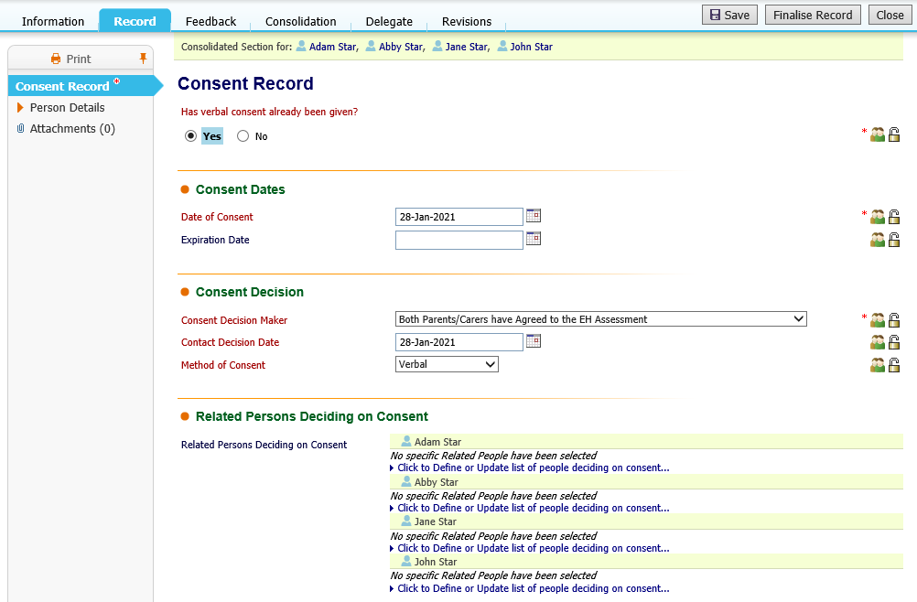
Before continuing, make note of the buttons at the top right of the form:
- Save – it’s recommended to click this before moving on to another page to save the current page, in case you lose connection to the system
- Finalise Record – only click this when you are finished with this form and ready to progress
- Close – you can click this to close the form without finalising it, so that you can come back and edit it later (which you can do from a task in your Home tray). Make sure to click Save first before clicking Close to save your current form.
Check and answer all the questions on the Consent Record form, (ensuring that you complete all the mandatory questions in red, as you will not be able to finalise the record if they have not been completed).
(Once you have received the written consent, you will be able to attach this as a document at a later stage. If you choose consent not given, you will not be able to continue with the process and episode will end at this stage).

Once you have completed all the form click on Finalise Record.
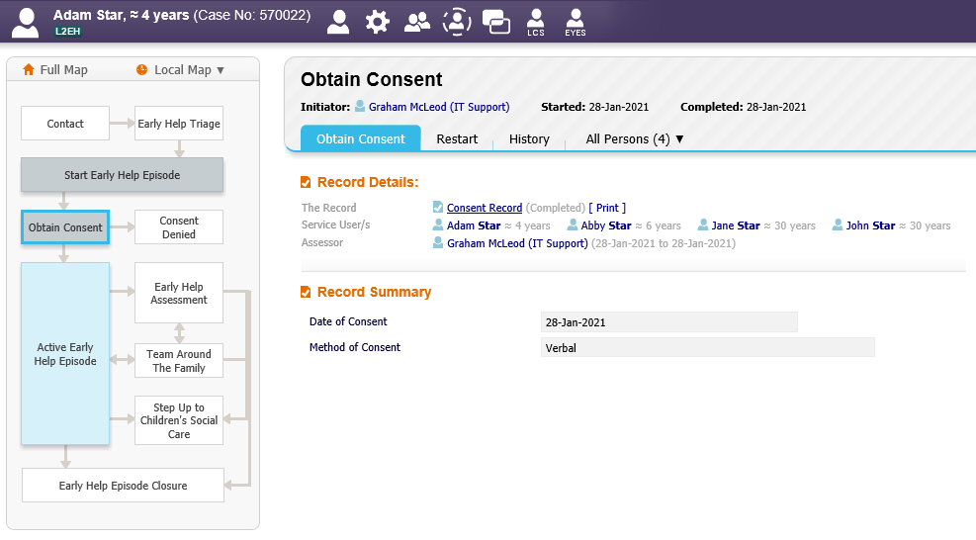
Once you have click finalised you will be taken back to this page. From here you can choose to:
- Click on the Active Early Help Episode box located on the pathway
- Or you can return to the work tray and click on the task, which will take you to the Active Early Help Episode

Episode Details

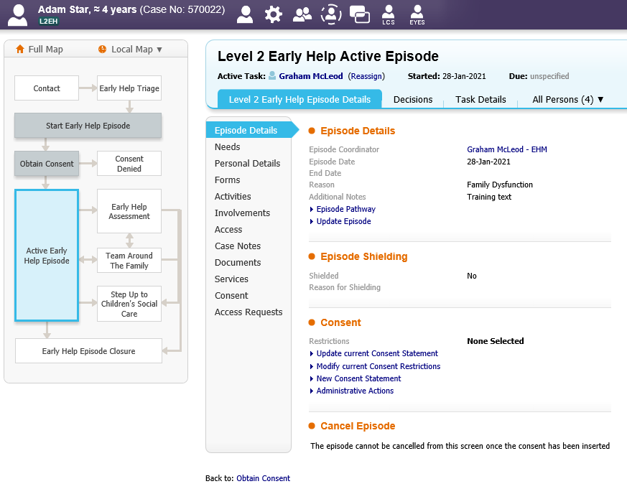
Once on the Active Early Help Episode screen you will be taken to the Level 2 Early Help Episode Details. From here you will be able to make any changes/add more information to the following areas:
  - Needs
  - Personal Details
  - Forms
  - Involvements
  - Case Notes
  - Documents
  - Consent

Starting an Assessment

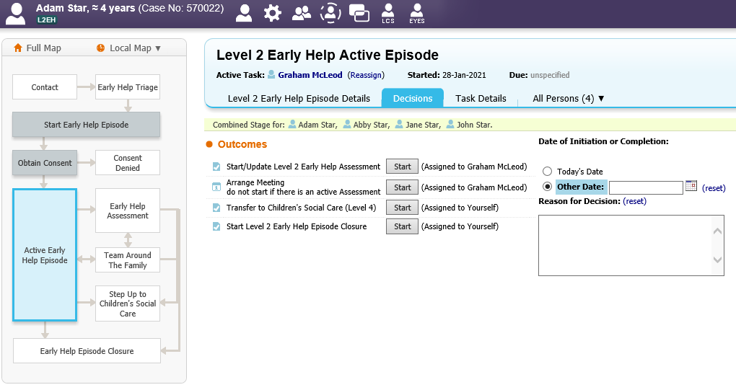
Click on the Decision tab within the Level 2 Early Help Active Episode.
You will then see the following options appear:
  - Start/Update Level 2 Early Help assessment
  - Arrange the meeting
  - Transfer to CSC Level 4
  - Start the Episode Closure
Click Start/Update Level 2 Early Help assessment.

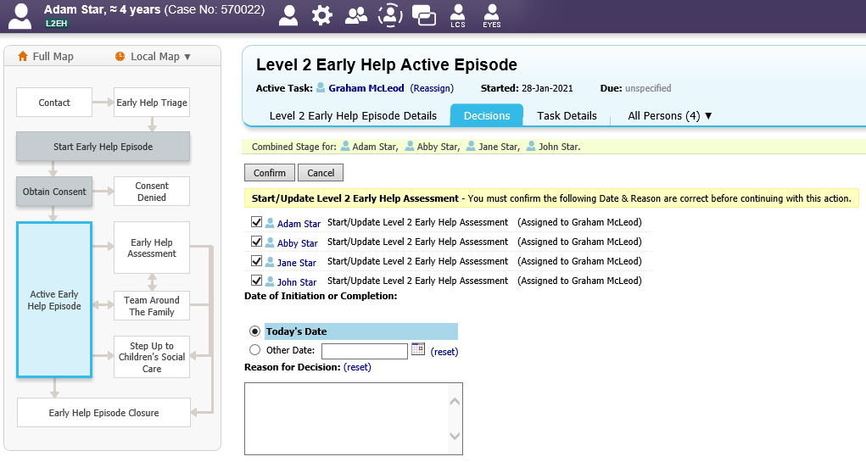
Ensure only the relevant Episode members are ticked before clicking on confirm. If someone has been added at a later stage, they will not be automatically ticked, therefore they will need to tick them at this stage. Then click Confirm.

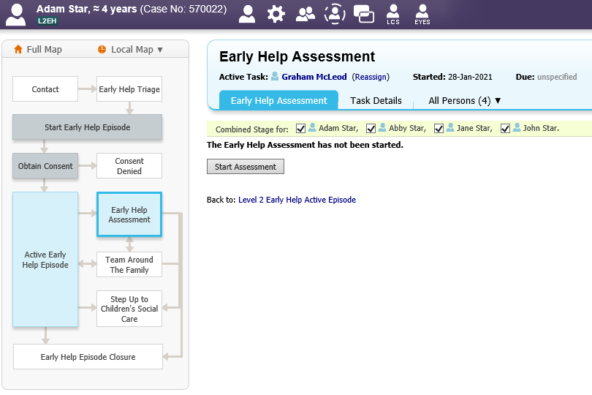
Then click Start Assessment. Once again please check that you have the right clients ticked in the Combined stage for section.

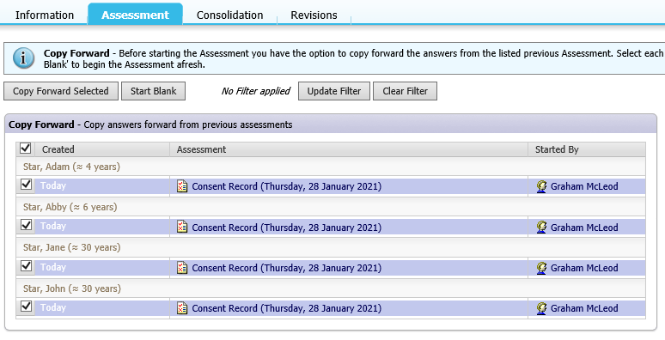
Click Copy Forward Selected. This will then copy the consent information forward to the assessment.

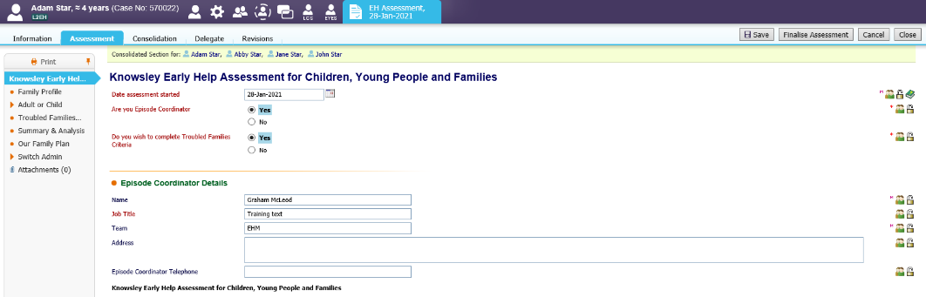
Then complete the assessment, making sure that you answer the mandatory questions in Red as you will not be able to finalise the assessment unless these are completed.

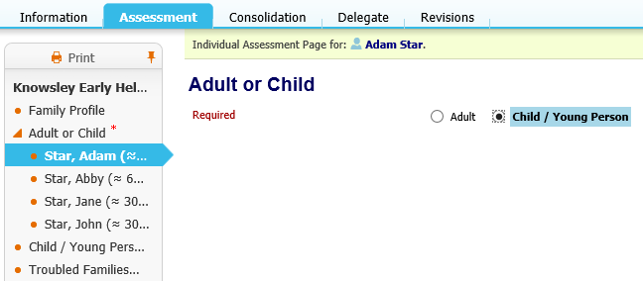
Please note that once you come to the Adult or Child section, you will need to complete the Adults and Childrens information individually, as you will be asked to select if they are an Adult or Child/Young Person.

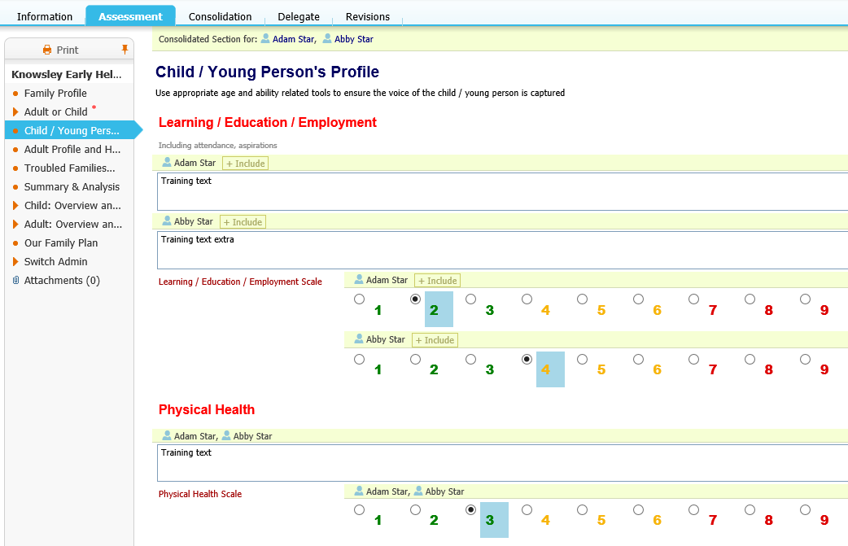
On both the Child/Young Person’s and Adults Profile pages you will need to enter the RAG rating details. This information can be different for each individual member so you are able to toggle out people so separate answers can be provided.
Note – when you can see names above a question, such as the text boxes and radio buttons in this example image, you can toggle out a person by clicking on their name to add another box just for them. You can add additional names by clicking on + Include. For text boxes it’s best to type up any shared notes before toggling out, as the text will then be copied in the additional boxes.

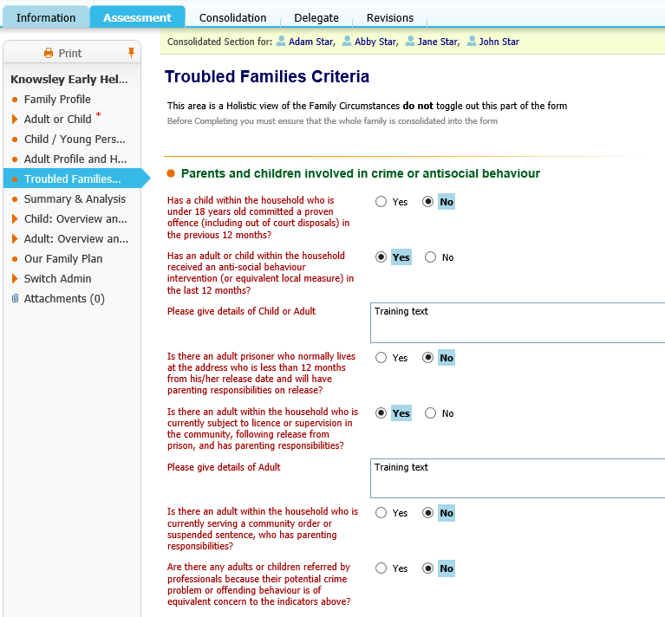
Note - that to continue with the assessment you will need to provide a Yes answer to at least 2 questions on the Troubled Families Criteria page.

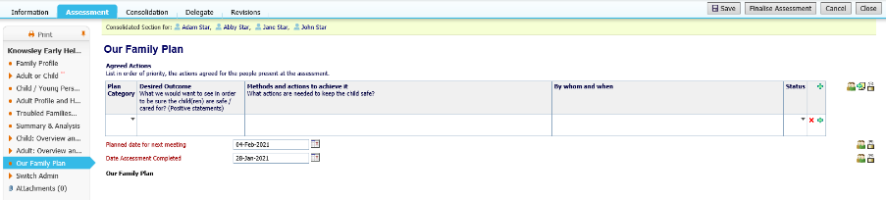
To add more rows to the care plan click on the plus icon. You can also remove a row by clicking on the X icon.
You can also click on the person icon on the right to toggle out for individual answers as previously demonstrated in the guide.
Once the assessment has been fully completed then click Finalise Assessment.

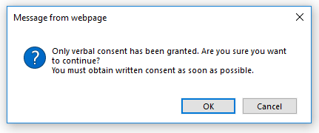
When finalising the assessment a reminder will appear to inform you that only verbal consent has been granted. Written consent will be added at a later stage, so click OK to continue with just verbal consent.

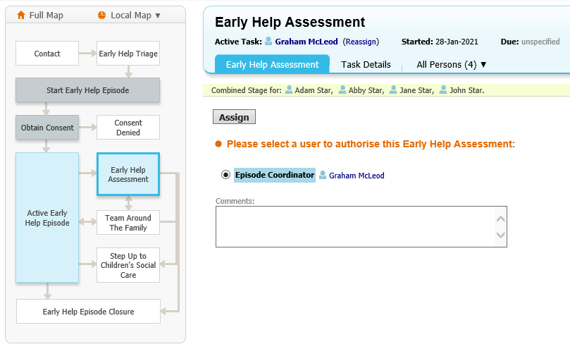
Assign it to yourself and then click Assign.

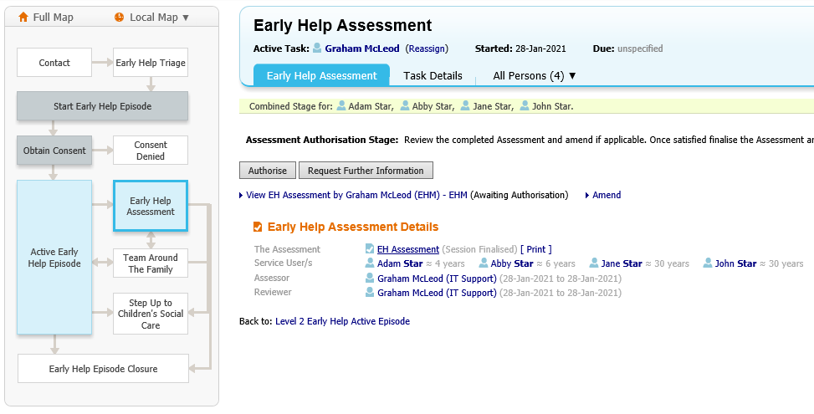
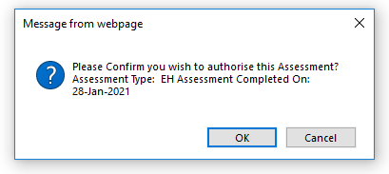
Then to authorise the assessment, click Authorise, then in the box that appears click OK.

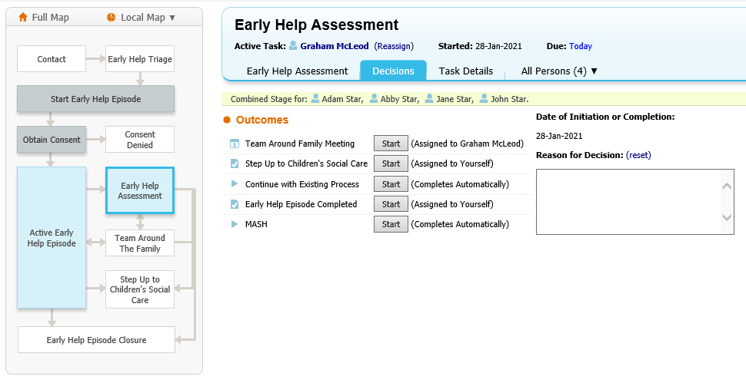
You will then be taken back to the Decision Tab within the Level 2 Early Help Active Episode.
You will then see the following options appear:
  - Team Around Family Meeting
  - Step up to Children’s Social Care
  - Continue with Existing Process (this will keep the episode open with no active task and will stay in your work tray until further action is taken)
  - Early Help Episode Completed
  - MASH

Adding a Case Note Meeting
Note: if you already use the other method of adding meeting details (such as adding attendees, writing up outcomes, etc.) then please use the next section, otherwise continue this section on adding a Case Note Meeting.

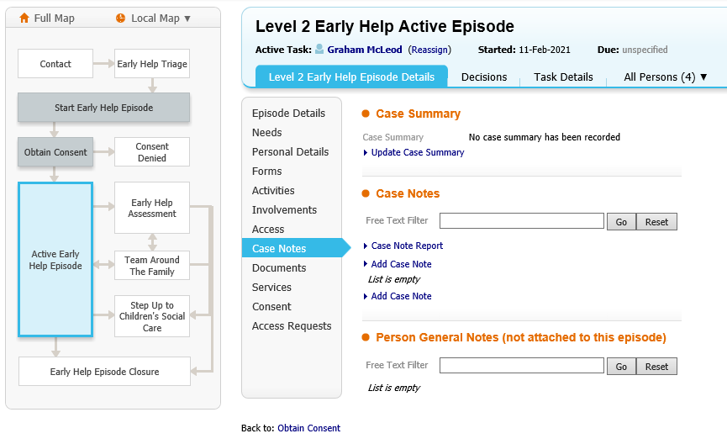
To add a new case note meeting, click on the Level 2 Early Help Episode Details tab, then Case Notes, then Add Case Note (to edit an existing case note, click on the actual case note and then click Update this Case Note)

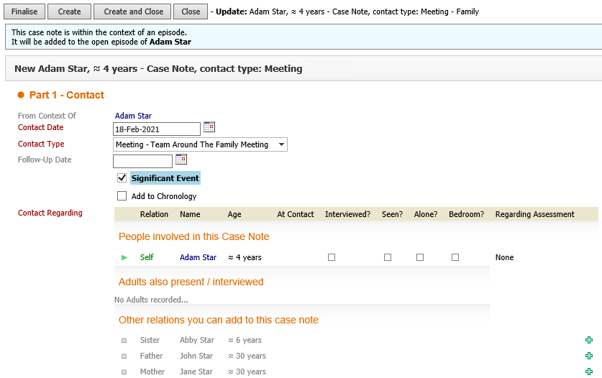
Enter a Contact Date, and under Contact Type choose Meeting – Team Around The Family Meeting in the dropdown box.
The Significant Event tickbox should also be ticked (unless not relevant).

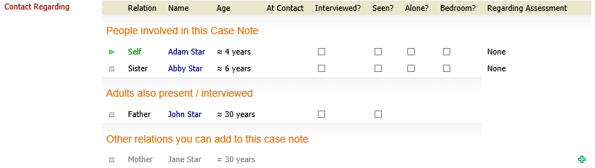
In the Contact Regarding section, use the + icon to add additional family members to the meeting.

Use the rest of the text boxes on the page to enter the following information:
- Reason for Contact – list who is present at the meeting, and include a summary of the discussion
- Detailed Notes – provide further information from the meeting, using separate lines for each attendee if required
- Analysis of information – a brief analysis of the meeting
- Management Decision – free text box for any further information
- Action – what the outcomes are, for example if a referral is needed

Once you are finished, at the top and bottom of the page are the following buttons:
- Finalise – will create and finalise the case note – only use this option when you are finished adding and amending all notes, as once finalised you can’t go back and amend this (you would have to log a call with IT to have the case note unfinalized)
- Create – this will create the case note but keep it open on your screen for further editing (it will then change to a Save button)
- Create and Close – this will create the case note and close this page (if you clicked Create first then this will change to Save and Close)
- Close – this will close the page without saving any changes

Starting a Team Around Family Meeting

Note: only complete this section if you have had training on, or already use this section, otherwise please see the last section on adding a Case Note Meeting.

Click Start next to Team Around Family Meeting.

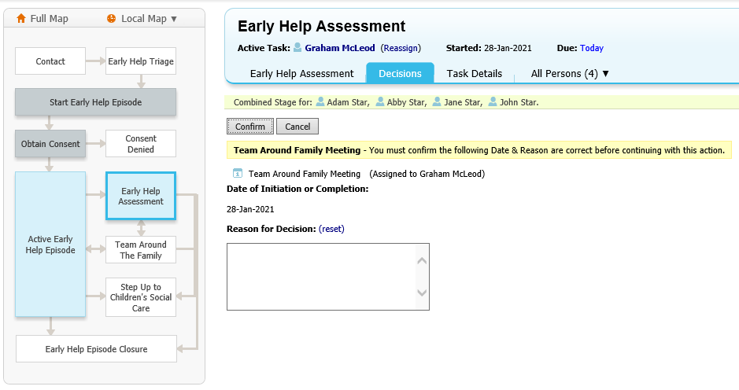
Ensure that you have all the correct clients ticked in the Combined Stage For section.
Click Confirm.

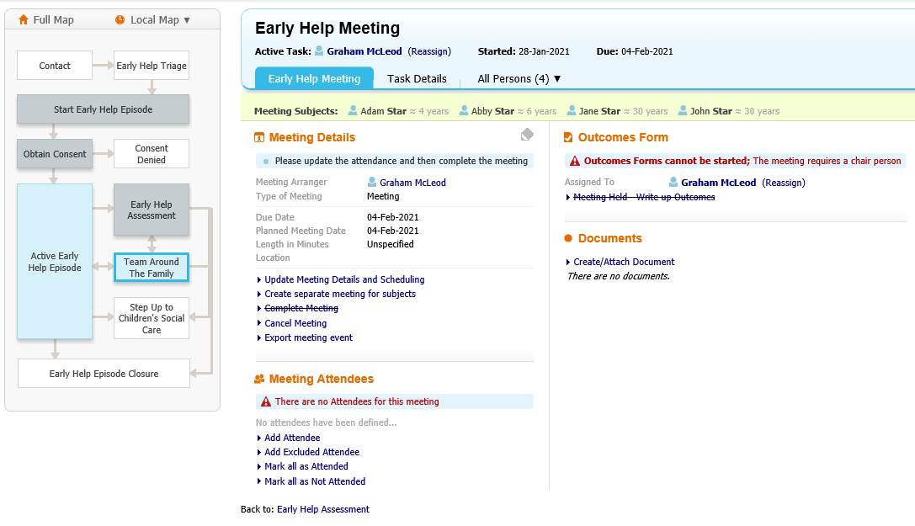
Then start inputting the meeting information:
- Enter the date and reason for decision by using the Pencil icon, and click Confirm
- Update Meeting details and scheduling
- Add attendee’s and update details of attendees (advising that they can update this table in the outcomes) NOTE: There must be a chair recorded to be able to write up the outcomes

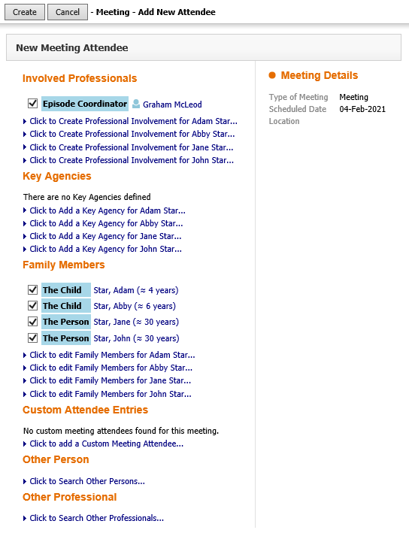
Tick each attendee to be added to the meeting and then click Create. You can also add/create additional attendees here that are not showing – it’s best to do this first as when you return to this screen any previously ticked attendees will have been unticked.

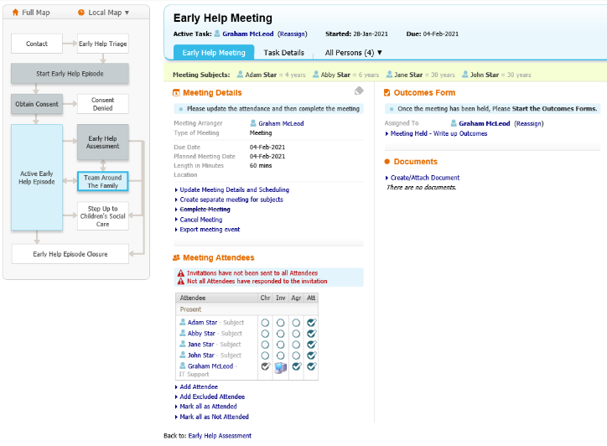
All meetings must have a Chair, so if one isn’t already ticked in the Chr box in the Attendees table then click on the tickbox for the relevant person.
Once the meeting has been held, tick on the Att tickboxes for all that attended, or click the Mark all as Attended link underneath the table.
Then click Meeting Held – Write up Outcomes.

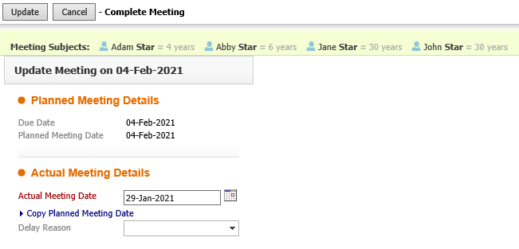
To start the meeting outcomes, click Copy Planned Meeting Date. Then click Update.

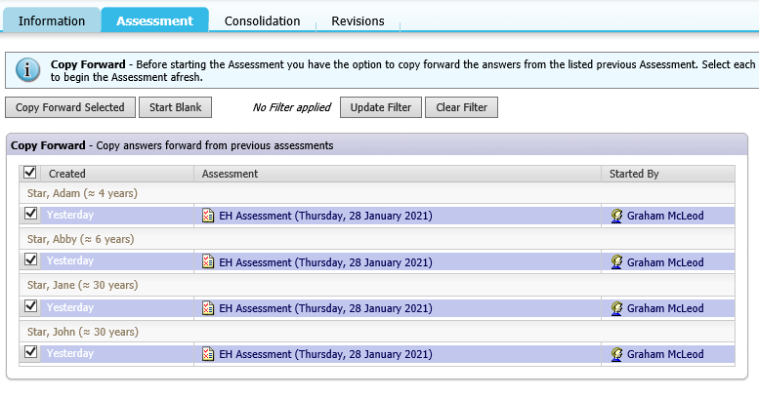
Click Copy Forward - this will copy forward any previous assessments.

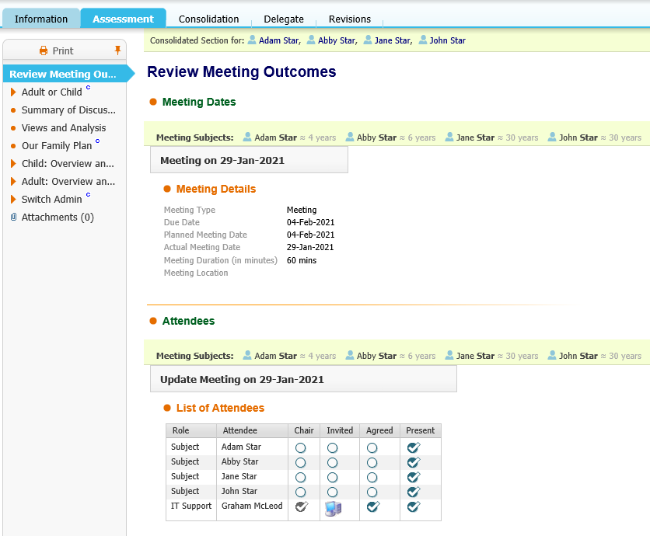
Then complete the assessment, making sure that you answer all of the mandatory questions in Red as you will not be able to finalise the assessment once completed.
Once you have completed all the information click Finalise to complete the meeting outcomes.

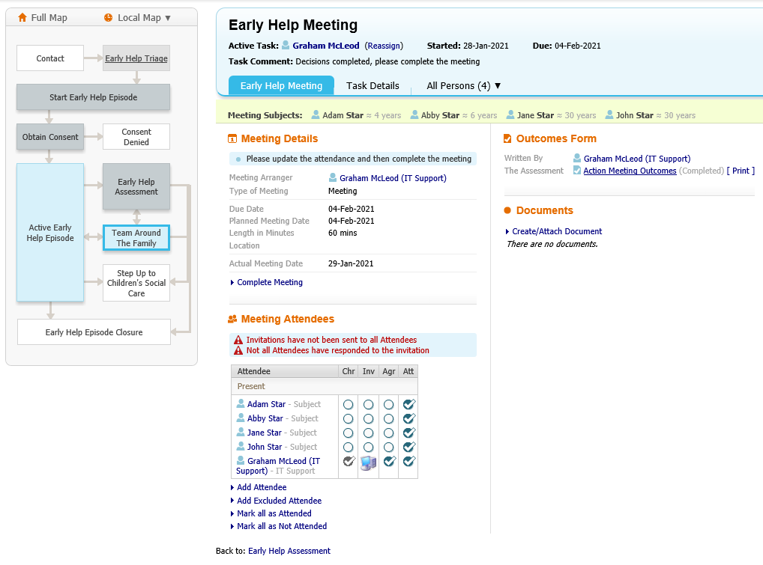
To complete the meeting, click on the hyperlink that says Complete Meeting.

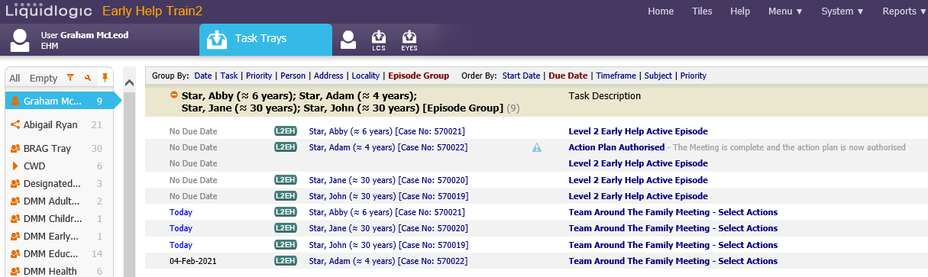
Make sure that you go back to your work tray and complete the alert.

To complete the alert, click on the Action Plan Authorised task and then the link that says Alert Completed.
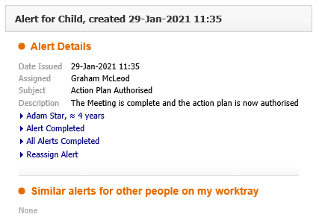

Episode Closure

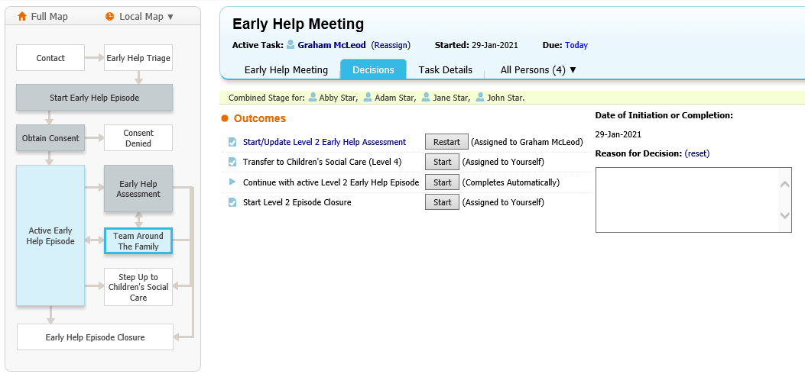
Click on Start Level 2 Episode Closure.

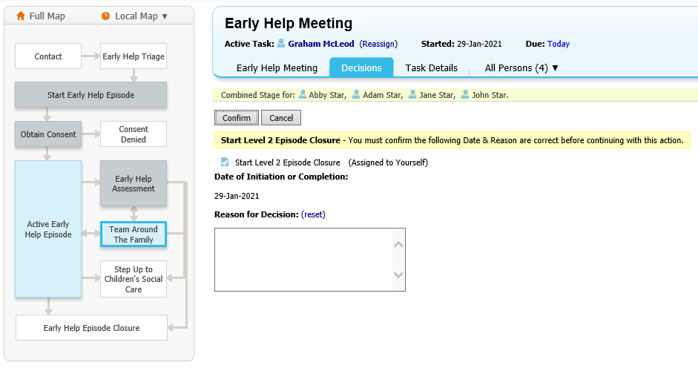
Untick any family members that need to remain open (if applicable) and then click Confirm.

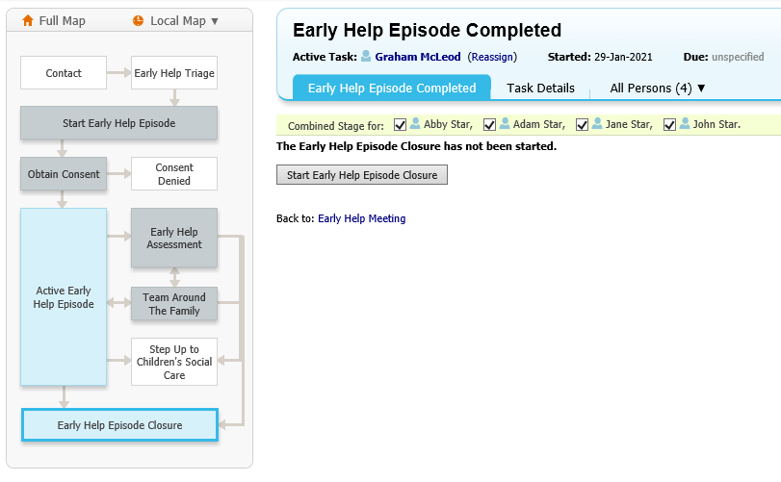
Click Start Early Help Episode Closure.

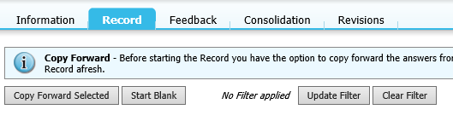
Click Start Blank.

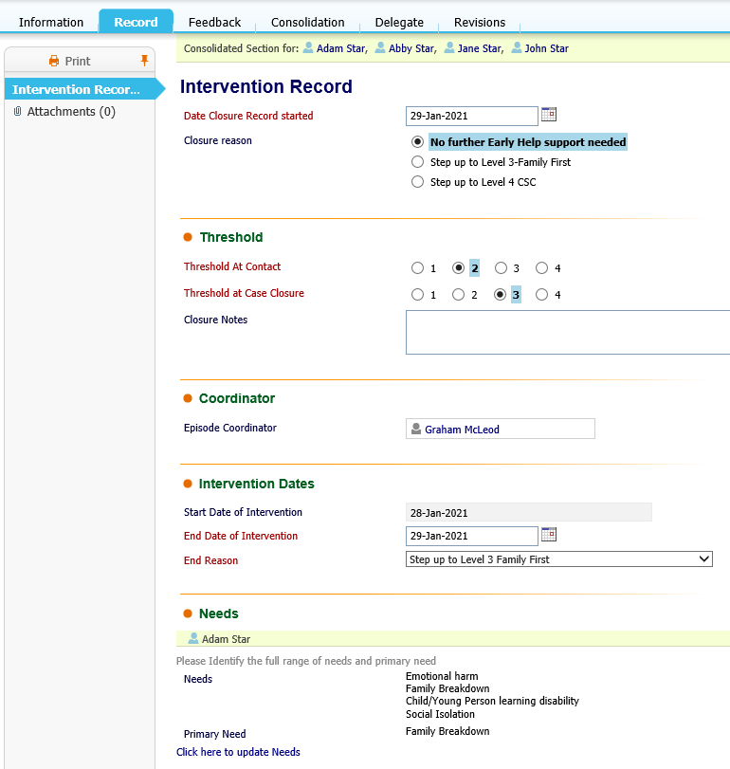
Then complete the assessment making sure that you answer all of the mandatory questions in Red, as you will not be able to finalise until completed.
Once you have completed the form click Finalise.

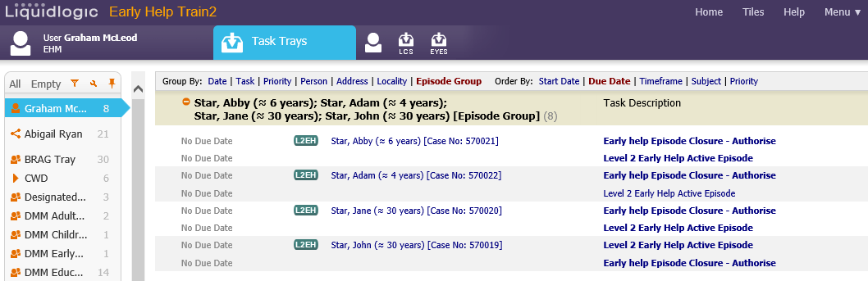
Click back Home to view your work tray, then click on the Early help Episode Closure – Authorise task.

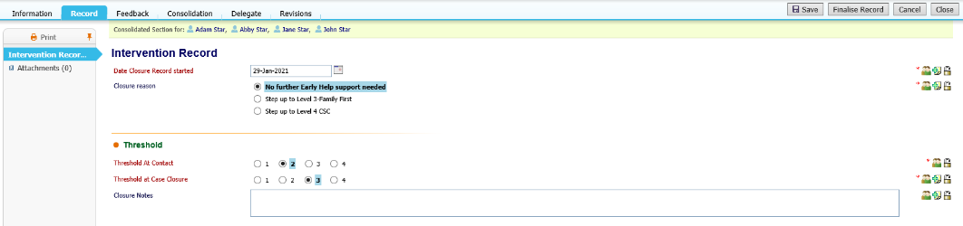
This will take you back to the Intervention Record. Then click Save and then Finalise Record.
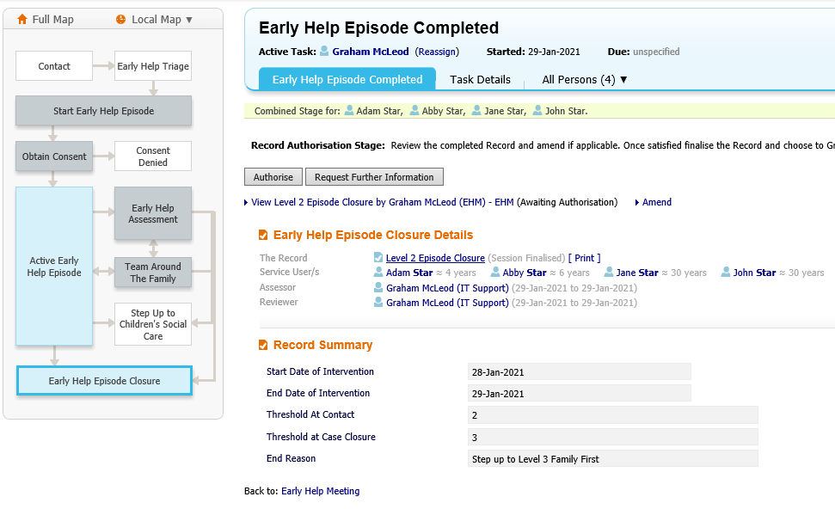
Then click Authorise.

Retention
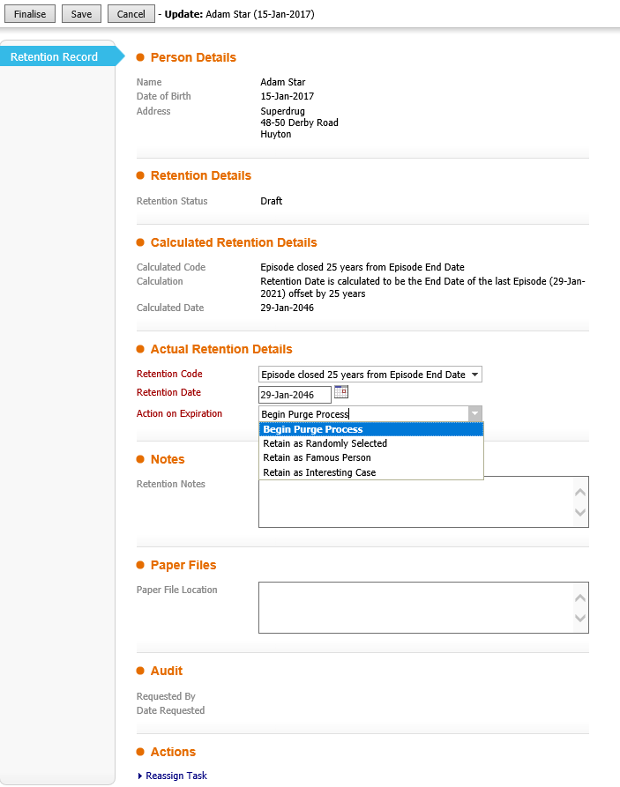
This will then bring you to the Retention stage. Make sure that you complete all the mandatory questions that are in Red. Click Save and then click Finalise.
Note – for Action on Expiration you will most likely be choosing Begin Purge Process, however there are other options such as Retain as Famous Person (for VIP cases).

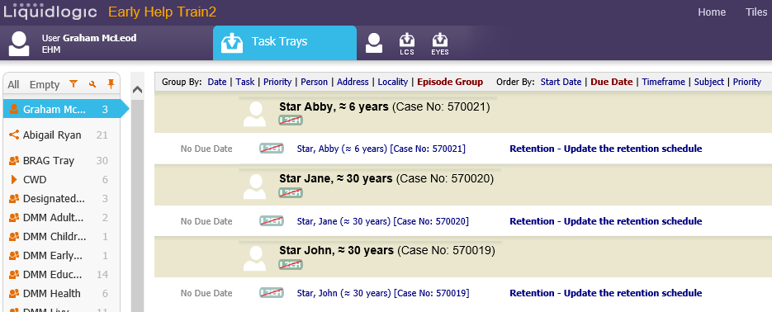
You will need to go back to your work tray and click on each Retention – Update the retention schedule task for all of the family members. This will need to be completed one by one.

