Knowsley Establishment Portal
User Guide

The Establishment Portal has been created as an online system for schools, which feeds into the Early Years and Education System (EYES). This guide has been created to explain how the portal should be used.
Contents
When to use the Establishment Portal 3
Getting Started 4
Registering for an Account 4
Logging in to the Portal 5
Contacting the EYES Support Team 6
Complete all fields then click Submit issue 7
Logging in and out of the portal 8
Using the Establishment Portal - Schools 10
Logging in - what you will see 10
Free School Meals 12
Admissions 13
School Information 13
Priority List 13
Key Dates 14
Primary Transfers 14
Secondary Transfers 14
Admissions Criteria 14
Applications & Offers 14
Register 14
Waiting List 14
Apply for a School Place 15
Allocated Places 15
Children in Care – Primary View only 16
Attendance Referral 17
Child Missing Education Referral 18
Permanent Exclusion Referral 19
Submitting Attainment Information 20

When to use the Establishment Portal
Below is a summary of what you can do in the Establishment Portal:
- Admissions – support a parent or carer to apply for a school place
- Free School Meals – view the children that are in receipt of free school meals
- Attendance and Exclusions – make a referral about attendance or notify the team of an exclusion or a child missing education
- Children in Care* – view information and submit attainment data for a looked after child
- Apply for SEN panel funding – Early Years
- Request Inclusion Support – Early Years
*Important: There is an area within the portal (Children in Care) where you should submit attainment information for Children who are Looked After. For a temporary period, you will need to submit attainment information through the portal as well as through the PEP.
Getting Started
Please click on the below link to access the establishment portal – you may need to hold the Crtl key (on your keyboard) when clicking on the link.
https://establishmentportal.knowsley.gov.uk/web/portal/pages/home
You may wish to save this link locally for ease of access in the future.
You will be taken to the home page of the portal. Select Your Account:
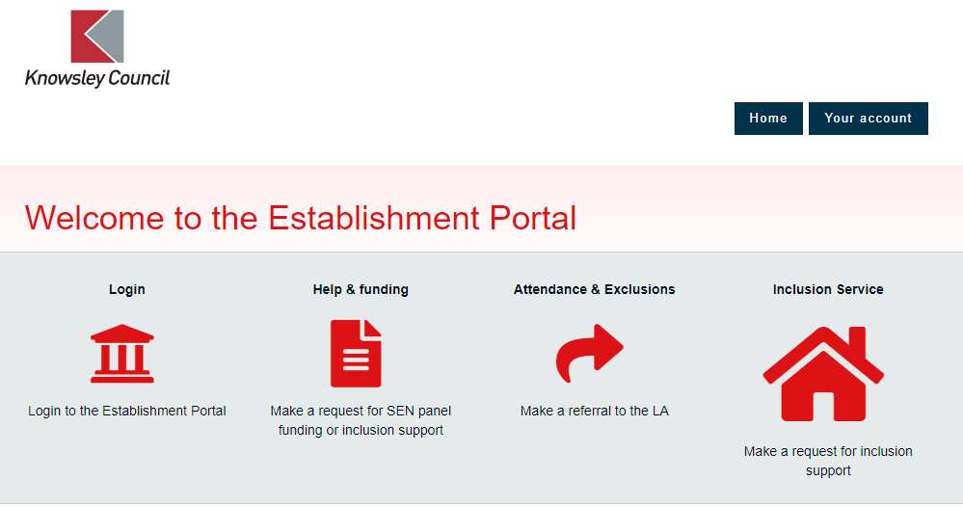

Registering for an Account
The first time you ever use the portal you will need to register, select Register for new account and follow the online instructions to set up your account.
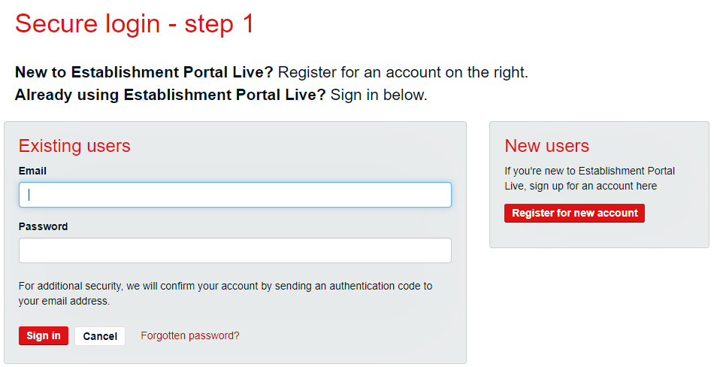
Follow the instructions entering:
- Forename;
- Surname;
- Next;
One the next screen you will be asked to enter an email address which will be used to log in to the portal. Important: The email address must be for an individual person and not a shared account, for example jo.smith@nameofschool.co.uk rather than nameofschool.co.uk.
Once you have entered an email address you will be asked to enter a password. The password must meet the following requirements:
- It must be at least 8 characters long
- It must contain at least one letter
- It must contain only letters, digits, and the following special characters: !@#$%&*
You will be asked to confirm the password chosen and click on the Next button.
A code will now be emailed to the email address entered to confirm the address. Enter the code in the box and click on NEXT – you are now all set up.

Logging in to the Portal
If you have previously registered for an account, enter the email address that you registered with, then your password. There is an option to select Forgotten password if you need it.
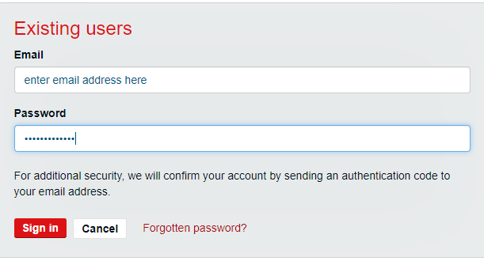

For security purposes, each time you log in, you will be sent an email containing a code. Add the code and select Next.
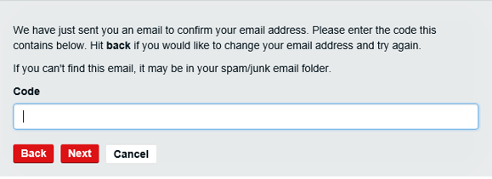
You are now logged in.
The name of the School(s) you are linked to will now appear on the top right-hand side of the home page. If this is incorrect or you are not set up as a portal user, you will need to contact the Eyes Support Team.
The below message indicates that you are not set up as a portal user.
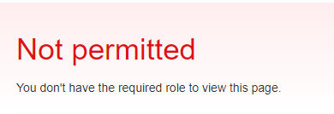

Contacting the EYES Support Team
The link below should be used to contact the EYES Support Team
https://kportal.mendixcloud.com/link/eyes

Ctrl+click on the link, to access the support system:

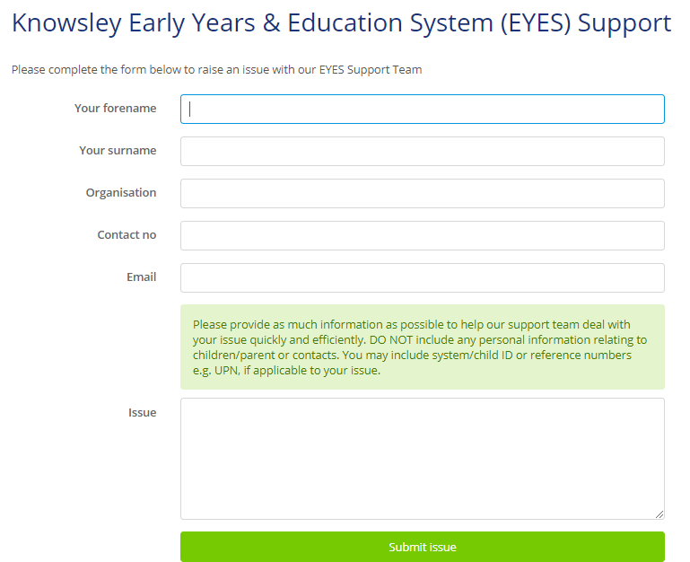

Complete all fields then click Submit issue

Logging in and out of the portal
Once you have registered for an account you will need to click on the below link every time you want to access the portal
https://establishmentportal.knowsley.gov.uk/web/portal/pages/home
Click on the button named Login. Enter the email you used to register the account along with the password.

The system will then generate a code to you email address which you will need to enter to access the portal
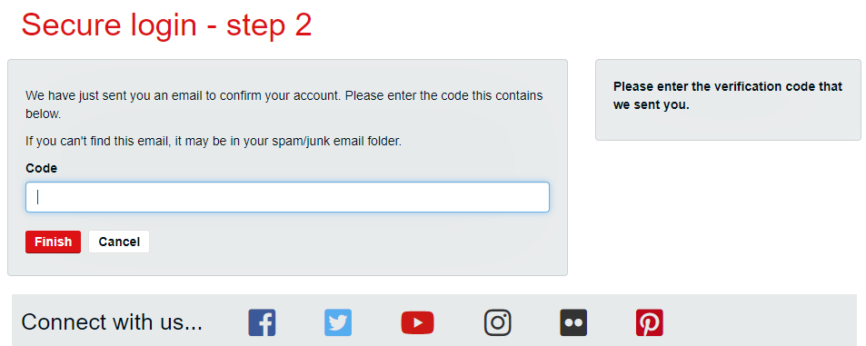
Enter the code and click on Finish. A new code will be sent via email each time you log in.
When you have finished using the portal, please click on the drop-down arrow next to your name and click “log out”
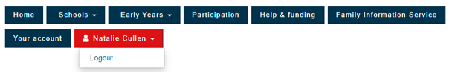
A message will now display showing you are logged out of the system.
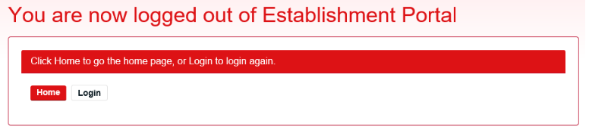

Using the Establishment Portal - Schools

Logging in - what you will see
If you have more than one establishment you are assigned to then the one which you were added to first will display.
You can change the school you are viewing by clicking on the drop-down arrow next to the name of the school under the headings
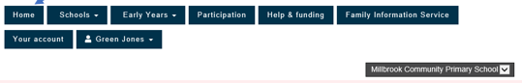
Your view will change depending on the education phase of your school.
Primary schools
When you first log into the portal you will be taken to a dashboard overview of the school you have access to. If this is more than one school the one listed first alphabetically will be displayed.
This is a summary of Early Years children attending your establishment along with information about headcount submissions.
You can either access relevant sections using the drop-down arrows next to each heading or you can click Home at the top left of the screen to access via the buttons there.
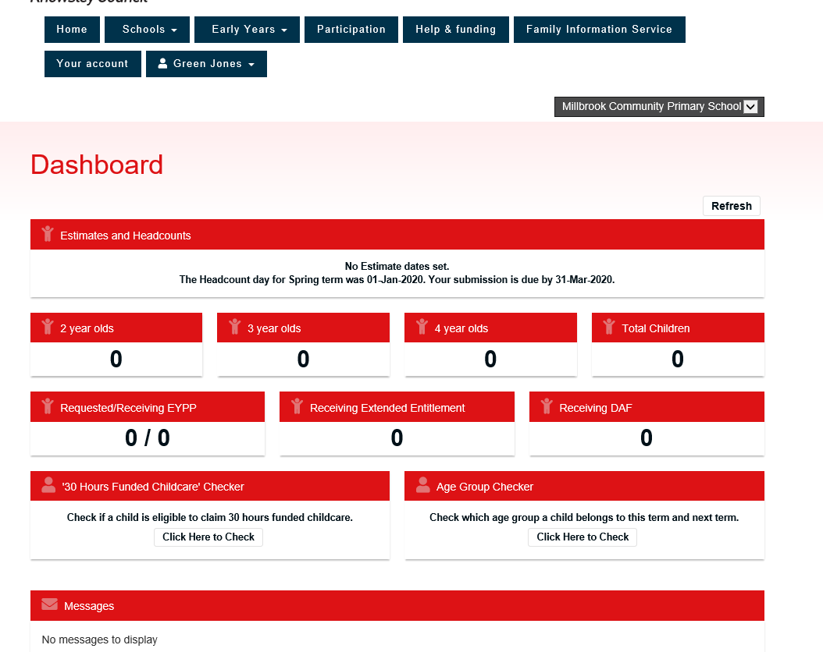

Secondary Schools
When you first log into the portal you will see the page – Forms to complete
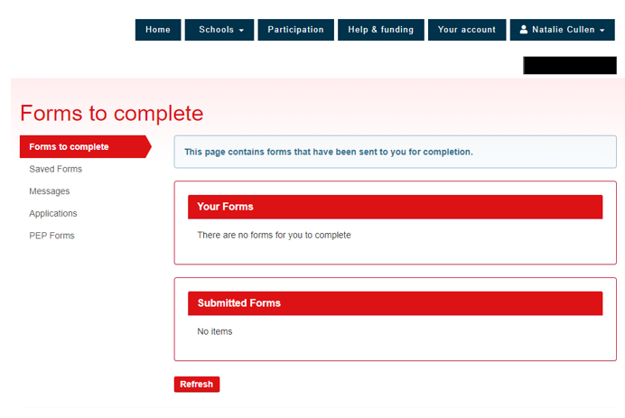
You can access sections relating to your school by clicking on the drop-down arrow next to schools
Here a list will appear with different options of what you want to view, they include:
- Free School Meals;
- Admissions; and
- Attendance & Exclusions.
Please note Attendance & Exclusions can be accessed either via the above list or via the Attendance and Exclusions link on the home page.
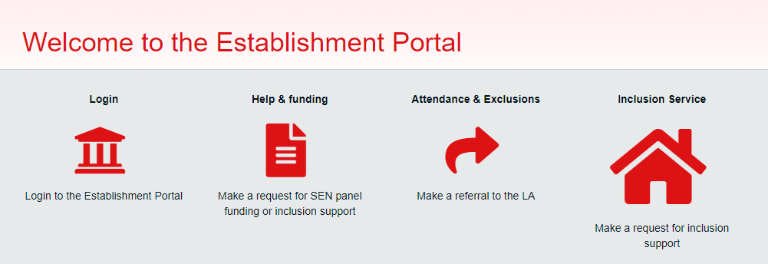

Free School Meals
This area displays all children at your establishment who are receiving free school meals.
From your menu bar across the top of your screen select Schools then Free School Meals.

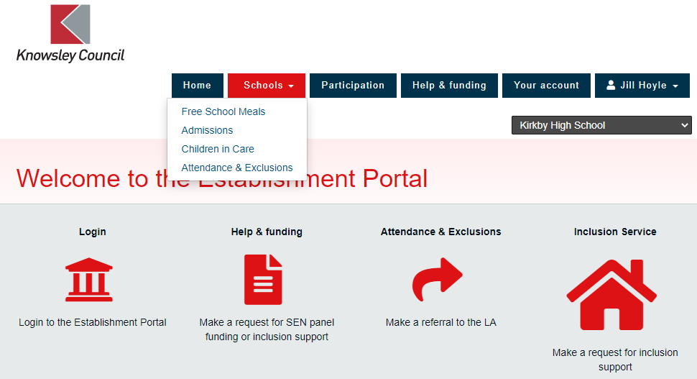

A dashboard will appear containing the below headings, the children’s details will appear below these headings.
Click on the Year to view different groups (the small number next to each year indicates the number of children receiving free school meals for that year).

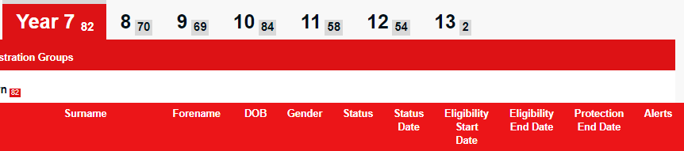

Admissions
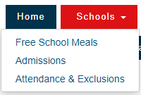

To access the admissions application, click the drop-down arrow
next to Schools and select Admissions from the list which appears.

You will then be taken to an Admissions dashboard.
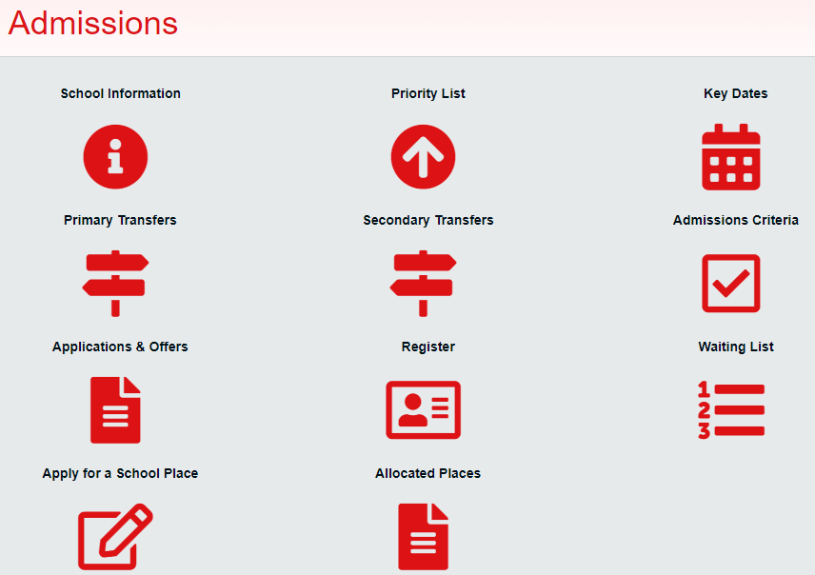

School Information
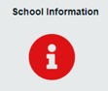
Here you can enter school information – this will only be viewed by the school users.

Priority List
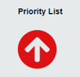
This area is for those who have their Own Admission Authority such as faith schools. It will list Pupils applications by rank.

Key Dates

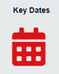
Here you can view the Key Admission dates for the applications for the next academic year.

Primary Transfers
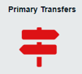
For Primary Schools with a Nursery provision ONLY - Here you can view those who are in your Nursery to see if they have applied for a school place.

Secondary Transfers
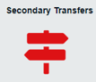
For Primary Schools ONLY - Here you can view those who are in Year 6 and are expected to make a transition to Year 7. Here you can see which pupils who have applied for a school place.

Admissions Criteria
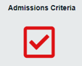
Here schools can view what their Admissions Criteria is which will be applied as part of the application process.

Applications & Offers
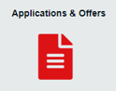
Once the date for All Schools and LA’s are informed of final offers and refusals has passed schools will be able to view Applications and those with offers for their school. The dates vary depending on the phase of education.

Register
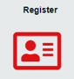
This was originally created so that schools could let us know if a new pupil started in the school but wasn’t yet on the register or if there was a change to a pupil’s details. However, as we are collecting your information via Groupcall there is no requirement to use this section.

Waiting List

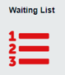
If it is agreed that Knowsley will monitor your waiting list, this will be maintained via EYEs but you will be able to view the waiting list from here. It will put them in order of criteria.

Apply for a School Place

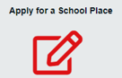
If needed to apply on a Parents behalf or to assist said Parent, you can do this via the portal – please see below for further guidance.
Then click on Start a new application
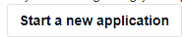
There are seven sections to complete, anything marked with a red Asterix indicates a mandatory field. Hover over any question marks for further guidance.
Because you are completing the application on behalf of the parent or guardian, please ensure the information you enter is theirs, not your own.
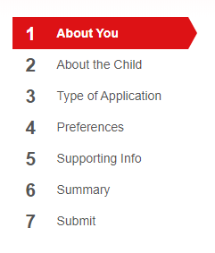
When all seven sections are complete, submit the application.
The Admissions Team will be notified of the application automatically.

Allocated Places
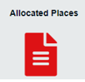
After National Offer Day (NOD) you will be able to see who has been offered a place at your school. This will also update after NOD with changes due to withdrawals and/or appeals etc.

Children in Care – Primary View only
In this area you can view some information about children who are looked after.

From your Home page, select Schools then Children in Care.

You will be taken to a dashboard showing all children who are looked after, below shows the headings of the information which will appear on your dashboard. Each child will appear in a row.

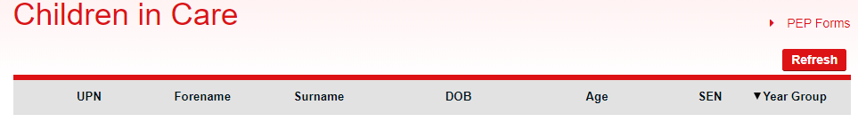

Click on a row to view more information.

Attendance Referral
From your Home page, select Attendance & Exclusions, or Schools then Attendance & Exclusions.

Then select Start an Attendance Referral
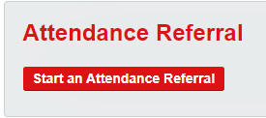

Complete sections one and two then submit the referral.
The Attendance Team will automatically be notified of the referral.

Child Missing Education Referral
From your Home page, select Attendance & Exclusions, or Schools then Attendance & Exclusions.
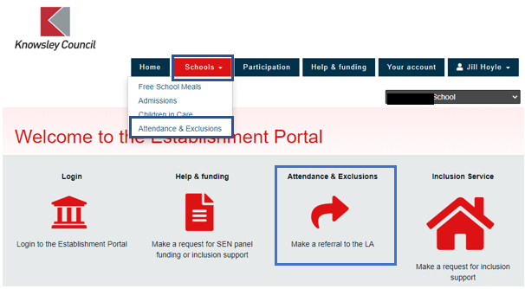
Then select Notify LA of Child Missing Education
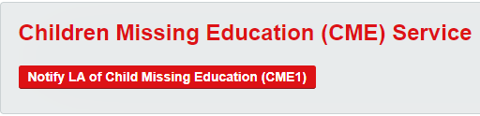
Complete sections one and two then submit the referral.
The Attendance Team will automatically be notified of the referral.

https://establishmentportal.knowsley.gov.uk/web/portal/pages/home

Permanent Exclusion Referral
This is to be used to notify the Education and Early Intervention Team of a permanent exclusion.
From your Home page, select Attendance & Exclusions, or Schools then Attendance & Exclusions.

Then select PEX request to LA
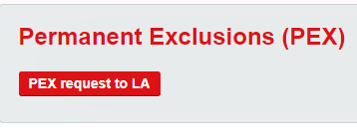
Complete sections one and two then submit the referral.
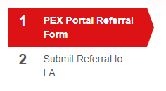
The Education and Early Intervention Team will automatically be notified of the referral.

Submitting Attainment Information

Click into the row of the child, then scroll down. You will see an area that should be completed to notify the Virtual Schools Team of the child’s attainment.
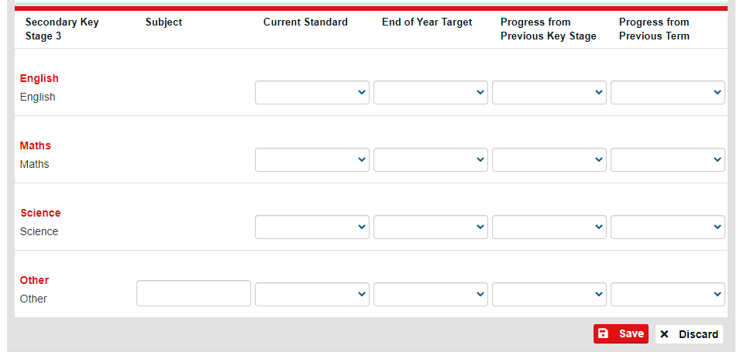

When you have finished adding the attainment information, click Save. This information will be immediately available to the Virtual School Team.

(For a temporary period, the above will need to be completed in addition to the PEP)

