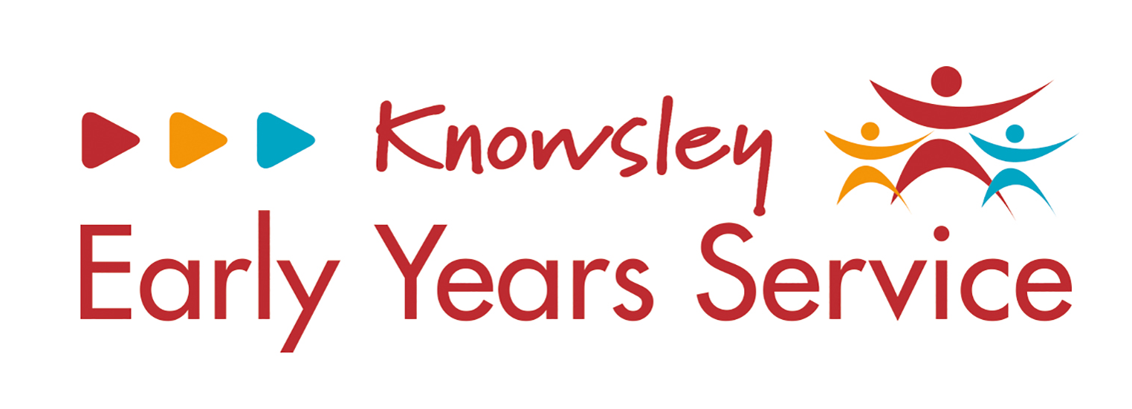
This form will be used by the LA when auditing settings from September 2023:
Setting Name: |  | Date audited/checked by LA Officer (name):
Child/Children audited: |  |  | EYPP Payment:
Parental Consultation: (Has this taken place) | Y / N |  | Outcomes/Impact of EYPP:

Total EYPP payment and term awarded | Resources purchased | Evidence / Invoice Reference | Amount | Remaining Balance
Additional Notes:

