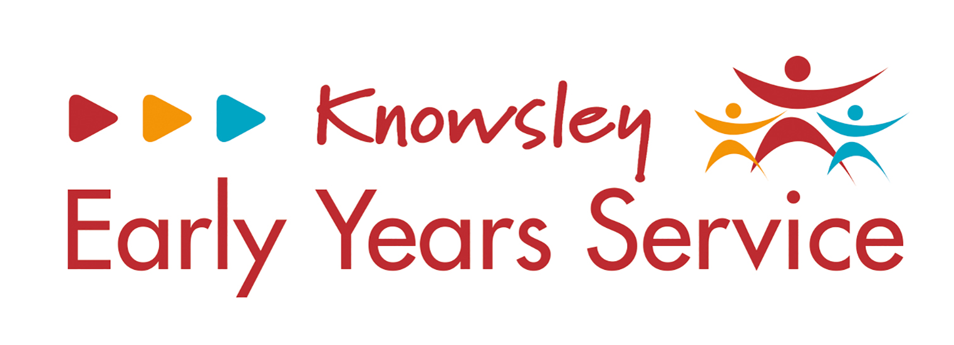
Childcare providers will need to use this Early Years Pupil Premium (EYPP) Audit form from April 2023. This form will need to be available when being audited by the LA in the future.
To be completed by childcare provider:  ‘Resources purchased’ | Invoice reference, as stated by nursery | Price (total) | Cross-check outcome, completed by Local Authority Officer
i.e. Clay / Sensory Fabrics | i.e. Amazon / Early Years Direct

Please reference parent/carer consultation that took place regarding the EYPP expenditure and evidence impact:

