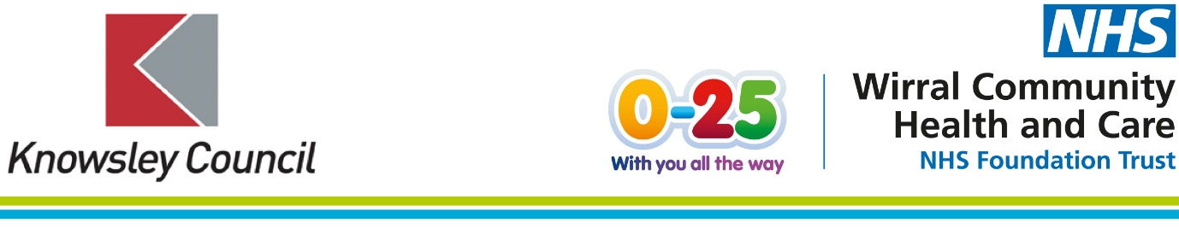

Healthy Child Programme in Knowsley - change of provider as of Tuesday 1 February 2022.

From Tuesday 1 February 2022, the Healthy Child Programme in Knowsley, which includes Health Visiting, Infant Feeding, School Nursing and the Enhancing Families Programme will be provided by Wirral Community Health and Care NHS Foundation Trust (WCHC).

These services will be referred to as the 0-25 Health and Wellbeing Service in Knowsley.

The Trust currently delivers the Healthy Child Programme in Wirral, Cheshire East and St Helens, providing care and support for over 212,000 children, young people and their families. From birth to adulthood the teams support young families to have the best possible start in life and have a huge impact on the long-term health of local young people and children.

Parents, carers and young people in Knowsley will continue to see the same health professionals in their local communities and should not experience any disruption to the dedicated care and support they already receive, as a direct result of this transfer. We will soon be launching a new contact telephone number for the 0-25 Health and Wellbeing Service, but families can continue to contact the service via the Children’s Care Admin Hub on 0151 514 2666.

Health Visiting and School Nursing Services will continue to be delivered across Knowsley. The School Nursing Service will be launching ChatHealth - a confidential NHS-approved text messaging service for young people aged 11-19. Delivered by School Nurses, young people in Knowsley will be able to access a range of advice and support.

The Enhancing Families Programme will replace Family Nurse Partnership (FNP). The team will continue to provide additional support for parents and families who may require it.

There are no changes to the current referral pathways. Please continue to refer into the services as normal. Over the coming week, we will be altering the names of our service email addresses, but don’t worry - all email addresses will redirect to the new mailboxes. We’ will keep you up to date of all changes.

The Trust has a dedicated children and young people’s website. From Tuesday 1 February parents, carers, and young people in Knowsley will be able to access a range of local and tailored support, information and advice, including videos and resources - ranging from baby packs and fussy eating to puberty support and vaccination schedules, as well as local online support groups.
When the services transfer over to WCHC the team from the 0-25 Health and Wellbeing Service will send you regular updates and will continue to attend local stakeholder networks and forums. You will also receive an invitation to attend a virtual stakeholder event.

Kind regards,

xxx

