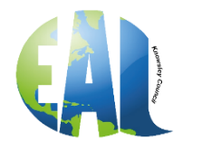
International Mother Language Day
21st February 2023

Why is International Mother Language Day celebrated?
International Mother Language Day is observed every year to promote linguistic and cultural diversity and multilingualism.
Through globalisation, many languages are under threat of disappearing altogether, but they are a crucial aspect of preserving cultures around the world. At least 43% of the world's estimated 6000 spoken languages are endangered. Every two weeks, a language completely disappears, and the cultural and intellectual heritage is gone with it. 40% of the people in the world don't have access to education in a language that they understand.
Therefore, celebrating International Mother Language Day is important because it ensures these languages are not forgotten, as well as keeping the cultural, heritage and history of countries intact. People should be proud of their mother language and want to have the drive to learn more.
What is the importance of mother language?
Research shows that education in the mother tongue is a key factor for inclusion and quality learning, and it also improves learning outcomes and academic performance. This is crucial, especially in primary school to avoid knowledge gaps and increase the speed of learning and comprehension.

History of International Mother Language Day

In 1952, four young students were killed in Bangladesh during a protest because of a Bengali and Urdu language controversy. After this unfortunate incident and many years of unrest, the United Nations Educational Scientific and Cultural Organisation (UNESCO) decided to make International Mother Language Day an annual event celebrated around the world. On the 17th of November 1999, UNESCO proclaimed the 21st of February to be International Mother Language Day. It was first observed in 2000.
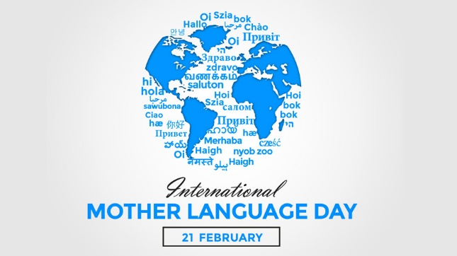
Fascinating facts about languages you did not know
