THE LANGUAGE OF THE MONTH FOR FEBRUARY IS PORTUGUESE.
The accompanying language mat has days of the week, months of the year, numbers 1 -10 and colours all in Portuguese.
World Stories has 24 Portuguese stories stories for children to read.
Within our school community we have many Brazilian children who speak Portuguese. There is very little difference between the Portuguese spoken in Portugal and that of Brazil.
Portuguese Greetings
- Olá (Hello)
- Bom dia (Good morning)
- Boa tarde (Good afternoon)
- Boa noite (Good evening / Good night)
- Bem-vindo (Welcome)

From YouTube record Portuguese speakers having a conversation so that students can listen to how the Portuguese language sounds.
In Brazil - Festa Junina is celebrated throughout the whole of Brazil for the entire month of June as a celebration of Saint John the Baptist, which gives it the other name of Festa de Sao João. Carnival - Undoubtedly the largest festival in Brazil, carnival is known worldwide for its non-stop one week of partying. The weeks leading up to the official carnival are peppered with random street parades and parties known as blocos, and if that wasn’t enough, the weeks after tend to have some post-carnival parties to ease off the end of carnival blues.
Almost every village in Portugal has a festival (festa) o a traditional pilgrimage (romaria) to celebrate the local Saint’s day or regional harvest. Many of Portugal’s public holidays are centred on the Christian calendar.
Brazil Portugal
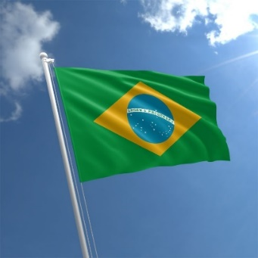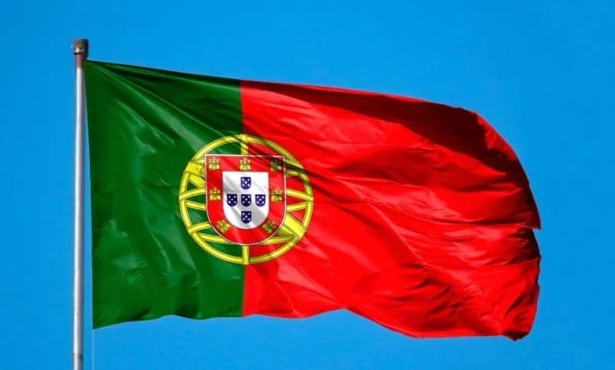

Esperamos que tenha gostado de aprender sobre a língua portuguesa e também sobre Portugal e o Brasil onde a língua é falada.

