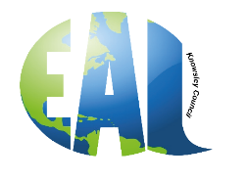THE LANGUAGE OF THE MONTH FOR JANUARY IS POLISH.
The accompanying language mat has days of the week, months of the year, numbers 1 -10 and colours all in Polish.
World Stories has 20 Polish stories for children to read.
Polish Greetings
Hello | Cześć
Good morning | Dzień dobry
Good Day | Dzień dobry
Good evening | Dobry wieczór
Good night | Dobranoc
From YouTube record Polish speakers having a conversation so that students can listen to how the Polish language sounds.
Polish traditions through the year are full of superstitions, rituals, and holiday celebrations. Some are firmly rooted in the predominant religion of Poland, Roman Catholicism; others stem from pagan rites of the seasons.
The drowning of Marzanna is a pagan farewell-to-winter tradition that occurs on Death Sunday, before Easter. An effigy of Marzanna, the goddess of the winter seasons, is taken to the riverbank and thrown into the water. Participants watch her "drown." With the passing of Marzanna, the ills of winter are forgotten, and spring can return with warm weather and natural bounty.
Wianki, which means "wreaths" in English, is a pagan festival honouring the midsummer solstice. Wreaths symbolize the cyclical seasons.
Powodzenia, mamy nadzieję, że nauka języka polskiego sprawiła Wam przyjemność.

