**If you require this leaflet in Braille, large print or another language please contact us on the number below.**

Portage is a home visiting educational service for children aged 0-3 with additional support needs and their families.



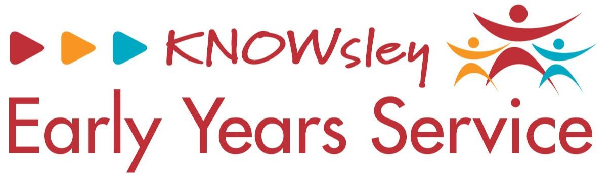

**Knowsley Early Years Portage Service**

•         *Text should be in Ariel*

•         *Text should be no smaller than 12pt*

•         *Text should be in black*

•         *Sub-headings should be bold*

•         *Make sure you have your flyer or poster approved by the communications team before issuing it.*

-          Image box (see sketch) – *‘Insert your image here. If you require an image from the Trust’s photo library please contact the communications department’*

**The Portage Model**

Any Portage service registered with the National Portage Association should be offering support based on the following characteristics

* Assisting the development of play, communication, relationships and learning for young children within the family
* Assisting the child’s and family participation and inclusion in the community in their own right
* Working together with Parents within the family with them taking the leading role in the partnership that has been established
* Helping Parents identify what is important to them and their child and plan goals for learning and participation
* Keeping a shared record of the child’s progress and other issues raised by the family
* Responding flexibly to the needs of the child and family when providing support
* Portage home visitors accessing support through regular team meetings on behalf of the family they work with

www.knowsley.gov.uk

Version 2 – September 2020

**SEND Local offer website**

**https://www.knowsleyinfo.co.uk/localoffer**

**If you have any queries, please contact:**

**Telephone: 0151 443 5633 Option 6**

**Email:** [**maria.williams@knowsley.gov.uk**](mailto:maria.williams@knowsley.gov.uk)

**How portage works**

Families are visited either weekly or fortnightly by one of our Portage Practitioners depending on the needs of your child. The Portage Practitioner will use developmental checklists to build up a picture of your child's strengths and to set targets for future visits. They will also support your child to access other services if needed

**Referrals to Portage**

Referrals can be made by a variety of Professionals as well as Parents. Referrals are sent to Knowsley's Child Development Team who will decide whether Portage is an appropriate service. If accepted your child will be placed on a waiting list until a Portage Practitioner has availability.

In the meantime, you will be asked to register with the Early Years Service and offered support from an Early Years Practitioner. Alternatively, depending on the age of your child you may be offered group sessions which take place in a Children's Centre.

**What is Portage**

The aim of our Portage Service in Knowsley is to support young children's development through play, supporting communication and building relationships to enable them to participate fully in family life at home and in the wider community.

In order to do this the Portage home visitor works alongside Parents and other Professionals offering practical help and ideas to:

* Make learning fun for all the family
* Encourage a child’s interests
* Address problematic situations
* All children and parents should be valued for their unique qualities.
* Parents play the key role in supporting their young child’s development.
* Building on abilities and strengths, rather than focusing on difficulties best supports children’s learning and enjoyment
* Support the child to access an Educational setting

**Portage groups**

If your child is identified as being suitable to attend a Portage Group you will be notified by the Team Administrator in writing/ by telephone.  If there are any barriers to you attending a group they will be considered at this time.

**Commitment to group sessions**

Group sessions run on a 6-weekly basis. You will be asked to commit to the full

6-week period to enable you and your child to gain the optimum benefit from them.

Cancellation due to appointments, illness etc, can be registered at the Children's Centre where the sessions are held.

Group sessions enable you to meet other families with young children and to build up support mechanisms.

If you are offered group sessions but choose not to attend then your child will be placed on our waiting list, however we cannot guarantee that your child will be offered 1 to 1 support from a Portage Practitioner before they are no longer eligible for our service.