Reviewing an Education, Health and Care Plan (EHCP)

Information for parents, carers and
their families.

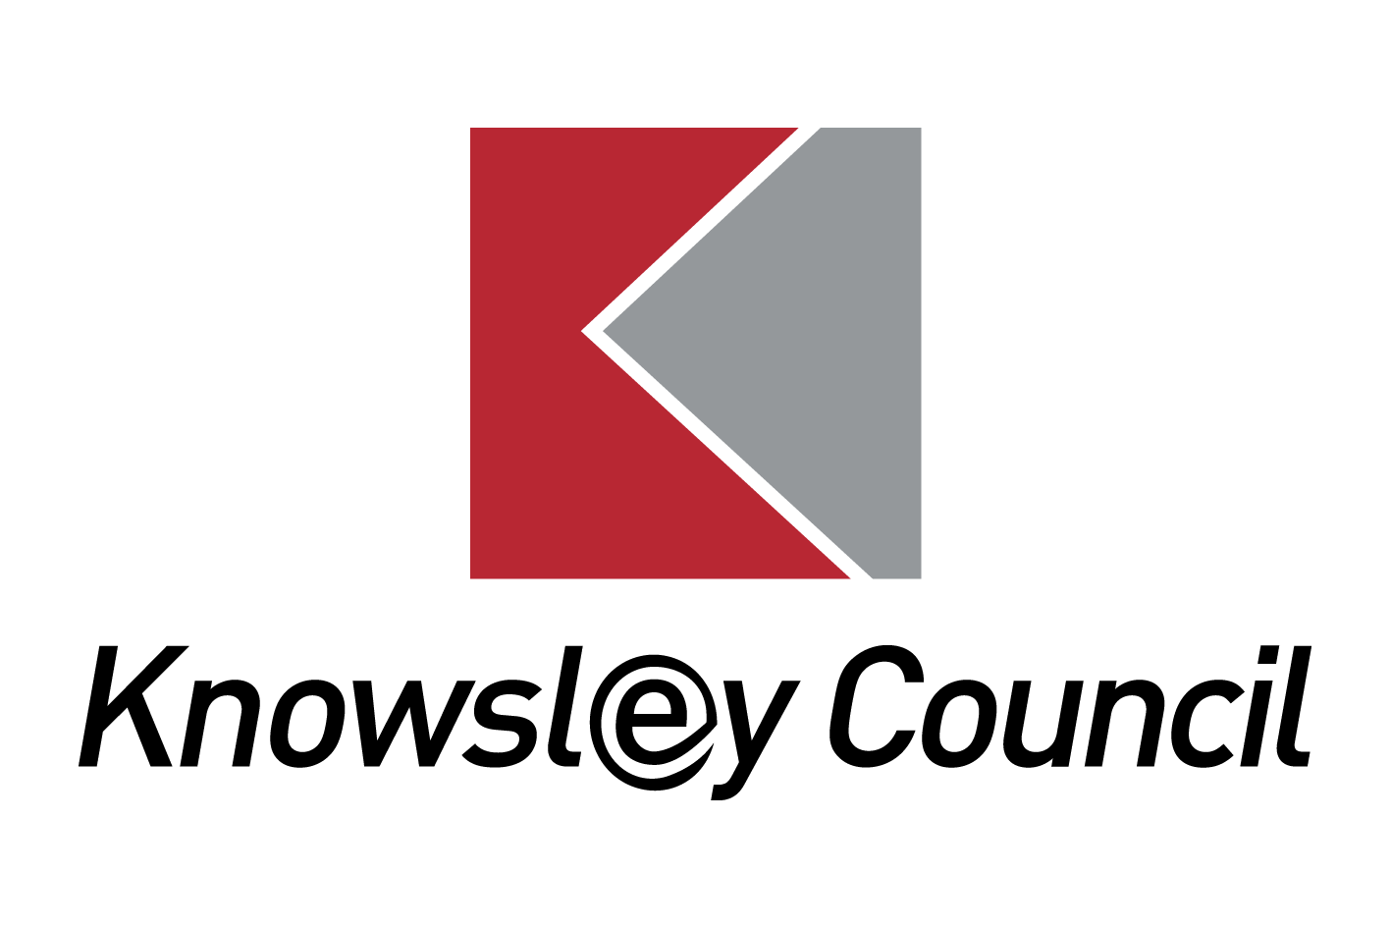

Reviewing an Education, Health and Care Plan (EHCP)

What is an Annual Review?

Education, Health and Care Plans should be used to actively monitor children and young people’s progress towards their outcomes and longer term aspirations. They must be reviewed by the Local Authority as a minimum every 12 months; this is usually done through the educational setting arranging an Annual Review Meeting.
Reviews must focus on the child or young person’s progress towards achieving the outcomes specified in the EHC plan. The review must also consider whether these outcomes and supporting targets remain appropriate.
The Annual Review meeting is a chance for everyone involved in supporting the child/young person to review how well they are progressing and whether anything needs to be changed.
The EHCP will remain in place until the child/young person child leaves education or the parent and Local Authority decides that the special educational provision is no longer needed and the EHCP can cease.
The Annual Review Process

The process the Local Authority must follow when reviewing an EHCP is set out by law and is described in detail in the SEN and Disability Code of Practice 2015.
This means:
- The LA must consult with the parent of the child or young person (and with the school or institution being attended if there is one) about the EHC plan;
- An annual review meeting must take place to discuss the EHC plan;
- Information must be gathered from parents and young people and from professionals about the EHC Plan and then circulated two weeks before the meeting.
- After the meeting the minutes of the meeting, and any other professional reports, must be prepared and circulated to everyone who attended and be sent to the Local Authority who will consider any recommendations for changes to be made to the EHC Plan.

Annual Reviews must be undertaken in partnership with the parent and the child/young person, they should be supported to fully engage in the process and the review must take account of their views wishes and feelings.

The Annual Review meeting should:

- Gather and assess information so that it can be used to support the child or young person’s progress and their access to teaching and learning
- Review the special educational provision made for the child or young person to ensure it is being effective in ensuring access to teaching and learning and good progress
- Review the health and social care provision made for the child or young person and its effectiveness in ensuring good progress towards outcomes
- Consider the continuing appropriateness of the EHC plan in the light of the child or young person’s progress during the previous year or changed circumstances and whether changes are required including any changes to outcomes, provision, change of educational establishment or whether the EHC plan should cease
- Review any interim targets set and decide any actions for the coming year
- All reviews taking place from Year 9 at the latest and onwards must include a focus on preparing for adulthood, including employment, independent living and participation in society.

Annual Reviews should also be combined with other reviews where possible, such as Reviews for children Looked After by the Local Authority or Transition Assessments for young people moving into adult care services.

Following the Annual Review meeting, the Local Authority must decide whether:

- To keep the EHCP as it is now (either because there are no changes or
because the Local Authority does not agree with the recommendations from the review meeting)

(2) To amend the EHCP (to make the changes recommended at the review
meeting)

- To cease the EHCP (if the special education provision is no longer needed
and it is no longer necessary for it to be in place)

If the Local Authority agrees to amend the EHCP, the process of amendment should be started without delay.

If the Local Authority decides not to amend the EHCP or decides to cease the EHCP, the Local Authority must notify the child’s parent or the young person of their right to appeal that decision.

How parents and children/young people can contribute to the Annual Review.

All children/young people should be invited to attend their review and fully supported to engage in the process.

In Knowsley we are committed to ensuring that reviews are person centred. This means parents, carers, children and young people are fully involved in the Annual Review process, whichever form this takes and are involved in all aspects of planning and decision-making.

Person-centred approaches will:
- Focus on the child or young person as an individual and the what THEY want to achieve
- Enable children and young people and their parents to express their views, wishes and feelings, celebrate achievements and to be part of the decision-making process
- Be easy for children, young people and their parents or carers to understand, and use clear ordinary language and images rather than professional jargon
- Highlight the child or young person’s strengths and capabilities
- Enable the child or young person, and those that know them best to say what they have done, what they are interested in and what outcomes they are seeking in the future
- Tailor support to the needs of the individual
- Bring together relevant professionals to discuss and agree together the overall approach, and
- Deliver an outcomes-focused and co-ordinated plan for the child or young person and their parents.

In Knowsley, the Local Authority provides settings with a template for Annual Review minutes which includes a section for the parent and a section for the child/young person to complete to share their views prior to the meeting however parents and children/young people should be supported to contribute in a variety of ways.
Not all children and young people will complete the Pupil Views and schools will need to think about and discuss with them and their parents, the best way for them to express their views and contribute to the review process. For some this might be by using technology such as the young person making a PowerPoint about themselves and their achievement’s, through art and crafts activities or drawings, through discussion with a trusted member of staff or other adult or in a variety of ways. Some children/young people may prefer to record their views before the meeting, to have a discussion outside of the main meeting, to attend for the whole meeting or to attend for only a part of it.

Support for families

You can find out more about Annual Reviews by:

• talking to your child’s teacher or the SENCO (Special Educational Needs Co-ordinator)

• reading Chapter 9 of the SEN Code of Practice

www.gov.uk/government/publications/send-code-of-practice-0-to-25

Parents and young people can seek impartial information, advice and support from Knowsley SENDIASS team:
Knowsley Special Educational Needs and Disability Information, Advice and Support Service (SENDIASS) provide impartial advice, information and support to parents/carers of children with special educational needs and/or a disability. The service can advise you about the informal arrangements to resolve or prevent any disagreements between yourself and the Local Authority.
Their contact details are;
Telephone: 0800-012-9066 and option 2 for Knowsley
Email: liverpoolandknowsleysend@wired.me.uk
Website: http://www.liverpoolandknowsleysend.com/

The Local Authority will always try to resolve any issues where possible, without the need for formal processes. However, if you are still not satisfied, there are arrangements in place to help prevent or resolve disagreements in relation to education, health and/or social care. These are mediation and disagreement resolution, which are positive ways of solving problems. The process aims to improve communication and help with negotiation.
Should you wish to consider either mediation or disagreement resolution, or to find out more information about what is involved, please contact:
Essential Mediation; Telephone: 01908-889-080
Email: admin@essentialmediation.co.uk
Website: http://www.essentialmediation.co.uk/

Where following Annual Review, parents disagree with the decision not to amend an EHCP, or to cease an EHCP, parents (and young people aged 16-25) have the right to appeal against this decision to the SEND Tribunal. This must be done within two months of receiving the decision letter. Before you can register an appeal you must have sought advice from a Mediation Adviser within the same timescale. If you wish to continue to appeal you must secure a mediation certificate from the Mediation Adviser. Any appeal must be made directly to the SEND Tribunal Office.
Address: First Tier Tribunal (Special Educational Needs and Disability), 1st Floor, Darlington Magistrates Court, Parkgate, Darlington, DL1 1RU
Telephone: 01325-289-350
Fax: 0870-739-4017
Email: sendistqueries@hmcts.gsi.gov.uk
Website: http://www.justice.gov.uk/tribunals/send

How to contact SEN Assessment and Commissioning.

Special Educational Needs, Assessment and Commissioning
Office Address
First Floor Nutgrove Villa
Westmorland Road
Huyton
Knowsley
Merseyside L36 6GA
Telephone 0151 443 5145

Postal Address
Education Improvement Team
Knowsley MBC
PO Box 21
Municipal Buildings
Archway Road
Huyton
L36 9YU

