What is an Education, Heath and Care Plan (EHCP)?

Information for parents, carers and
their families.

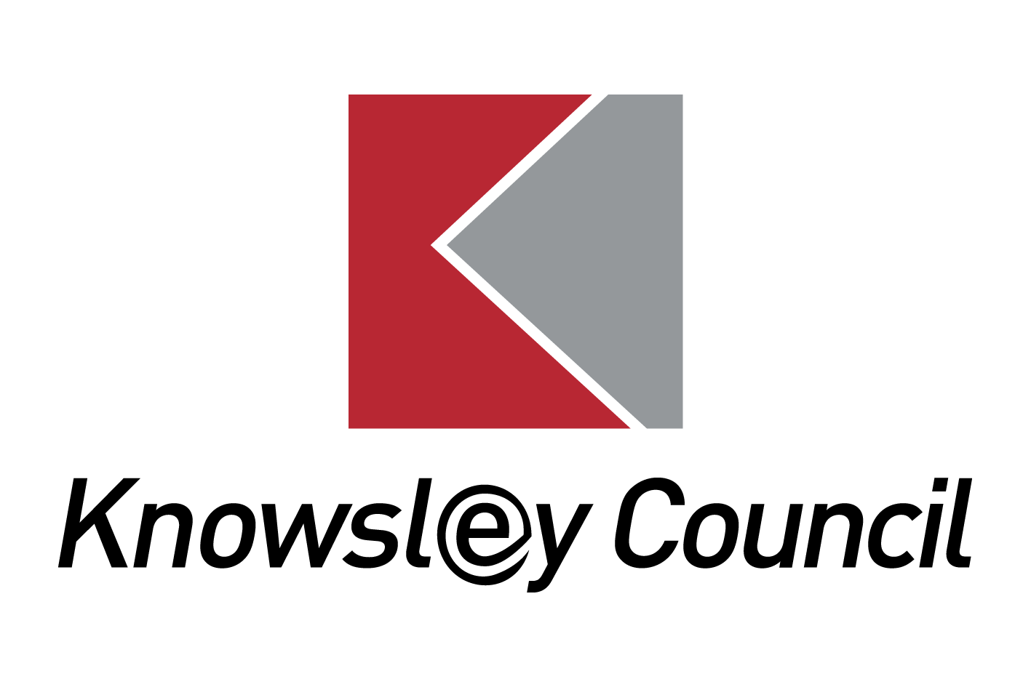

What is an Education, Health and Care Plan (EHCP)?

An EHCP is a legal document that describes a child or young person's special educational, health and social care needs. It explains the extra help that the child or young person will receive from School, the Local Authority, Social Care and Health services to meet those needs and how that help will support the child or young person to make progress and achieve what they want to in their life. The EHCP is drawn up by the Local Authority after an EHC Needs Assessment has taken place.
An EHCP can be issued to a child or young person between the ages of 0 and 25 years.
Who needs an EHCP?

EHC plans are for children and young people whose special educational needs require more help than would normally be provided in a mainstream education setting (a college, school or nursery). Although the EHCP can include health or social care needs, your child will not get a plan if they only have health or social care needs that do not affect their education.
What does an EHCP look like?

The EHCP has 11 sections A to K as follows:
A: The views, interests and aspirations of the child/young person.
B: A description of the child/young person’s Special Educational Needs (SEN).
C: Health needs related to SEN.
D: Social care needs related to SEN.
E: Outcomes - how the extra help will benefit the child/young person
F: Special educational provision (support).
G: Health provision.
H: H1 and H2 detail Social Care provision.
I: Placement - type and name of school or other institution.
J: Personal budget arrangements.
K: Advice and information - a list of the information gathered during the EHC needs assessment.
The EHCP should be written so that everyone can understand it. It should be clear and detailed about the amount and type of support your child will get and how the support will help your child.
What happens when an EHCP has been prepared for a child/young person?

When the Local Authority carries out an EHC Needs Assessment, a decision is taken by the end of week 16 (of the 20 week process) whether to issue an EHCP.
If the Local Authority decides to issue an EHCP we will send out a Draft Education Health and Care Plan with a copy of all the reports and Advice that we have used to write the EHCP. This is sent to the parent and child/young person and to the people who have contributed to the assessment process.
The Draft EHCP is sent out so that parents and the child/young person can make any comments or suggestions for amendments. The Draft EHCP will not contain the name of the school or setting that your child will attend. This is left blank so that parents can ‘express a preference’ for the educational setting they would prefer their child to attend; this could mean the educational setting they already attend or a move to another setting. Parents may request a nursery, maintained mainstream school, college or special school.
Parents are asked to approve the Draft EHCP and express their preference for a setting within 15 days. In Knowsley, the Local Authority sends out a form for the parent/young person to complete and return; Response to Draft EHCP.
When a parent expresses a preference for a particular educational setting, the Local Authority will then formally consult that setting who have 15 days to respond and indicate whether they feel they are they are able to meet the child/young person’s Special Educational Needs and deliver the provision outlined in the EHCP.

The Final Education, Health and Care Plan.

The Final EHCP is issued within 20 weeks of the original request being received; it will be sent to the parent and child/young person and the educational setting they will attend (which is recorded in Section I of the Final EHCP)

When the educational setting receives that Final EHCP they, and the other agencies involved must begin to implement the provision agreed, for example the school will employ a Teaching Assistant for the number of hours agreed in the Final EHCP.

Where a move to a Special School placement has been agreed, the Local Authority will inform the parent and the child/young person of when this move is likely to take place, which may be dependent on when a place becomes available.
The Educational setting should arrange an initial review of The Final EHCP at the end of them first term following its issue. This usually involves inviting the parent and child/young person to a meeting to ensure that the provision in the Final EHCP has been put in place. A formal Annual Review meeting will then be held each year to review and evaluate the child/young person’s progress.
The EHCP will remain in place until the child/young person leaves education or the parent and Local Authority decides that the special educational provision and therefore the EHCP are no longer needed to help the child/young person in their education. If a child/young person moves to another Local Authority the EHCP will be transferred to the other authority.
What support is available for families?

You can find out more about Education, Health and Care Plans by:

• talking to your child’s teacher or the SENCO (Special Educational Needs Co-ordinator)

• reading Chapter 9 of the SEN Code of Practice

www.gov.uk/government/publications/send-code-of-practice-0-to-25

Where the Local Authority is currently carrying out an EHC Needs Assessment, parents and young people can contact their named Lead Education Officer from within the Special Educational Needs Team to discuss any queries.
Parents can seek impartial information, advice and support from Knowsley SENDIASS team:
Knowsley Special Educational Needs and Disability Information, Advice and Support Service (SENDIASS) provide impartial advice, information and support to parents/carers of children with special educational needs and/or a disability. The service can advise you about the informal arrangements to resolve or prevent any disagreements between yourself and the Local Authority.
Their contact details are;
Telephone: 0800-012-9066 and option 2 for Knowsley
Email: liverpoolandknowsleysend@wired.me.uk
Website: http://www.liverpoolandknowsleysend.com/

(LINK) SENDIASS
The Local Authority will always try to resolve any issues where possible, without the need for formal processes. However, if you are still not satisfied, there are arrangements in place to help prevent or resolve disagreements in relation to education, health and/or social care. These are mediation and disagreement resolution, which are positive ways of solving problems. The process aims to improve communication and help with negotiation.
Should you wish to consider either mediation or disagreement resolution, or to find out more information about what is involved, please contact:
Essential Mediation; Telephone: 01908-889-080
Email: admin@essentialmediation.co.uk
Website: http://www.essentialmediation.co.uk/

Where parents disagree with the contents of the Final EHCP, or the education setting named in Section I of the EHCP, Parents (and young people aged 16-25) have the right to appeal against this decision to the SEND Tribunal. This must be done within two months of receiving the decision letter. Before you can register an appeal you must have sought advice from a Mediation Adviser within the same timescale. If you wish to continue to appeal you must secure a mediation certificate from the Mediation Adviser. Any appeal must be made directly to the SEND Tribunal Office.
Address: First Tier Tribunal (Special Educational Needs and Disability), 1st Floor, Darlington Magistrates Court, Parkgate, Darlington, DL1 1RU
Telephone: 01325-289-350
Fax: 0870-739-4017
Email: sendistqueries@hmcts.gsi.gov.uk
Website: http://www.justice.gov.uk/tribunals/send

How to contact SEN Assessment and Commissioning

Special Educational Needs, Assessment and Commissioning
Office Address
First Floor Nutgrove Villa
Westmorland Road
Huyton
Knowsley
Merseyside L36 6GA
Telephone 0151 443 5145

Postal Address
Education Improvement Team
Knowsley MBC
PO Box 21
Municipal Buildings
Archway Road
Huyton
L36 9YU

