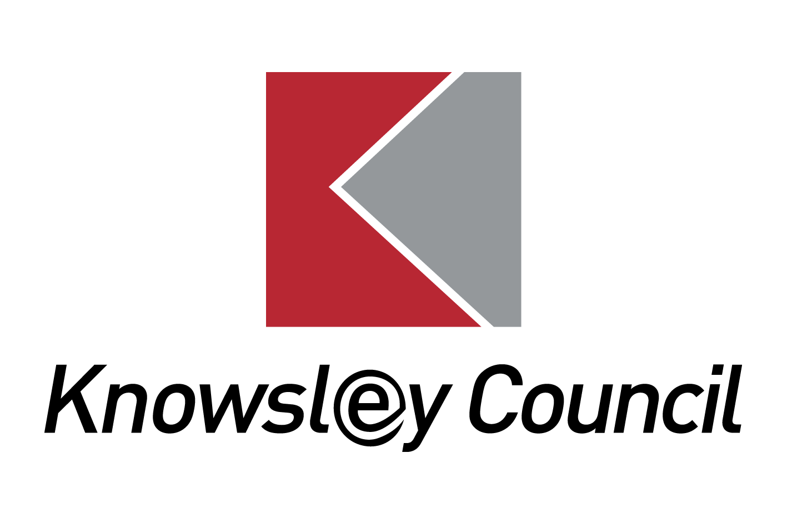
What is an Education, Heath and Care (EHC) Needs Assessment?

Information for parents, carers and their families.

What is an EHC Needs Assessment?

Most children with Special Educational Needs (SEN) will be supported by extra help provided in their school, nursery or college. This is called SEN Support. All educational settings receive funding for children with special educational needs to be able to deliver support and interventions for children who need SEN Support.

For a small number of pupils with more severe and/or complex needs that are long-term in nature, additional support may be required from the Local Authority. This is when an EHC Needs Assessment of a child or young person’s education, health and care needs may be carried out.

This is a detailed assessment of reports and other evidence to identify if a child or young person’s Special Educational Needs require significant help. The conclusion of the EHC Needs Assessment will be to decide if an Education, Health and Care (EHC) Plan is needed. It will not automatically lead to an EHC Plan being issued.
Who can request an EHC Needs Assessment?

- The child’s parent
- A young person over the age of 16 but under the age of 25
- A person acting on behalf of an educational setting, this person is usually called the special Educational Needs Coordinator (SENCO). These requests should be with the knowledge and agreement of the parent or young person
In addition other people can bring a child to the attention of the Local Authority where they think an assessment might be necessary; this includes for example Foster Carers, health and social care professionals or teams that work with young people such as youth offending teams.
Educational settings should work together with parents and young people to make the request for an assessment; settings in Knowsley should use the Local Authority Application for an EHC Needs Assessment (known as the K Form)
Parents can also make a request for assessment in writing, explaining the reasons why they feel their child has special educational needs that require further assessment by the Local Authority. They should make a request for assessment to the SEN Assessment and Commissioning Team at the address below.
(IPSEA) Independent Parental Special Education Advice
How will the Local Authority consider requests for an EHC Needs Assessment?

The Local Authority must make a decision on whether to carry out an EHC needs assessment within 6 weeks of receiving the request. In Knowsley, all requests for an EHC Needs Assessment are considered by the Knowsley Assessment, Placement and Provision Panel (KAPP Panel). KAPP Panel includes members from the Local Authority Special Educational Needs Team, Educational Psychology Service, Post 16 Team, Early Years Team as well as representatives from schools and from health and social care services.

The KAPP Panel considers the request and looks for clear evidence that despite the best efforts of the school, the child or young person continues to have a significant barrier to learning and the school cannot respond from within its own resources.

The KAPP Panel meets fortnightly during term time to consider requests.
After considering all the information supplied, the Local Authority will make a decision and inform the person making the request, and the parent of the outcome in writing.

The Local Authority will decide either:

- We will not start an EHC Needs Assessment- this can be for many reasons, the KAPP Panel may feel that a child’s special educational needs can be supported through the funding available at school or there may not ne be enough information for the KAPP Panel to reach a decision- in these cases the KAPP Panel will explain the reasons in writing and give recommendations on what could happen next.

or

- Yes we will start an EHC Needs Assessment- this means that the Local Authority will start an assessment to gather further information about a child’s special educational needs and what help they may need from the Local Authority

How parents and children and young people will be involved in the assessment.

The Local Authority must consult the child/young person and the child’s parent on their views, opinions and aspirations for the future. A form called a Parental Advice for Assessment and an All About Me for children/young people are part of the Local Authority Application Form (the K Form). The parents and child/young person’s views therefore are usually completed as part of the initial request for Assessment, so that they can be considered by the KAPP Panel alongside any other information.
If the Local Authority does start an EHC Needs Assessment then we will write to the parent or young person to ask if there is any more information they would like to be considered as part of the assessment. Each child/young person will also have a named person, who is a Lead Education Officer from within the Special Educational Needs Team who can answer any questions or concerns during the assessment process.
As part of the assessment process the Local Authority will contact the professionals working with the child/young person and also ask them if there is any more information to be considered; other professionals should also ask the child/young person and the parents for their views.
What happens during the assessment?

The Local Authority will contact the professionals working with the child/young person and also ask them if there is any more information to be considered, some of the professionals involved, such as the Educational Psychologist or Community Paediatrician may write a report called a Professional Advice to give their opinion on what help and support a child or young person needs.
The whole EHC Needs Assessment Process should take no longer than 20 weeks to complete. This includes up to 6 weeks to make a decision to agree the assessment and up to 10 weeks after that to gather additional reports or information.
What happens at the end of the EHC Needs Assessment?

At the end of the assessment period (at around week 16) the Local Authority will, using the information gathered, take the decision to
- Issue an Education, Health and Care Plan (EHCP)
Or
- Not to issue an EHCP- in which case we will write to the parent or young person, and the person who made the original request to let them know the reasons and the options available if the parent disagrees with the decision.

What support is available to families during the EHC needs assessment?

You can find out more about an Education, Health and Care Needs Assessment by:

• talking to your child’s teacher or the SENCO (Special Educational Needs Co-ordinator)

• reading Chapter 9 of the SEN Code of Practice

www.gov.uk/government/publications/send-code-of-practice-0-to-25

Where the Local Authority is currently carrying out an EHC Needs Assessment, parents and young people can contact their named Lead Education Officer from within the Special Educational Needs Team to discuss any queries.
Parents can seek impartial information, advice and support from Knowsley SENDIASS team:
Knowsley Special Educational Needs and Disability Information, Advice and Support Service (SENDIASS) provide impartial advice, information and support to parents/carers of children with special educational needs and/or a disability. The service can advise you about the informal arrangements to resolve or prevent any disagreements between yourself and the Local Authority.
Their contact details are;
Telephone: 0800-012-9066 and option 2 for Knowsley
Email: liverpoolandknowsleysend@wired.me.uk
Website: http://www.liverpoolandknowsleysend.com/

(LINK) SENDIASS
The Local Authority will always try to resolve any issues where possible, without the need for formal processes. However, if you are still not satisfied, there are arrangements in place to help prevent or resolve disagreements in relation to education, health and/or social care. These are mediation and disagreement resolution, which are positive ways of solving problems. The process aims to improve communication and help with negotiation.
Should you wish to consider either mediation or disagreement resolution, or to find out more information about what is involved, please contact Essential Mediation;
Telephone: 01908-889-080
Email: admin@essentialmediation.co.uk
Website: http://www.essentialmediation.co.uk/

Where parents disagree with the decision not to carry out an EHC Needs Assessment, or following the assessment, not to issue and Education, Health and Care Plan, parents (and young people aged 16-25) have the right to appeal against this decision to the SEND Tribunal. This must be done within two months of receiving the decision letter. Before you can register an appeal you must have sought advice from a Mediation Adviser within the same timescale. If you wish to continue to appeal you must secure a mediation certificate from the Mediation Adviser. Any appeal must be made directly to the SEND Tribunal Office.
Address: First Tier Tribunal (Special Educational Needs and Disability), 1st Floor, Darlington Magistrates Court, Parkgate, Darlington, DL1 1RU
Telephone: 01325-289-350
Fax: 0870-739-4017
Email: sendistqueries@hmcts.gsi.gov.uk
Website: http://www.justice.gov.uk/tribunals/send

Useful documents

Application Forms and further information
How to contact SEN Assessment and Commissioning

Special Edcuational Needs Assessment and Commissioning

Office Address
First Floor Nutgrove Villa
Westmorland Road
Huyton
Knowsley
Merseyside L36 6GA
Telephone 0151 443 5145

Postal Address
Education Improvement Team
Knowsley MBC
PO Box 21
Municipal Buildings
Archway Road
Huyton
L36 9YU

