**Seema’s English Book 1**



**Name ………………………………………………………………**

**Class …………………………………………………………………**

**School ………………………………………………………………**

**Unit 1 Naming an object**

Key instruction: **‘show me a …’**

Key response: **pupil points and says ‘a book’**

* **10 classroom nouns**; a pencil, a book, a chair, a ruler, a bin, a brush, a table, a door, window, a rubber

**Activities:**

* 1. **Name real objects.** Point to the relevant objects around the classroom. Say **‘a chair, a table, a book …’,** take care to use the indefinite article (the word **a** or **an**) each time. Ask pupil to repeat each time. Make sure he or she uses the article **a** or **an**. Say **‘show me a …’** and get pupil to point and name the object, using **a** or **an** each time.
  2. **Name the pictures**. Cut out the pictures on sheet 1.2, lay them out on the table. Pick up each card naming it **‘a book, a table …’,** say **‘show me a table’.** Get the pupil to point and say **‘a table’.**
  3. **Read the words**. Cut out the words and show how to match the words to the pictures. Then check that the pupil can read each word.
  4. **Write the words**. Set the work for independent and supported practice. Give pupil sheet 1.4 and demonstrate the task of writing the word with the **a** or **an** article by each picture. Ask the pupil to do number 1 of the writing task to ensure understanding.

Key expectations:

* *Pupils use the word* ***a*** *before saying each noun.*
* *Pupils begin to read and write the words.*

**Cut and match sheet 1.2**

|  |  |
| --- | --- |
| a ruler | a chair |
| a bin | a book |
| a pencil | a brush |
| a door | a table |
| a window | a rubber |

**Cut and match sheet 1.3**

|  |  |
| --- | --- |
| **a ruler** | **a chair** |
| **a bin** | **a book** |
| **a pencil** | **a door** |
| **a brush** | **a rubber** |
| **a table** | **a window** |

**Colour and write sheet 1.4**

|  |
| --- |
| a chair  **1** …………………………………………………… |
| a ruler  **2**…………………………………………………… |
| a book  **3**…………………………………………………… |
| a bin  **4** …………………………………………………… |
| a table  **5**…………………………………………………… |

**Colour and write sheet 1.4**

|  |
| --- |
| a brush  **6** …………………………………………………… |
| a pencil  **7**…………………………………………………… |
| a door  **8**…………………………………………………… |
| a window  **9** …………………………………………………… |
| **10**……………………………………………………  a rubber |

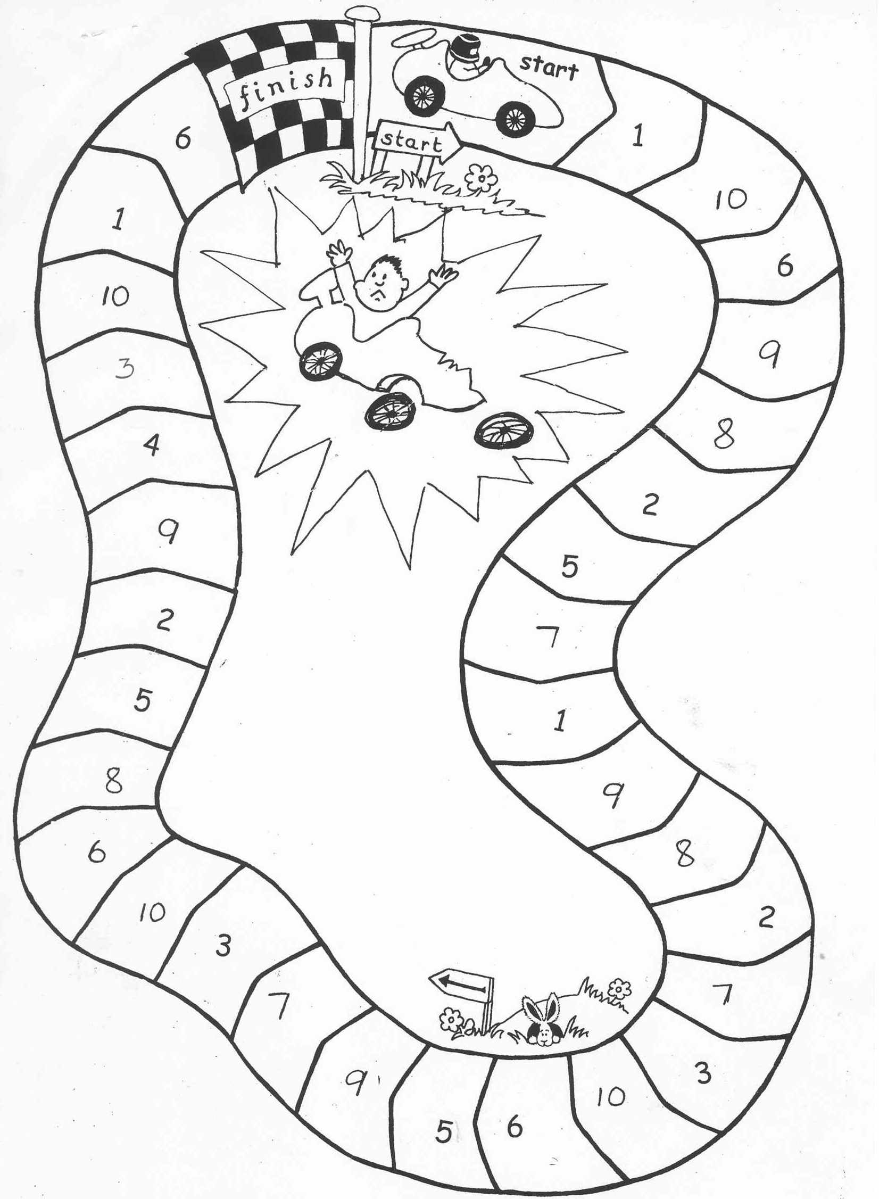

**9**

**1**

**3**

**10**

**6**

**8**

**5**

**2**

**9**

**4**

**7**

**5**

**2**

**7**

**8**

**2**

**7**

**3**

**10**

**9**

**6**

**5**

**1**

**3**

**10**

**8**

**9**

**6**

**10**

**6**

**1**

**Car Chase**

* This game is ideal for further practice with peers and with parents. It can be played with any new words. Number the cards 1-10 on the back.
* Spread all the cards (numbers up) on the table.
* Player 1 throws a dice and calls the number he or she lands on. Player 2 picks up the card with that number on, and asks player 1 to say the word. Ask more able pupils to write the word.
* If correct, player 1 stays on that square.
* If incorrect, player 1 stays on that square, but places the card on the crashed car with the word up to say or spell before his of her next throw.
* First one home wins.

The game can be coloured and laminated for future use.