Who is this?
My family Book
Seema’s English Book 11d

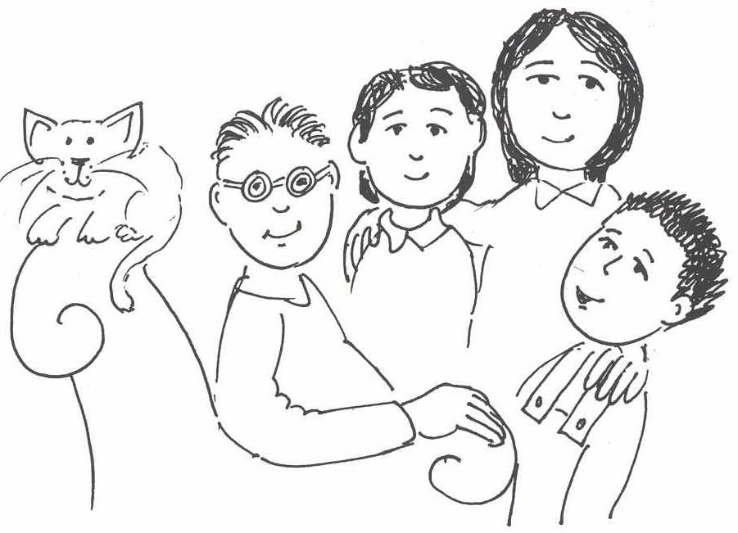

Who is this?

Name ………………………………………………………………
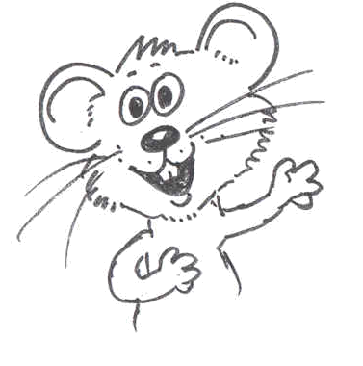
Class …………………………………………………………………

School ………………………………………………………………
Unit 11 My Family

Activities:
11.1 Check the sentence and colour work from Unit 10.
11.2 Talk about the My Family picture. Introduce the words and practise with the word cards.
11.3 Read the page: Begin by modelling to the pupils on how to read the page. Ask pupils to point as you read. Ask pupils to read and point. Practise until secure.
11.4 Talk about the page: Ask the questions and model answers in sentences. Ask pupils to repeat. Practise all questions and answers orally. Make sure that pupils ask questions correctly and answer in full sentences. Practise as many pages as you think the pupils can manage.
11.5 Make a sentence: Model making up a sentence using the picture as a cue, e.g., The ball is by the flower. The flower is red and blue. Ask pupils to make up a sentence to be written as number 6 on the answer sheet. Practise as many pages as you think the pupils can manage.
11.6 Write questions and answers: Ask pupils to complete the answers in class during independent time.
11.7 Write a page of text: Practise saying sentences about the picture. Use the sentence grid to help. Set the task of writing for independent work.
Key expectation:
- Pupils speak and write two or more sentences about a picture.
- Pupils read and respond to simple text, orally and in writing.
Unit 11 My Family words

mum | dad
brother | sister
Billy | friend

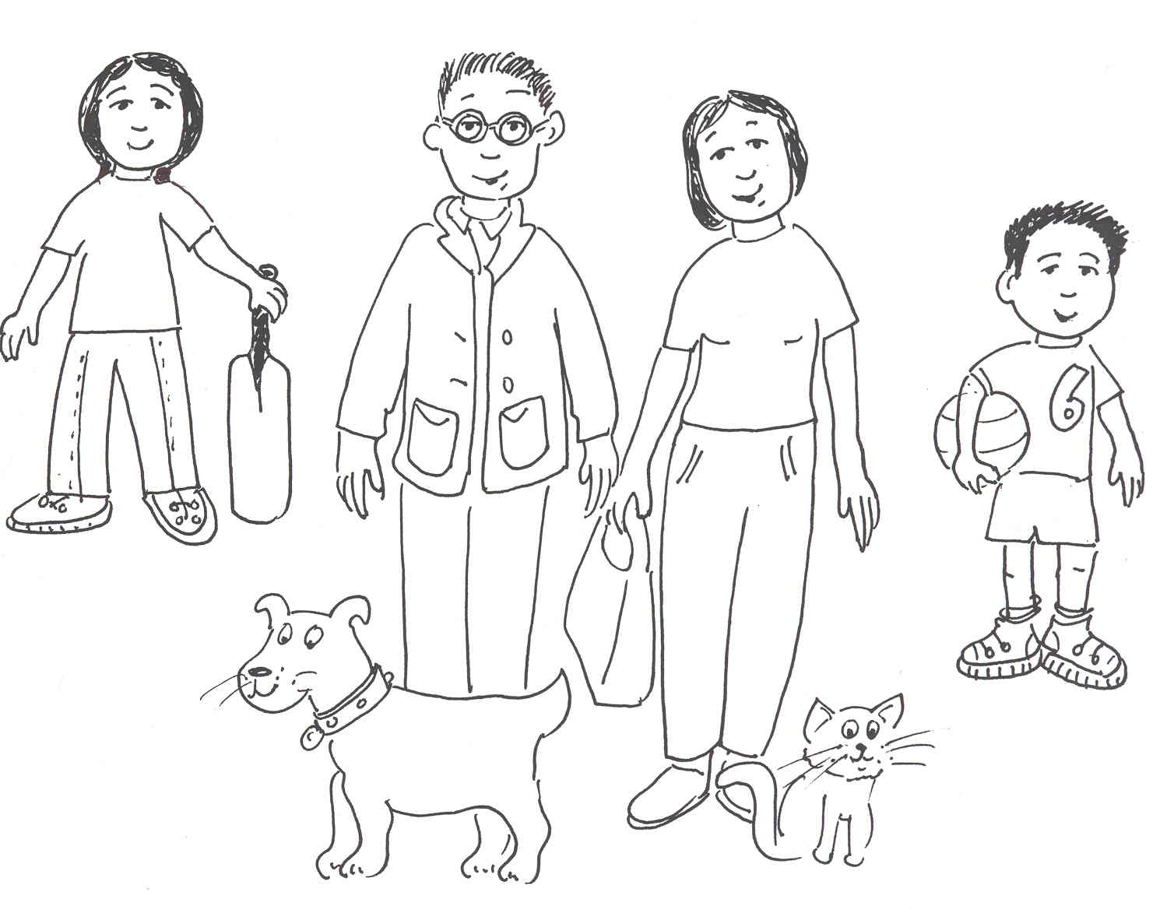
My mum

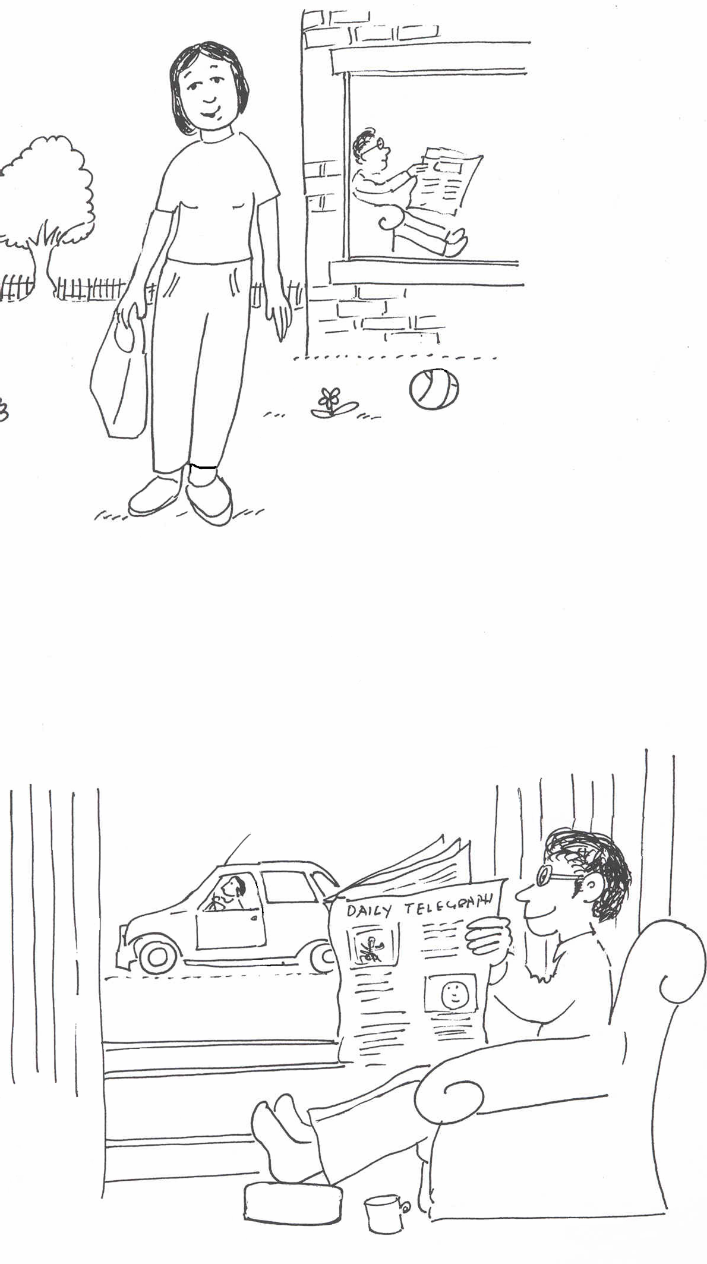
Who is this?

This is my mum.
My mum has a big pink bag.
My mum has an orange jumper and purple trousers.
She has black shoes.
She is happy.
My dad is in the house.
He is in the chair.

- 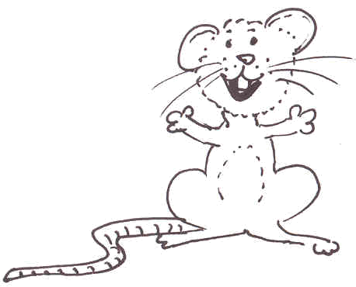What colour is mum’s bag?
- What colour are mum’s clothes?
- Where is dad?
- Who is in the chair?
- Where is the ball?

My mum
1
2
3
4
5
Now say and write your own sentence about the picture.
6

My dad

Who is this?

This is my dad.
My dad has a brown chair.
He has a yellow jumper and blue trousers.
He has orange socks.
My dad is a happy man.
My mum is in the car.
The car is red.

- Who is this?
- Where is he?
- What colour are his trousers?
- Where is mum?
- Is dad sad?
- What colour is the car?

My dad
1
2
3
4
5
Now say and write your own sentence about the picture.
6

My brother

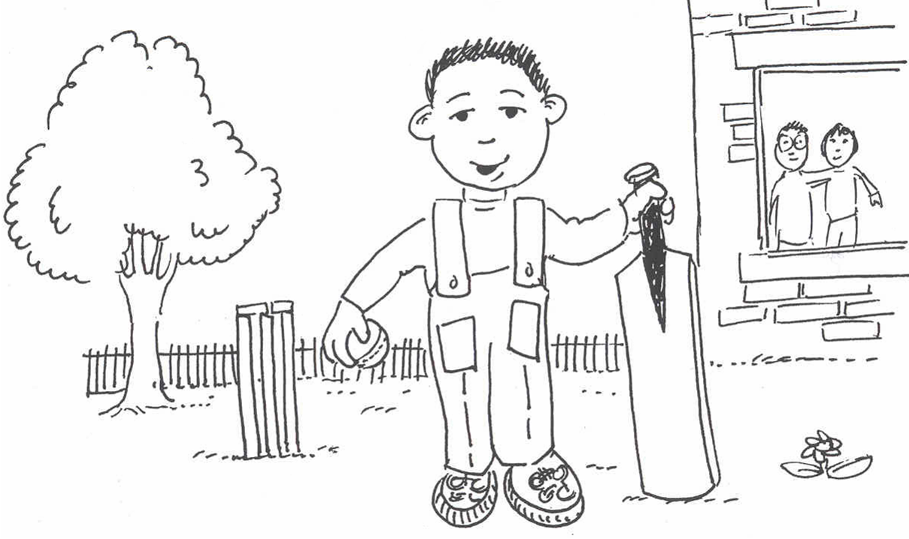

Who is this?

This is my brother.
My brother has a bat and a ball.
He has a yellow jumper and blue trousers.
He has red and blue trainers.
My brother is a happy boy.
My mum and dad are in the house.
They are by the window.

- Who is this?
- What colour is his jumper?
- What colour are his trainers?
- Where are mum and dad?
- Is he a sad boy?
- Are mum and dad happy?

My brother
1
2
3
4
5
Now say and write your own sentence about the picture.
6

My sister

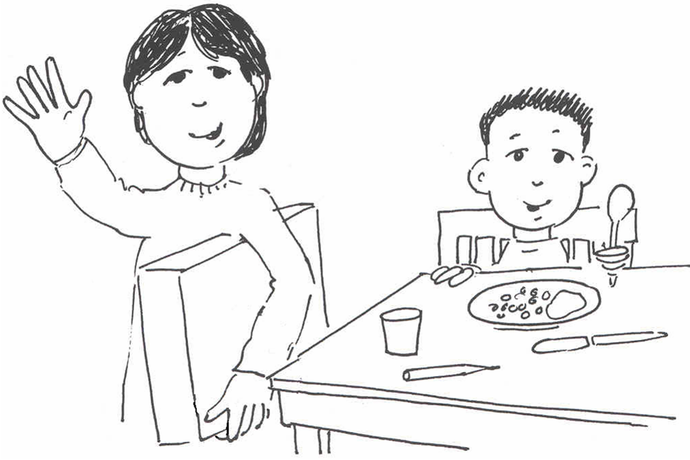

Who is this?

This is my sister.
My sister has a big blue box.
My sister has black hair and a brown face.
She has a green dress.
My brother is at the table.
My brother has a little red spoon.

- Who is this?
- What has she got under her arm?
- What colour is her dress?
- Where is her brother?
- What is in his hands?
- What is on the table?

My sister
1
2
3
4
5
Now say and write your own sentence about the picture.
6

My family

Who is this?

This is my family.
My mum, my dad, my brother and sister, and my cat Billy are in my family.
Dad is in the chair.
Billy is on the chair.
My family is a happy family.
My sister has a green dress.
My mum has an orange jumper.

- Who is this?
- Where is dad?
- What colour are his trousers?
- Where is Billy?
- Is my sister happy?
- What colour is mum’s jumper?

My family
1
2
3
4
5
Now say and write your own sentence about the picture.
6

My cat

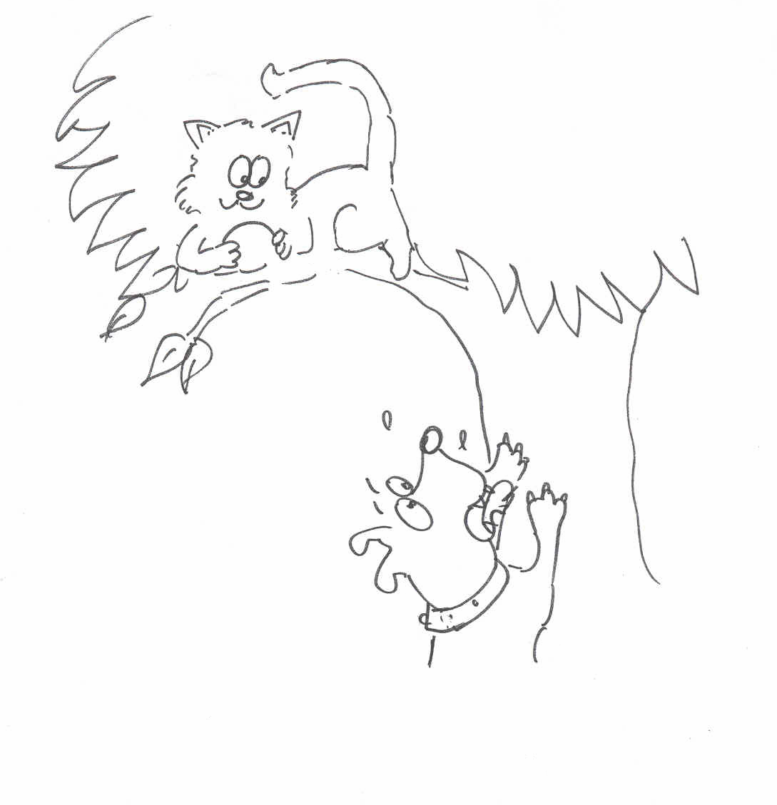

Who is this?

This is my cat.
My cat’s name is Billy.
Billy is up the tree.
He is black and white.
Billy has the dog’s ball.
The dog is under the tree.
He is not happy.

- Who is this?
- What is his name?
- What colour is he?
- Where is he?
- Why is the dog not happy?

My cat
1
2
3
4
5
Now say and write your own sentence about the picture.
6

My friend

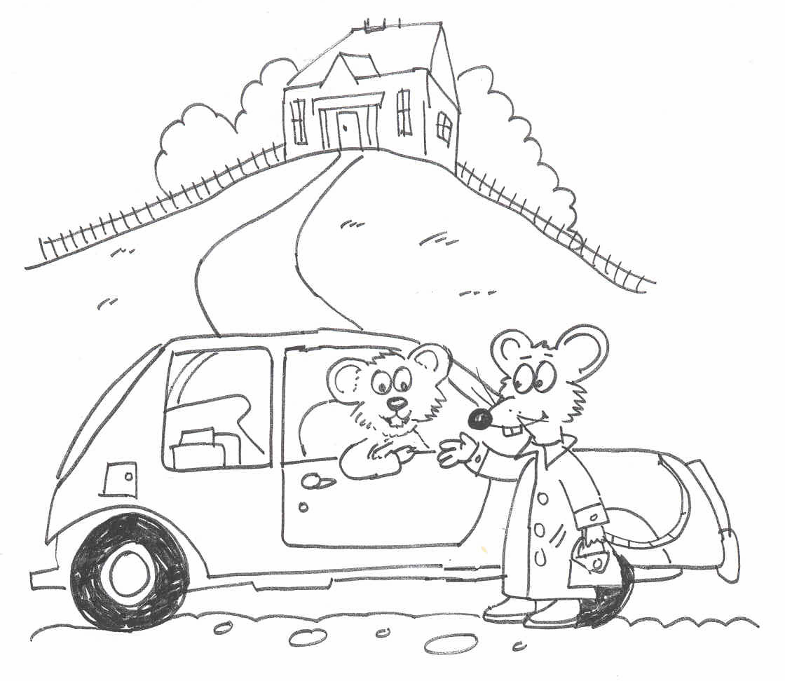

Who is this?

This is my friend Yasmin.
Yasmin is a little orange mouse.
She is a happy mouse.
She has a red coat and black shoes.
Yasmin has a big yellow house on the hill.
Yasmin is next to the car.
We are at Yasmin’s house.

- Who is this?
- What colour is Yasmin?
- Is Yasmin a big mouse?
- Where is Yasmin’s house?
- Who is Yasmin’s friend?

My friend
1
2
3
4
5
Now say and write your own sentence about the picture.
6

My Family
What can you see in the picture?
My Family

What can you see in the picture?
How many sentences can you write?

 |  |  |  |  |  | hair | .
The |  | sister |  |  | sad | ball | .
 | big | dog |  |  | black | face | .
 |  | cat |  |  | blue | trainers | .
 |  | mum | is | a | red | trousers | .
 |  | dad | has |  | yellow | shorts | .
 |  | man |  |  | green | top | .
 | little | brother |  |  | brown | shoes | .
My |  | mouse |  |  | happy | scarf | .
 |  |  |  |  |  | tail | .
Draw and colour

Write about it

…………………………………………………………………………………….............................................................................................................................................................................................................................................................................................................................................................................................................................................................................................................................................................................................................................................................................................................................................................................................................................................................................................................................................................................................

