What are you doing?
My doing words book
Seema’s English Book 12

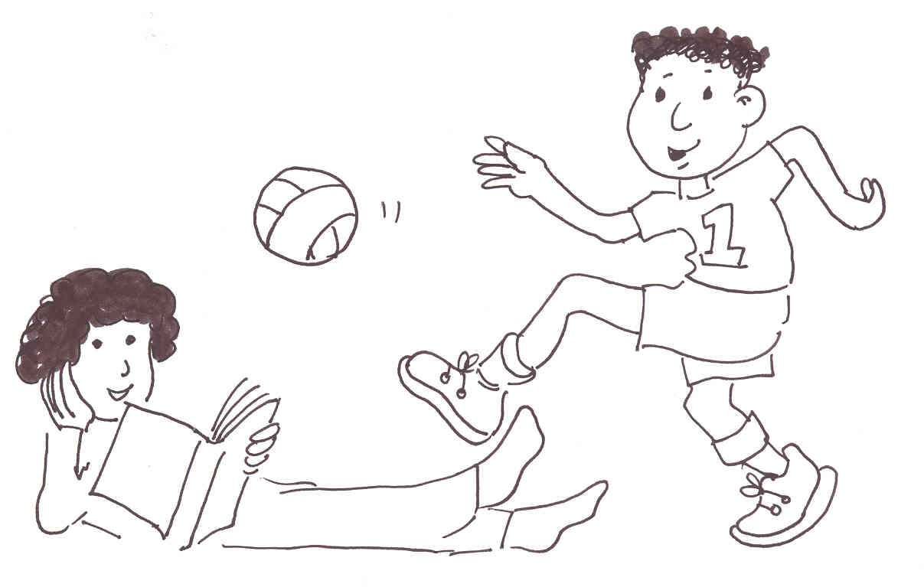

Name ………………………………………………………………

Class …………………………………………………………………

School ………………………………………………………………
Unit 12 Doing Words (verbs)

Activities:
12.1 Check the sentence and colour work from Unit 11.
12.2a Commands: Give pupils some simple commands, e.g., stand, sit draw, write … etc.
12.2b Simple present tense: Introduce the words and pictures, and practise with the word cards. Set pupils the write the word task to do during independent work in class.
12.3a Present continuous tense: Practise the What are you doing? question and model each answer in a complete sentence. Ask pupil to point as you read. Ask pupil to copy. Ask pupil to read and point. Practise the questions and answers orally. Make sure that pupils ask questions correctly, and answer in full sentences. Practice until secure.
12.3b Set pupils the What are you doing? tasks to do during independent work in class.
12.4a Present continuous tense: Practise the What is Seema doing? question and model each answer in a complete sentence. Ask pupil to point as you read. Ask pupil to copy. Ask pupil to read and point. Practise the questions and answers orally. Make sure that pupils ask questions correctly, and answer in full sentences. Practice until secure.
12.4b Give pupils the What is Seema doing? tasks to do during independent work in class.
Key expectations:
- Pupils listen, speak, read and write answers about a picture using present continuous tense.

12.2a
Word | Responds to | Says | Reads | Writes
sit
sitting
stand
standing
read
reading
write
writing
draw
drawing
jump
jumping
look
looking
say
saying
go
going
play
playing
come
coming
run
running
read
reading
I

12.2b Write the word
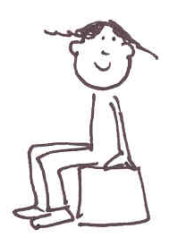 | 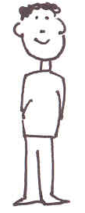
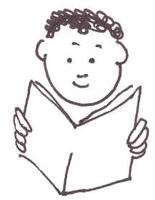 | 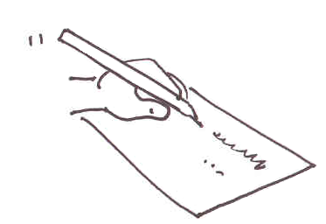
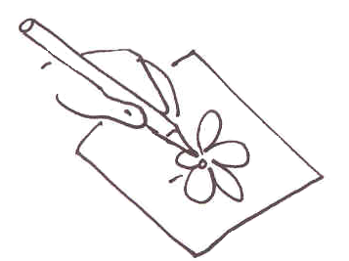 | 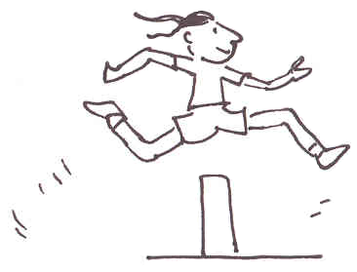
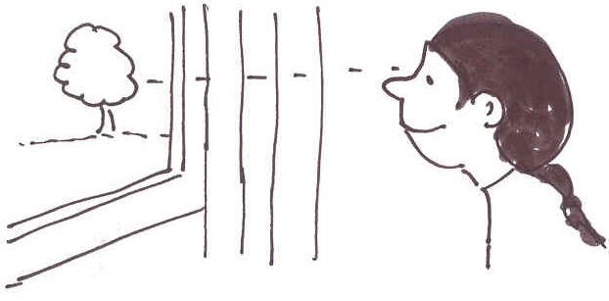 | 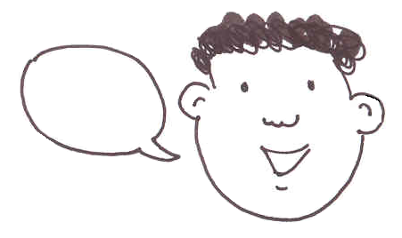
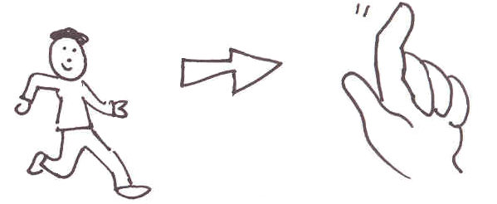 | 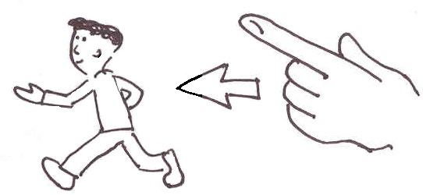
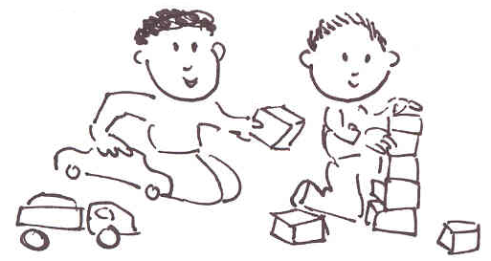 | 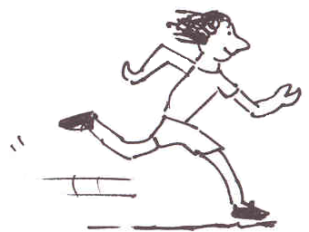

sit | stand
read | write
draw | jump
look | say
go | come
play | run

sit stand read write draw jump look say go come play run

sit stand read write draw jump look talk go come play run

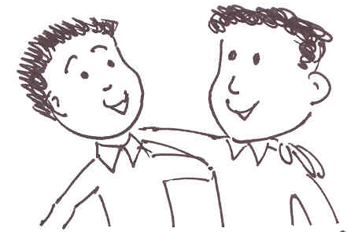 | 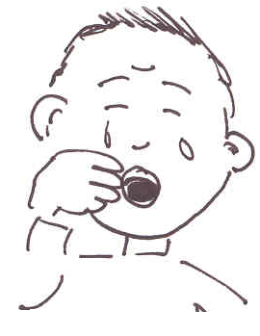
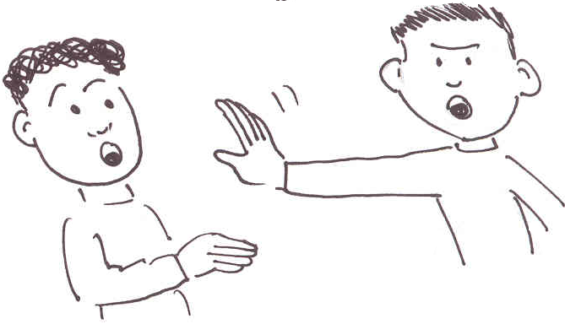 | 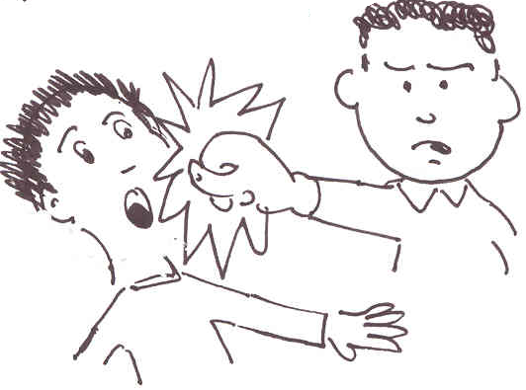
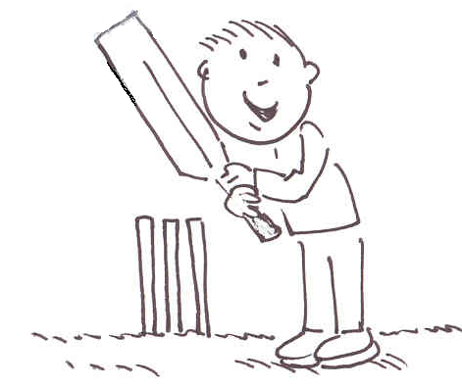 | 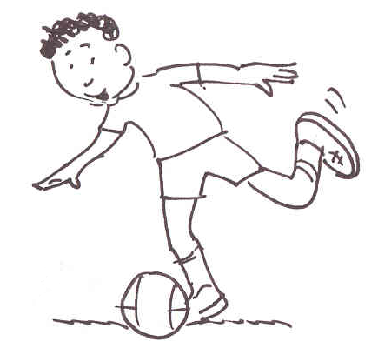
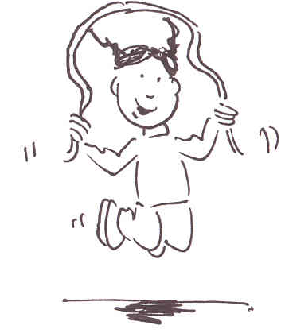 | 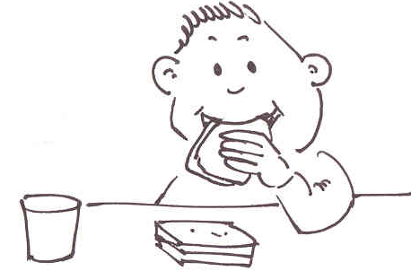

cry | hit
push | play football
play cricket | skip
like | eat

eat push like cry hit play football play cricket skip
I am …  12.3a What are you doing? | I am …
I am … | I am …
I am … | I am …
I am …  “……”. | I am …
I am … | I am…
I am… | I am…
I am sitting. | I am standing.
I am reading. | I am writing.
I am drawing. | I am jumping.
I am looking. | I am saying.
I am going. | I am coming.
I am playing. | I am running.
12.3b What are you doing?
I am …

I am …
I am …
I am …
I am…
I am…
sitting reading drawing looking coming playing standing writing jumping saying going running

12.3b What are you doing?
I am …

I am …
I am …
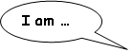
“……”.
I am …
I am …

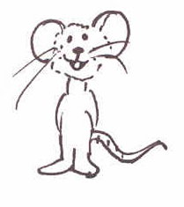  12.4a What is Seema doing? | 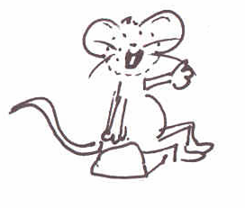
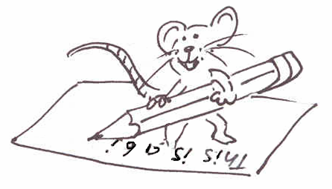 | 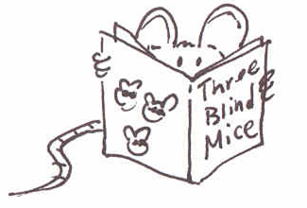
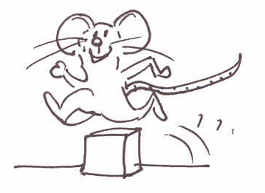 | 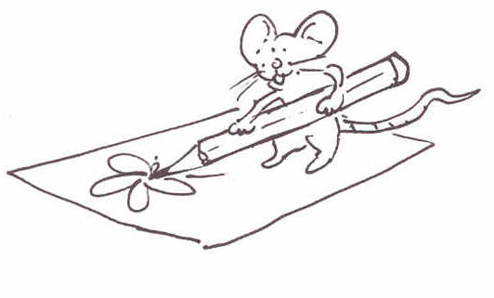
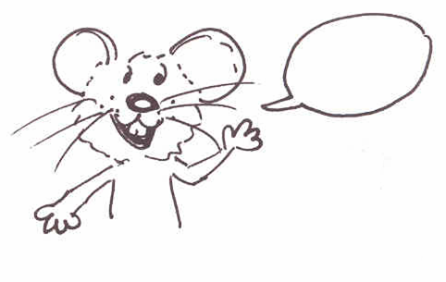 | 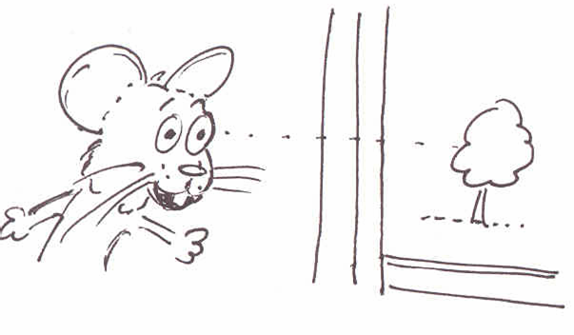
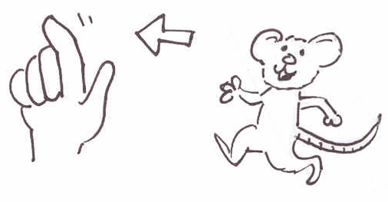 | 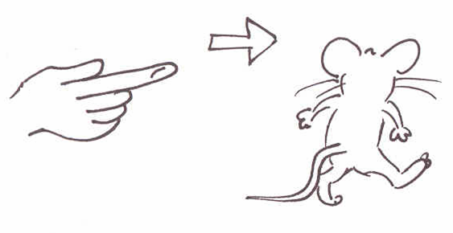
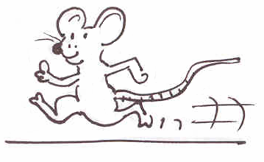 | 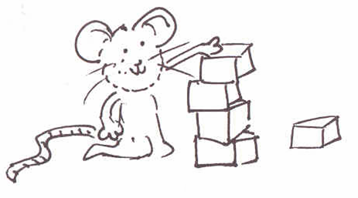

Seema is sitting. | Seema is standing.
Seema is reading. | Seema is writing.
Seema is drawing. | Seema is jumping.
Seema is looking. | Seema is saying.
She is going. | Seema is coming.
Seema is playing. | Seema is running
12.4b What is Seema doing?
sitting standing reading writing drawing jumping looking saying going coming playing running
eating pushing liking crying hitting playing football
playing cricket skipping
12.4b What is Seema doing?
sitting standing reading writing drawing jumping looking saying going coming playing running

