What time is it?
My number and time book
Seema’s English Book 15

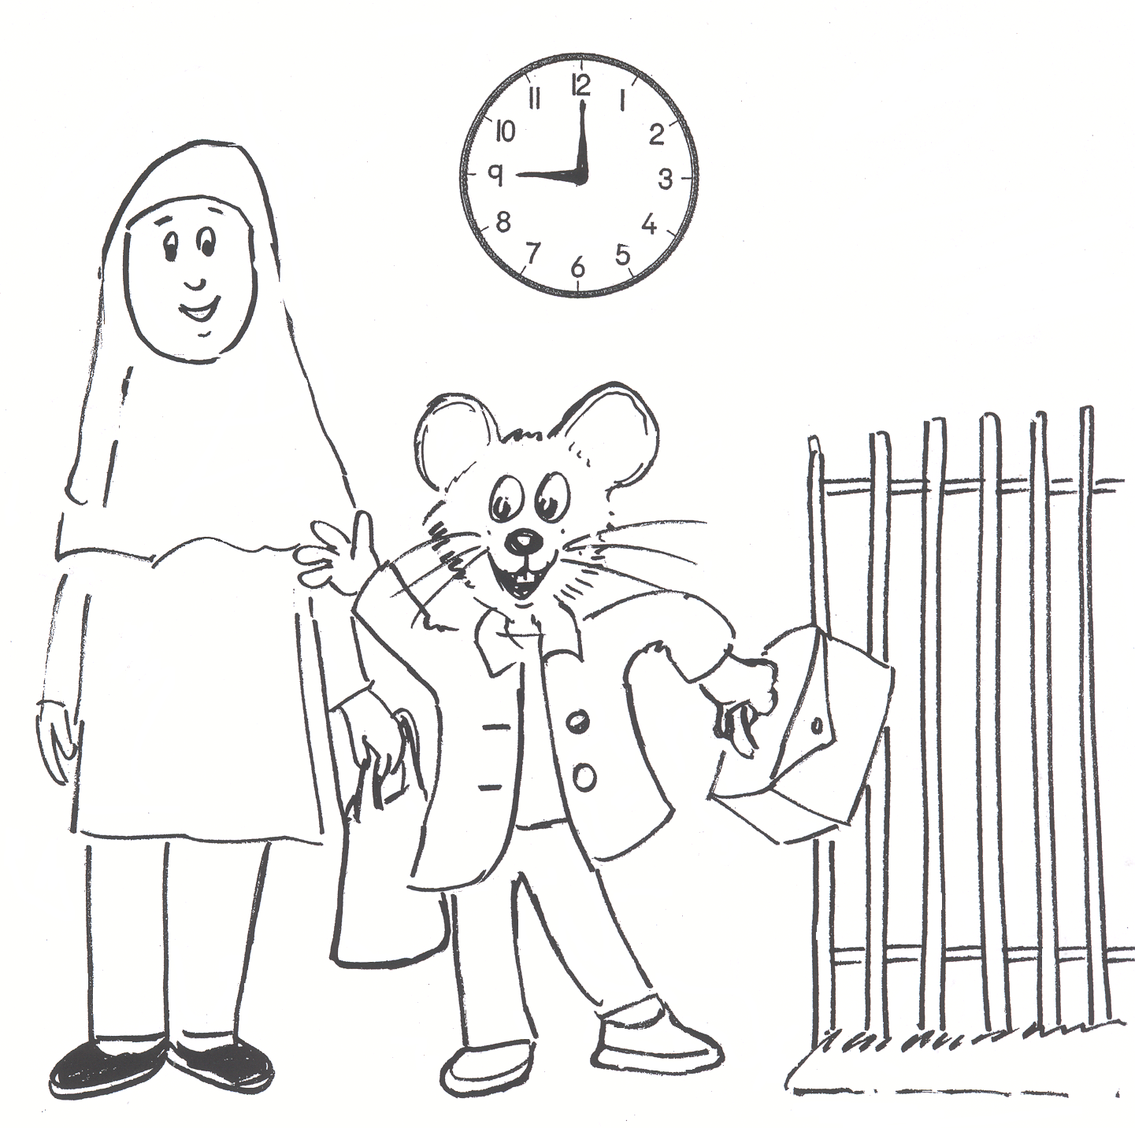

Name ………………………………………………………………

Class …………………………………………………………………

School ………………………………………………………………
Unit 15 What time is it? (number and time words)

Activities:
  - Check the work from Unit 14.
  - The time words: Practice reading the time words.
  - Read the clock: Cut out the clock and the hands and practice reading the time. Use the sentence grid to help.
  - Seema’s Day: Read the pages. Begin by modelling to the pupils on how to read the page. Ask pupils to point as you read. Ask pupils to read and point. Practise until secure.
  - Talk about the page: Ask the questions and model each answer in a sentence. Ask pupils to practise all questions and answers orally; make sure they ask questions correctly and answer in full sentences. Practise as many pages as you think they can manage.
  - Write the questions and the answers. Ask pupils to complete the answers in class during independent time.

Key expectations:
- Pupils read a clock to tell and write the time.
- Pupils read and respond to simple text, orally and in writing.

15.2 The time words

What time is it?

 |  |  |  | one.
 |  |  |  | two.
 |  |  |  | three
 |  | five |  | four.
 |  | ten |  | five.
It | is | quarter | past | six.
It | is | twenty | to | seven.
 |  | twenty five |  | eight.
 |  | half |  | nine.
 |  |  |  | ten.
 |  |  |  | eleven.
 |  |  |  | twelve.
 |  | one
 |  | two
 |  | three
 |  | four
 |  | five
It | is | six | o’clock.
It | is | seven | o’clock.
 |  | eight
 |  | nine
 |  | ten
 |  | eleven
 |  | twelve

What time is it?

12
3
9
1
2
4
5
6
7
8
10
11

one | two
three | four
five | six
seven | eight
2 | 1
4 | 3
6 | 5
8 | 7

nine | ten
eleven | twelve
thirteen | fourteen
fifteen | sixteen

10 | 9
12 | 11
14 | 13
16 | 15

seventeen | eighteen
nineteen | twenty
quarter to | half past
quarter past | o’clock

18 | 17
20 | 19
clock | time
minutes | hour

