What colour is it?

Seema’s English Book 2

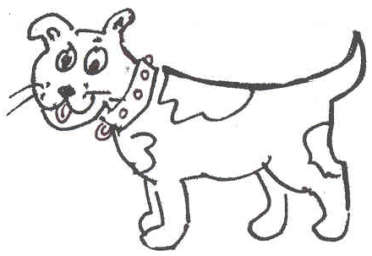
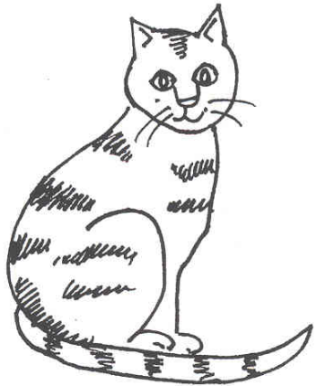
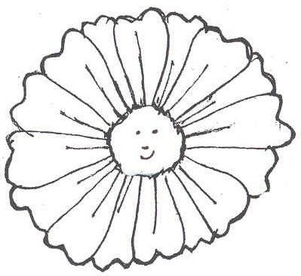
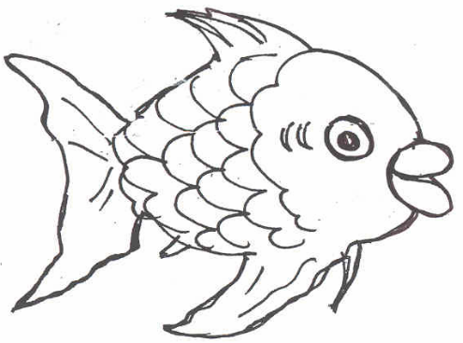
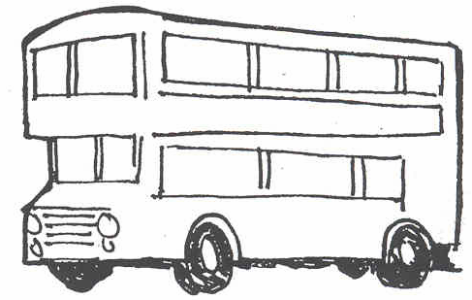

Name ………………………………………………………………

Class …………………………………………………………………

School ………………………………………………………………
Unit 2: First Colours
Key question: ‘What colour?’ etc.
Key response: pupil picks up and says ‘yellow’ … etc.

- 6 new nouns: bus, cat, fish, flower, cup, dog
- 4 colours: red, blue, yellow, green

Activities:
2.1 Check with pupils the work set from Unit 1.
2.2 Name new objects. Point to the picture and say ‘a bus, a cat, a fish …’, take care to use the indefinite article (a or an) each time. Ask pupils to repeat each time, using the article a or an. Say ‘show me a…’ Get pupils to point and name the object, using a each time. Cut out the words and pictures on sheet 2.1. Lay them out on the table and match them.
  - Read the colours. Colour in and cut out the shapes and words on sheet 2.3. Show pupils how to match the words to the pictures. Check that the pupil can read each colour word.
  - Write the colours. Set the work for independent and supported practice. Give pupil sheet 2.4 and demonstrate the task of colouring and writing.

Key expectations:
- Pupils continue to use the word a before saying each noun.
- Pupils begin to recognise colours.
Cut and match Words for activity 2.1

a cup | a dog
a flower | a bus
a fish | a cat

Cut and match Pictures for activity 2.1

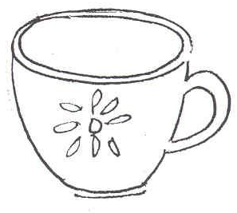 | 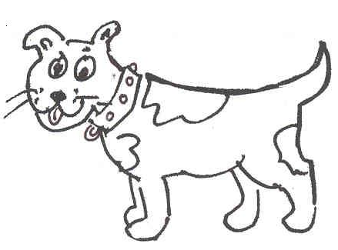
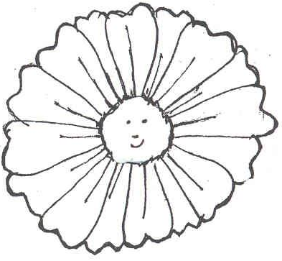 | 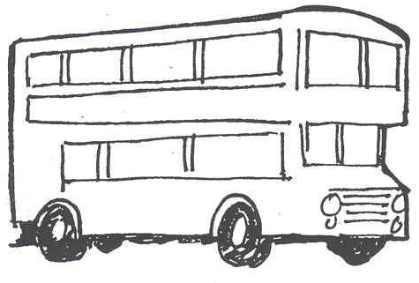
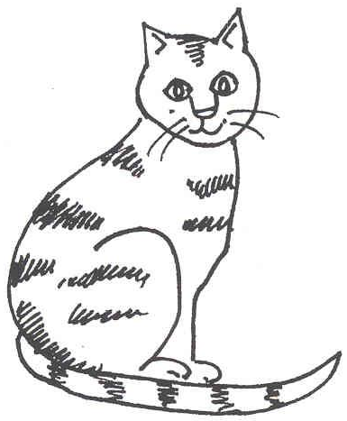 | 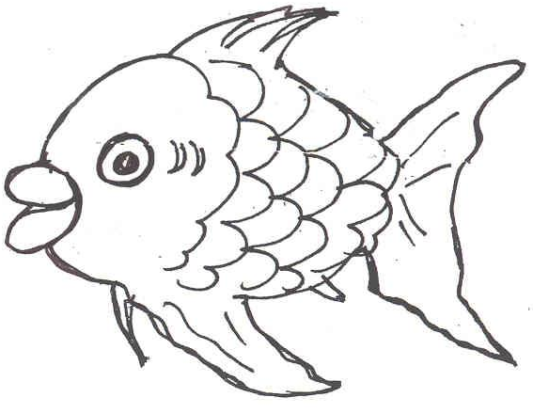
Cut and match Activity sheet 2.3

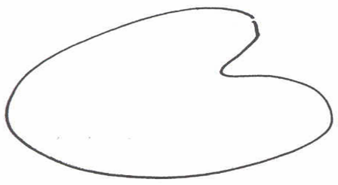 | yellow
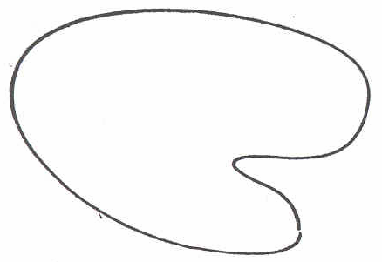 | green
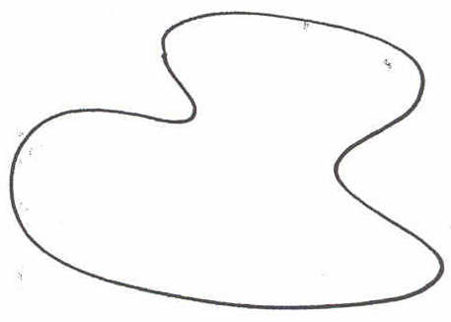 | blue
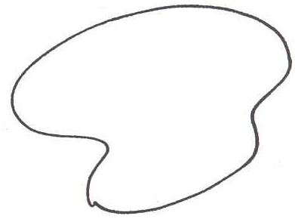 | red
Activity sheet 2.4 colour and write

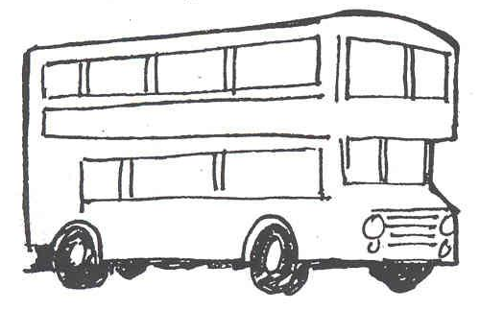  _______________  red yellow blue green | 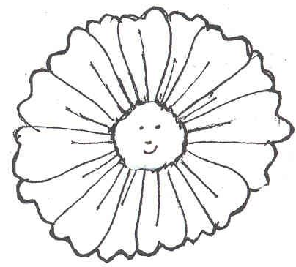  _______________
_______________ | _______________
_______________ | _______________
_______________ | _______________
Snakes and Ladders

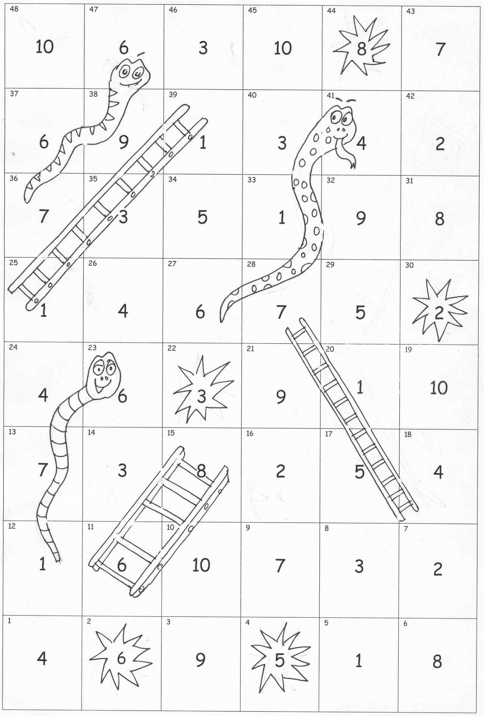

Snakes and Ladders

- This game is ideal for further practice with peers and with parents. It can be played with any new words. Number the cards 1-10 on the back.
- Spread all the cards (numbers up) on the table.
- Player 1 throws a dice and calls the number he or she lands on. Player 2 picks up the card with that number on, and asks player 1 to say the word. Ask more able pupils to write the word.
- If correct, player 1 stays on that square.
- If incorrect, player 1 stays on that square, but places the card nearby with the word up, to say or spell before his of her next throw.
- If you land on a starburst number and get it right, you get another throw.
- First one home wins.

The game can be coloured and laminated for future use.

