The cat is yellow
A first sentence
Seema’s English Book 3

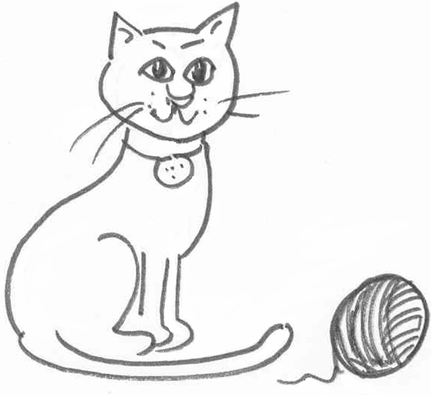

Name ………………………………………………………………

Class …………………………………………………………………

School ………………………………………………………………
Unit 3 A first sentence
Key question: ‘What colour is the pencil?’ etc
Key response: pupil says ‘The pencil is yellow’ etc.

- The definite article; ‘the’
- A four word sentence: ‘The … is …’

Activities:
3.1 Saying the sentence: Get together red, blue, yellow and green pencils. Point to a red pencil and ask, ‘What colour is the pencil?’ Answer in the full sentence. ‘The pencil is red’. Take care to use the definite article (the) each time. Ask the pupil to repeat each time using ‘the’.
3.2 Read the sentence: Colour the objects on sheet 3.2 to match the sentences. Cut out and match the picture with the sentence.
3.3 Draw Pictures: Draw and colour pictures to match the sentences on
sheet 3.3.
  - Make a sentence: Use sentence maker 3.4 to make up new sentences. Point to each word as you make the sentence. Point to the full stop at the end. Model by saying, “The bus is blue. Full Stop.” Ask the pupil to say the sentence, and to add the full stop orally. Ensure the pupil uses the capitals and full stops.
  - Write a sentence: Use sentence maker 3.4 and writing sheet 3.5 to make a sentence. Set pupil the task of writing five or more sentences on colour and write sheet 3.6 before the next session.

Key expectations:
- Pupil speaks and writes in complete sentences.
- Pupil begins to use full stops and capitals.
The bus is red. | 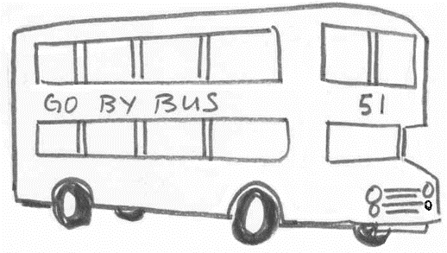
The cat is yellow. | 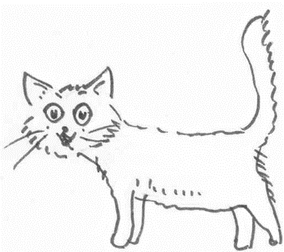
The fish is blue. | 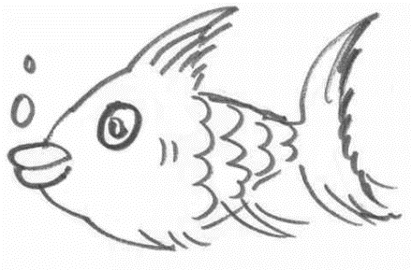
The pencil is green. | 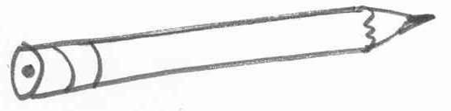
The dog is yellow. | 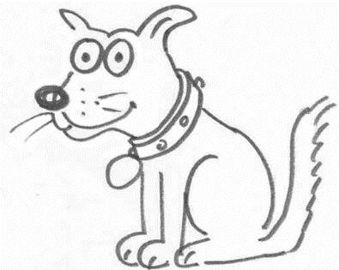
The flower is red. | 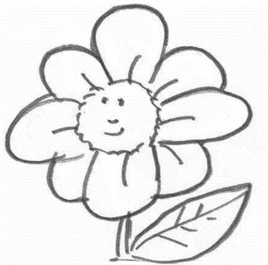
Colour objects to match the sentences 3.2
Draw and colour activity 3.3

The bus is green. | The fish is yellow.
The cat is black. | The pencil is red.
The car is blue. | The chair is red.
The book is yellow. | The cup is green.

Sentence maker sheet 3.4

 | car
 | fish
 | flower
 | cup |  | red.
The | book | is | yellow.
 | cat |  | blue.
 | dog |  | green.
 | bus
 | pencil
 | chair

Colour and write sheet 3.5

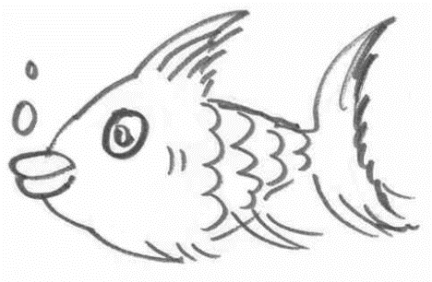

1 ……………………………………………………………………………………………….
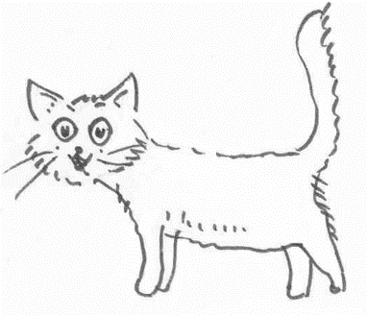

2 ………………………………………………………………………………………………
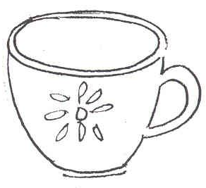

3 ………………………………………………………………………………………………
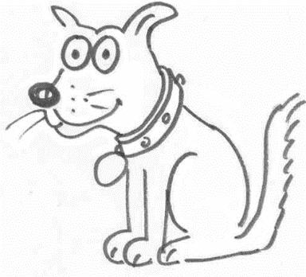

4 ………………………………………………………………………………………………
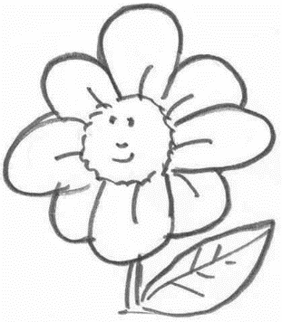

5 ..................................................................................................
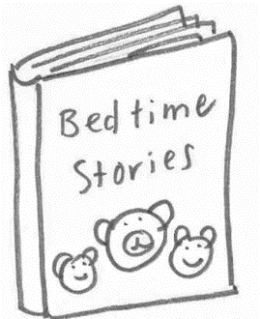

6……………………………………………………………………………………………….
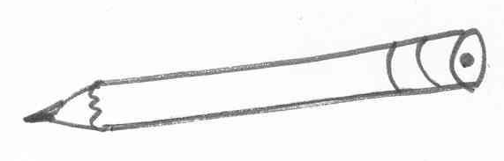

7………………………………………………………………………………………………
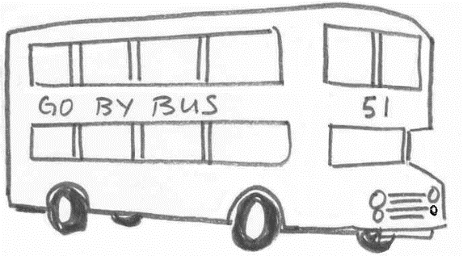

8 ………………………………………………………………………………………………
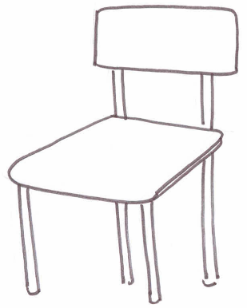

9 ………………………………………………………………………………………………
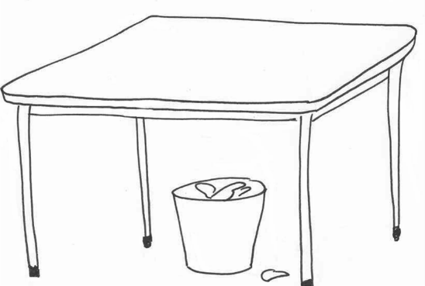

10..................................................................................................

Writing sheet 3.6
Draw and colour

Write about it

……………………………………………………………………………………....................................................................................................................................................................................................................................................................................................................................................................................................................................................

