In the big box
in, on, under, by, behind
big and little
Seema’s English Book 5

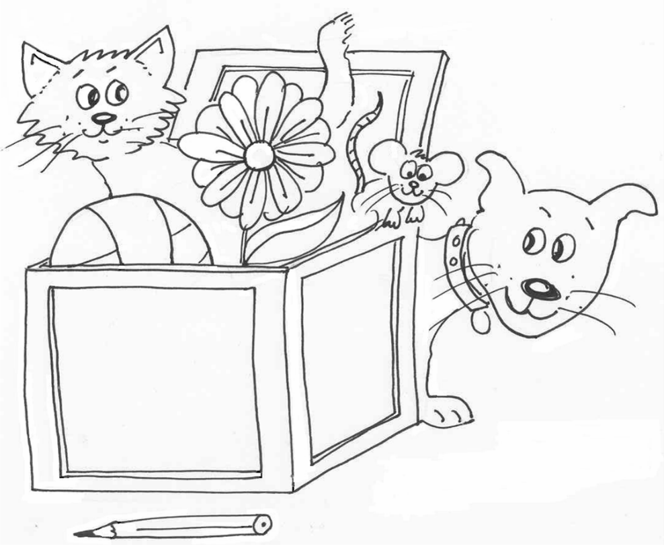

Name ………………………………………………………………

Class …………………………………………………………………

School ………………………………………………………………
Unit 5 Prepositions: in, on, under, by, behind
Adjectives: big, little
Key question: ‘Where is the ____?’
Key response: pupil say ‘The cat is by the door’ … etc.

- Prepositions: in, on, under, by, behind
- A six word sentence: ‘The … is … (in) the …’

Activities:
5.1 Check the work from Unit 4.
5.2 Say the preposition: Gather together objects. Place a pencil on a chair. Ask, ‘Where is the pencil?’ and pretend to be puzzled. Point to the pencil and model answer, ‘The pencil is on the chair!’ miming being pleased of finding it. Repeat with other objects and the other prepositions. Ask pupils to repeat each time.
  - Big and little: Practise the big and little pictures and words on sheets 5.3 and 5.4.
  - Read the words: Cut out the words and pictures on sheets 5.3 and 5.4. Lay them out on the table and practise look and say.
  - ‘In the boxes’ barrier game: Make and colour two copies of sheet 5.5, cut out and colour two sets of pictures from sheet 5.5a. Play the barrier game. Use sheet 5.5b as a prompt.
  - Read and draw: Practise sheet 5.6 orally for work in class.
  - Write a sentence: Use sentence maker 5.7 and writing sheet 5.7a to make a sentence. Set pupils the task of writing five or more sentences before the next session.
  - Look and write: Write a sentence for each picture on sheet 5.8.
Key expectations:
- Pupil knows the basic prepositions.
- Pupils write a series of correctly punctuated sentences.
in | on
by | under
 | behind
Activity sheet 5.2
Activity sheet 5.3 big and little

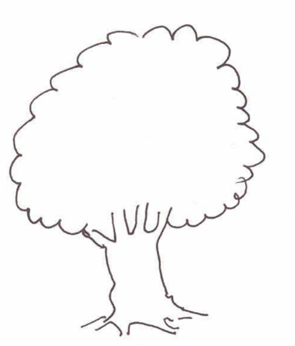  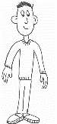 | 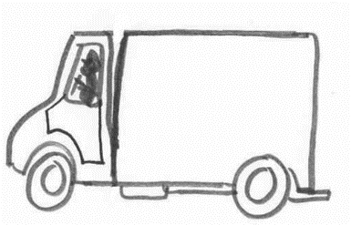
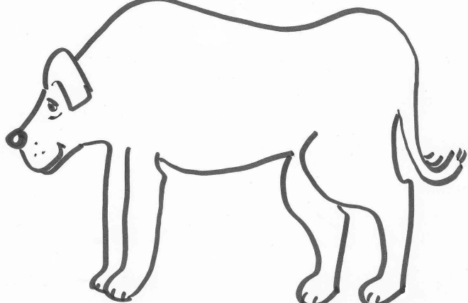 | 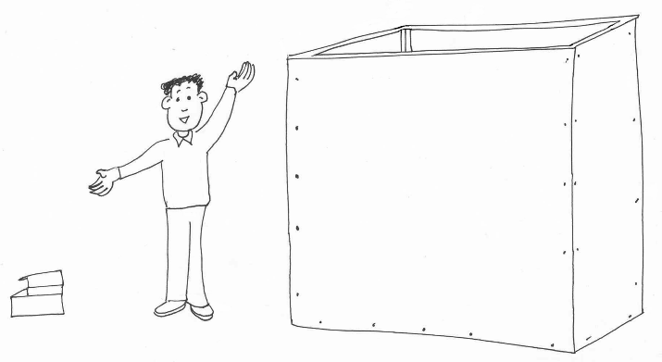
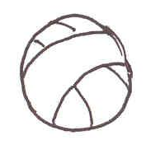 | 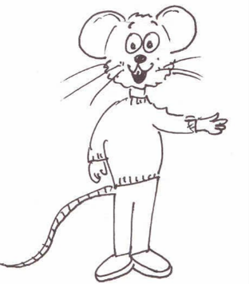  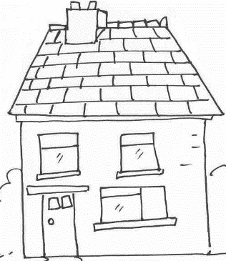
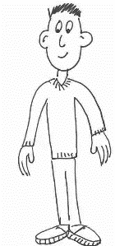 | 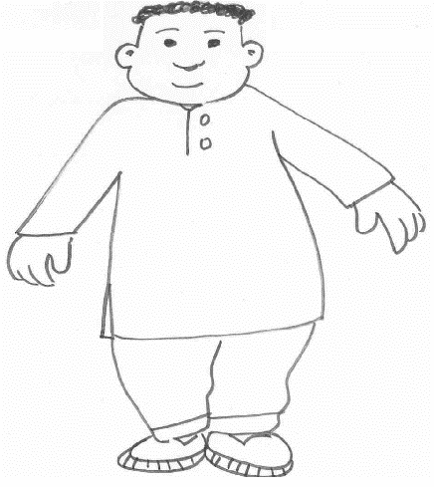

Activity sheet 5.4 big and little

a | big
little | ball
house | dog
man | box
tree | lorry

Colour the boxes to play barrier game 5.5

red | blue
green | yellow
orange | brown
white | black

Colour the pictures to play barrier game 5.5a

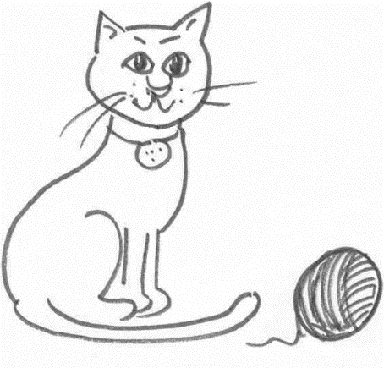 | 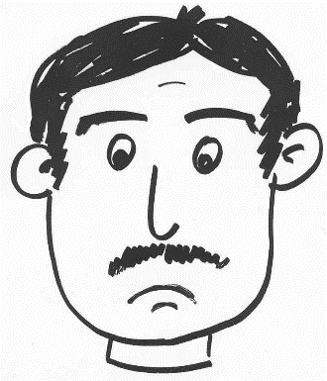 | 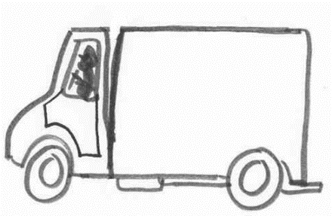
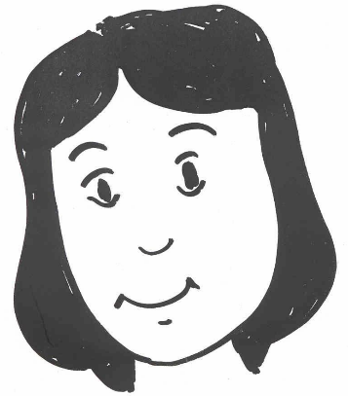 | 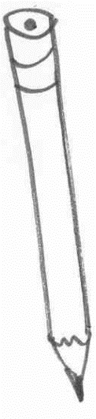 | 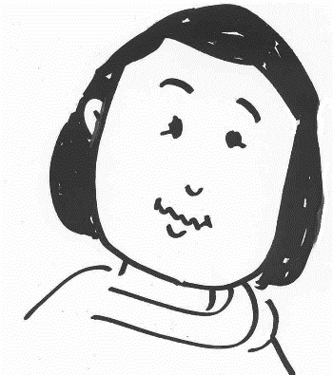
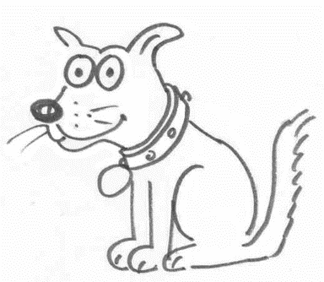 | 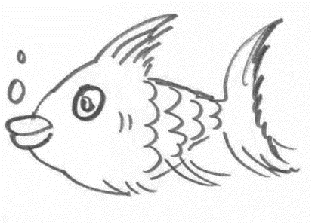 | 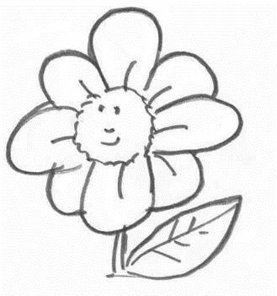

Prompt sheet 5.5b for Barrier Game

- Put the blue fish in the blue box.
- Put the white cat in the yellow box.
- Put the brown dog in the red box.
- Put the green man in the black box.
- Put the red girl in the white box.
- Put the blue lorry in the brown box.
- Put the red flower in the back box.
- Put the red pencil in the orange box.
- Put the blue woman in the white box.
Read and draw activity 5.6

The bin is under the little table. | The pencil is on the big red chair.
The fish is by the green door. | The book is under the orange chair.
The flower in on the red table. | The cat is in the purple bus.
The pencil is in the green bin. | The cat is by the fish.

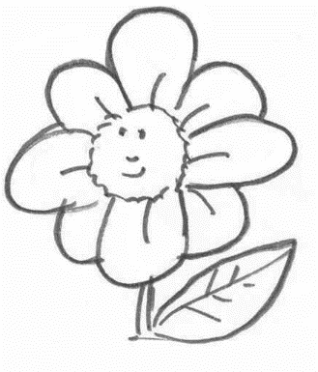
Sentence maker 5.7

The | brown | cat | is | in | the | brown | box.
 | yellow | dog |  | on |  | white
 | white | man |  | under |  | yellow | bus.
 | blue | girl |  | by |  | blue | door.
 | pink | lorry |  | behind |  | orange
 | black | flower |  |  |  | pink | table.
 | orange | pencil |  |  |  | black | chair.
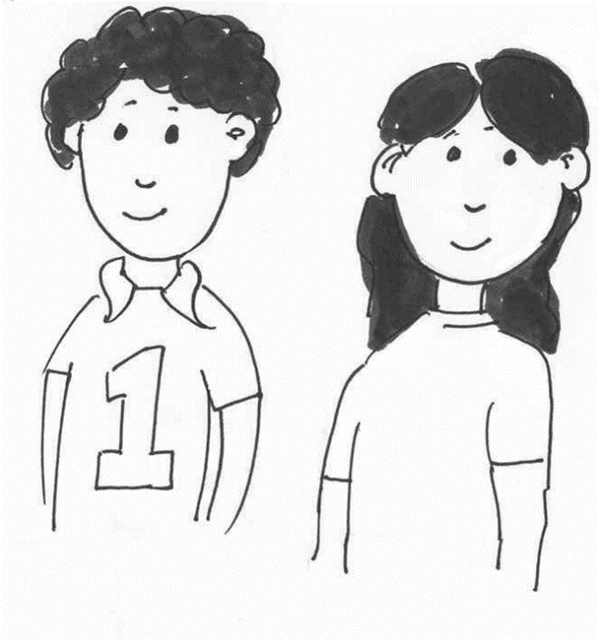
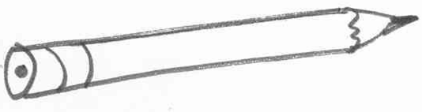
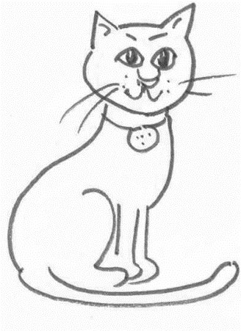
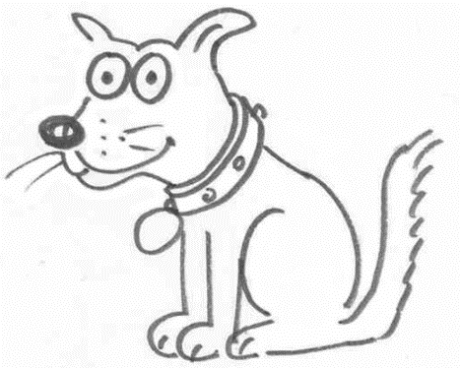
Writing sheet 5.7a

Write about it

……………………………………………………………………………………....................................................................................................................................................................................................................................................................................................................................................................................................................................................
Sheet 5.8
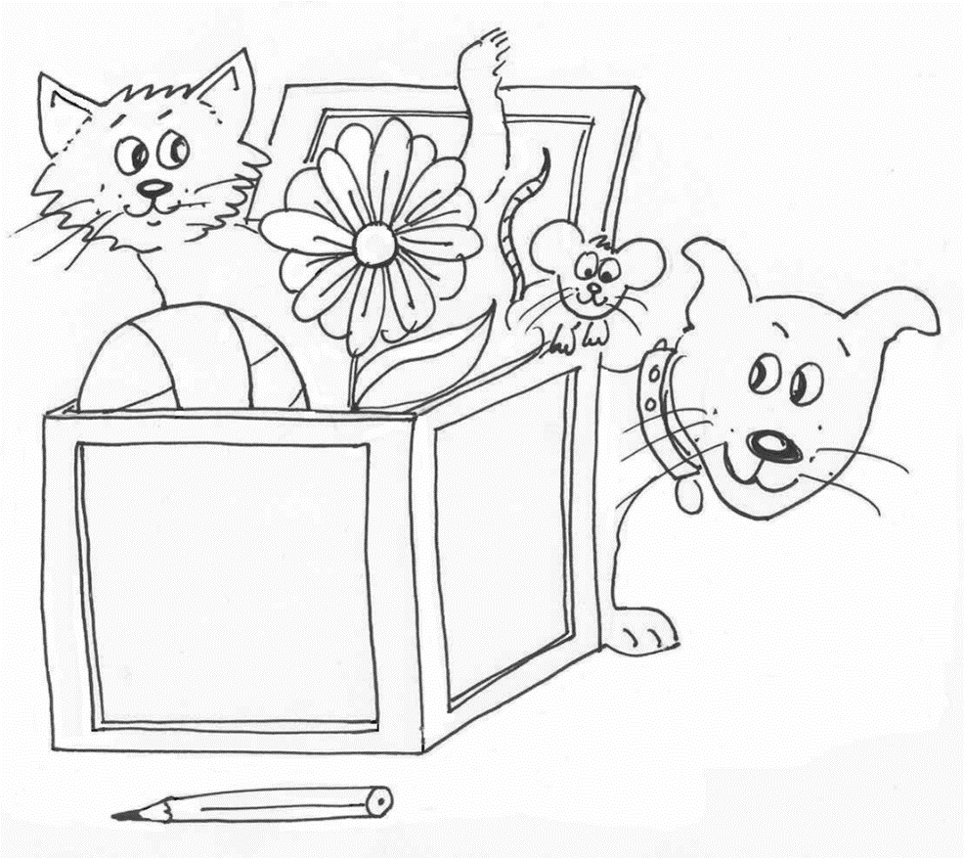
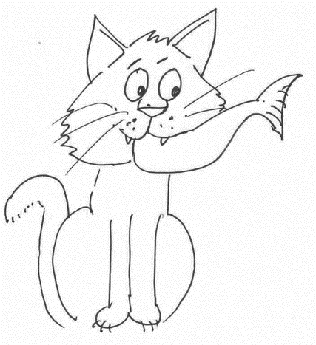
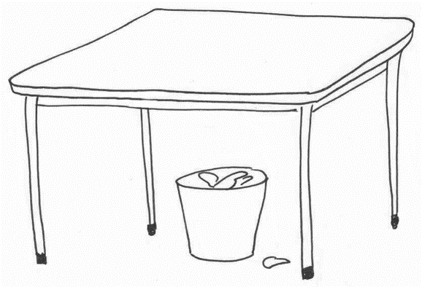
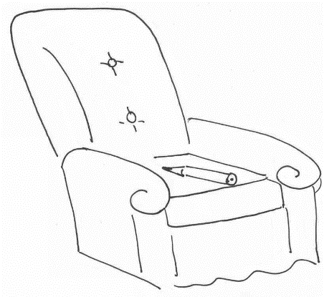
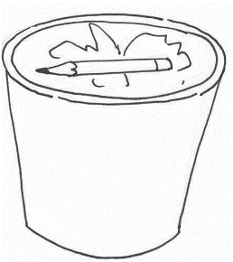
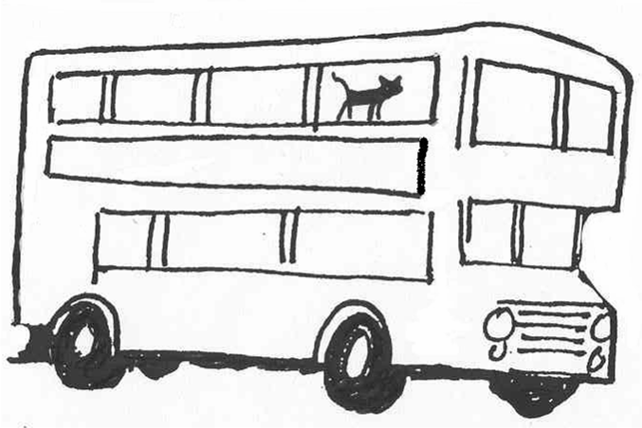
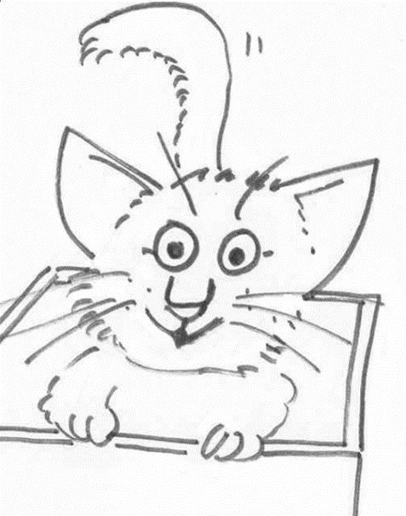
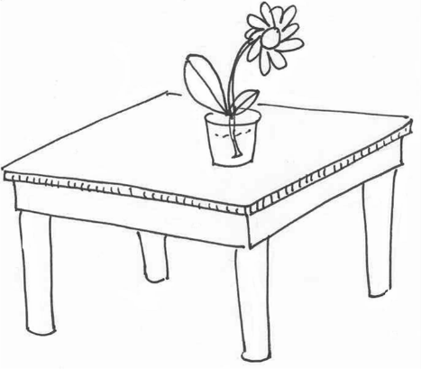
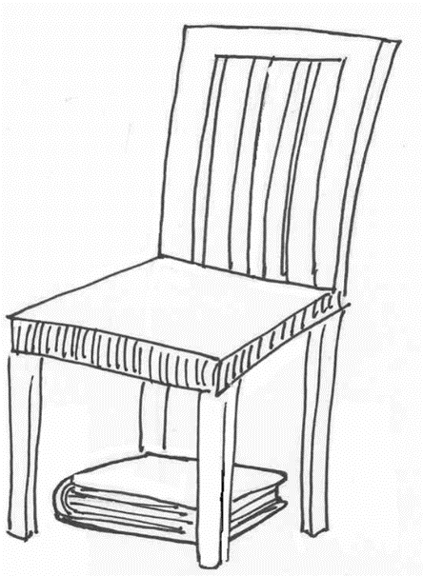
Look and write sentence sheet 5.8
1…………………………………………………………………………………………………………………………………..

2…………………………………………………………………………………………………………………………………….

3…………………………………………………………………………………………………………………………………….

4………………………………………………………………………………………………………………………………….

5…………………………………………………………………………………………………………………………………….

6…………………………………………………………………………………………………………………………………….

7…………………………………………………………………………………………………………………………………….

8…………………………………………………………………………………………………………………………………….

9…………………………………………………………………………………………………………………………………….

10………………………………………………………………………………………………………………………………….

