What is this?
Practising ‘This is a …’
big and little
Seema’s English Book 6

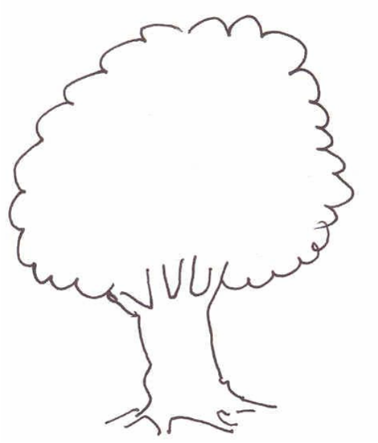
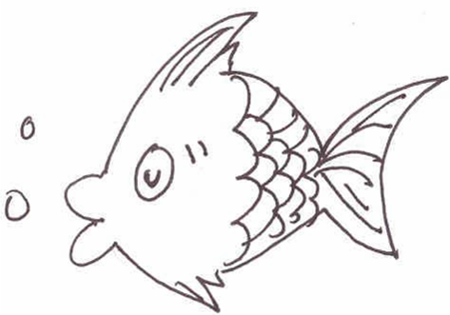

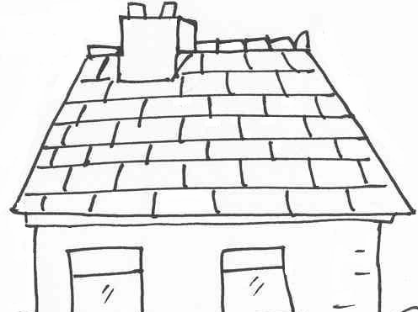
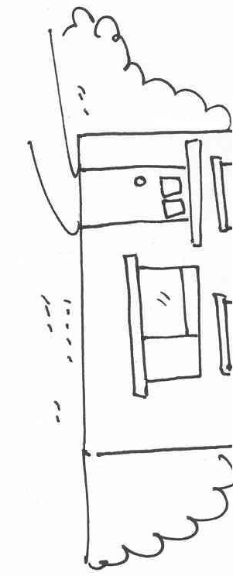

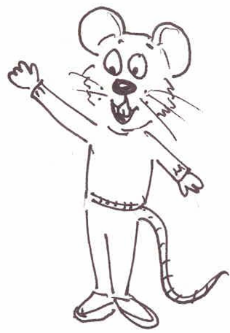

Name ………………………………………………………………

Class …………………………………………………………………

School ………………………………………………………………
Unit 6 What is this?
Key question: ‘What is this?’
Key response: Pupils say ‘This is a big red house.’ etc

- The sentence: ‘This is a …’

Activities:
6.1 Check the sentence and colour work from Unit 5
6.2 Say the sentence: Choose everyday classroom objects and ask pupils, ‘What is this?’ and demonstrate answer: ‘This is a (red) (pencil)’; ask pupils to repeat each time. Practise with the nouns already learned, using the picture cards already developed.
  - Colour and Say. Colour the pictures on sheet 6.3, lay them out on the table and say a sentence about each one.
Read the sentence. Match the pictures and the sentences on sheet 6.4. Set read and draw activity 6.4a.
6.5 Write a sentence. Use sentence maker 6.5 and writing sheet 6.5a to
make sentences orally. Set pupil the task of writing five or more
sentences before the next session.
6.6 Colour and write. Ask the pupil to colour in picture 6.6 and write some
sentences about what they have done.
Key expectations:
- Pupils speak and write in a complete sentence.
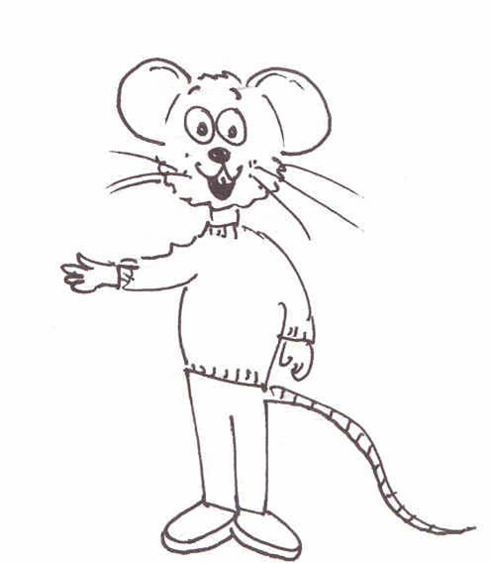  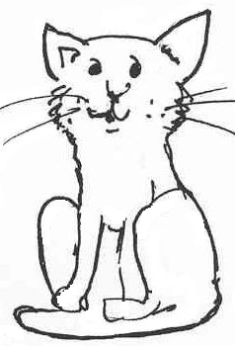 | 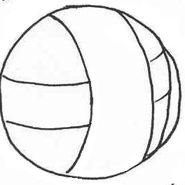  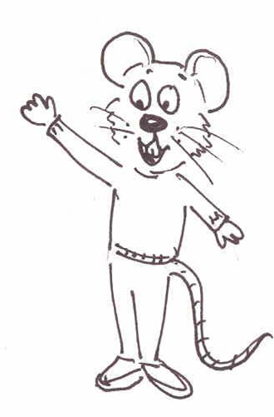
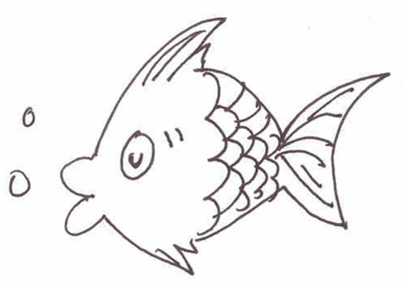 | 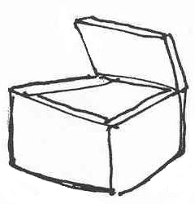  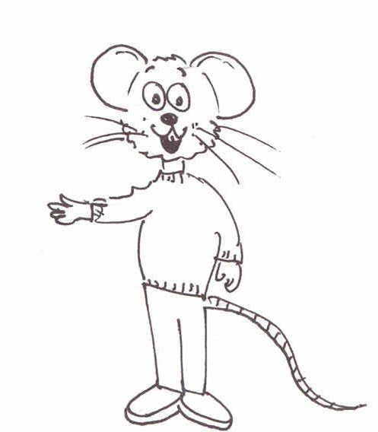
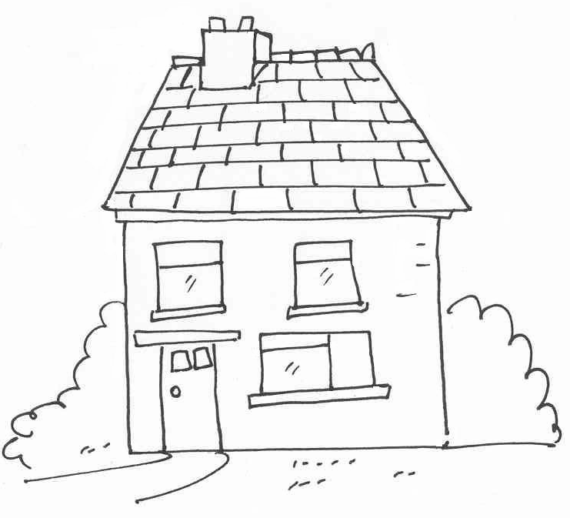 | 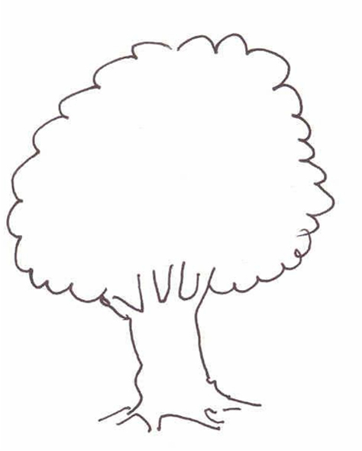
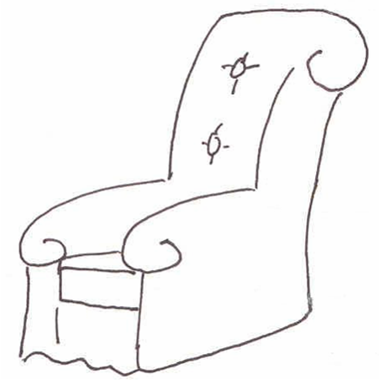 | 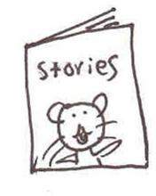
Colour and Say Sheet 6.3
6.4 sentences
This is a big red fish. | This is a little black cat.
This is a big green tree. | This is a big green ball.
This is a little blue book. | This is a little yellow house.
This is a big brown chair. | This is a little orange box.
Read and draw sheet 6.4a
This is a big red fish. | This is a little black cat.
This is a big green tree. | This is a big green ball.
This is a little blue book. | This is a little yellow house.
This is a big brown chair. | This is a little orange box.

What is this? Sentence maker 6.5

This | is | a | big | black | box.
 |  |  |  | brown | tree.
 |  |  | little | white | house.
 |  |  |  | yellow | fish.
The |  |  |  | blue | book.
 |  |  |  | orange | chair.
 |  |  |  | pink | cat.
 |  |  |  | red | ball.
Writing sheet 6.5a

Draw and colour ‘What is this?’

Write about it

……………………………………………………………………………………....................................................................................................................................................................................................................................................................................................................................................................................................................................................
……………………………………………………………………………………

Colour the picture and write about it. 6.6
