Where are they?
and and are
Seema’s English Book 7

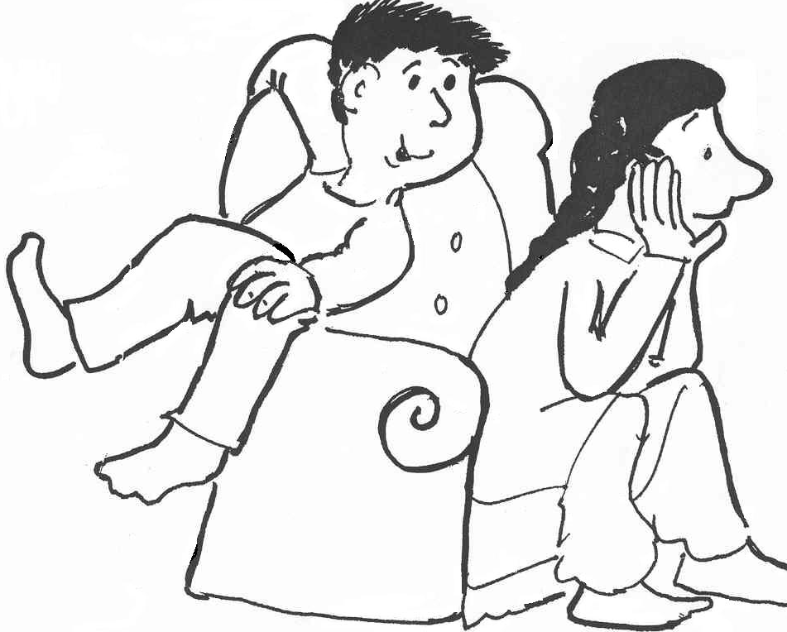
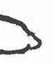

Name ………………………………………………………………

Class …………………………………………………………………

School ………………………………………………………………
Unit 7 ‘are’ and ‘and’
Key questions: Where are they?
Key response: Pupils say
- ‘The cat and the dog are in the big blue bus.’
- ‘The fish is blue and pink.’

- The plural form of the word to be ‘are’
- The connective ‘and’

Activities:
7.1 Check the sentence and colour work from Unit 6.
7.2 Say the sentence: Choose two everyday classroom objects and say to pupils ‘A pencil and a ruler’. Ask pupils to copy. Repeat with sets of other objects. Put the pencil and the ruler on a chair; say ‘The pencil and ruler are on the chair.’ and ask the pupil to copy. Ask ‘Where are the… and the …?’
  - Ask and Say. Look at the pictures on sheet 7.3; ask the question and say a sentence about each one. Ask pupils to copy. Practise until secure.
  - Read the sentence. Match the pictures from sheet 7.3 and the sentences on sheet 7.4. Set read and draw activity 7.4a.
  - Write a sentence. Use sentence maker 7.5 and writing sheet 7.5a to make sentences orally. Set pupil the task of writing five or more sentences before the next session.
Key expectation:
- Pupils speak and write in a complete sentence
Where are they? Sheet 7.3

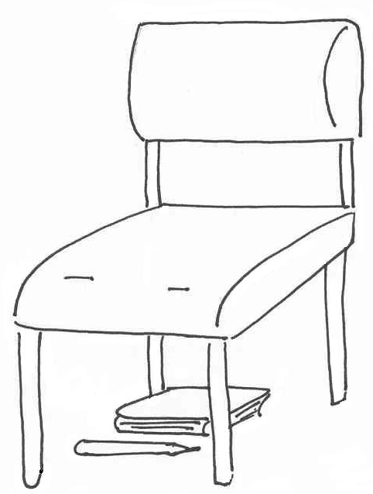
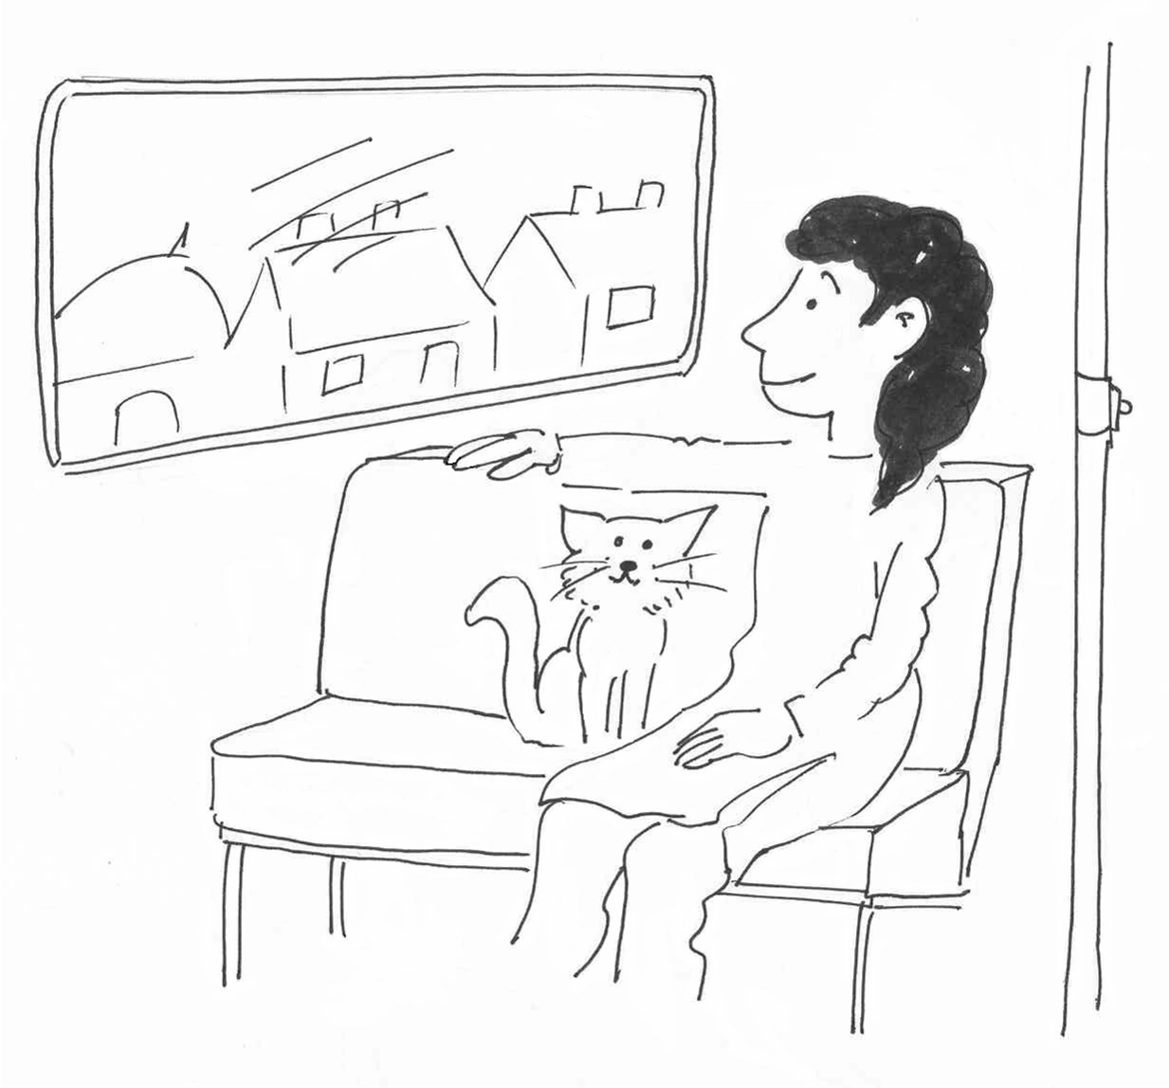

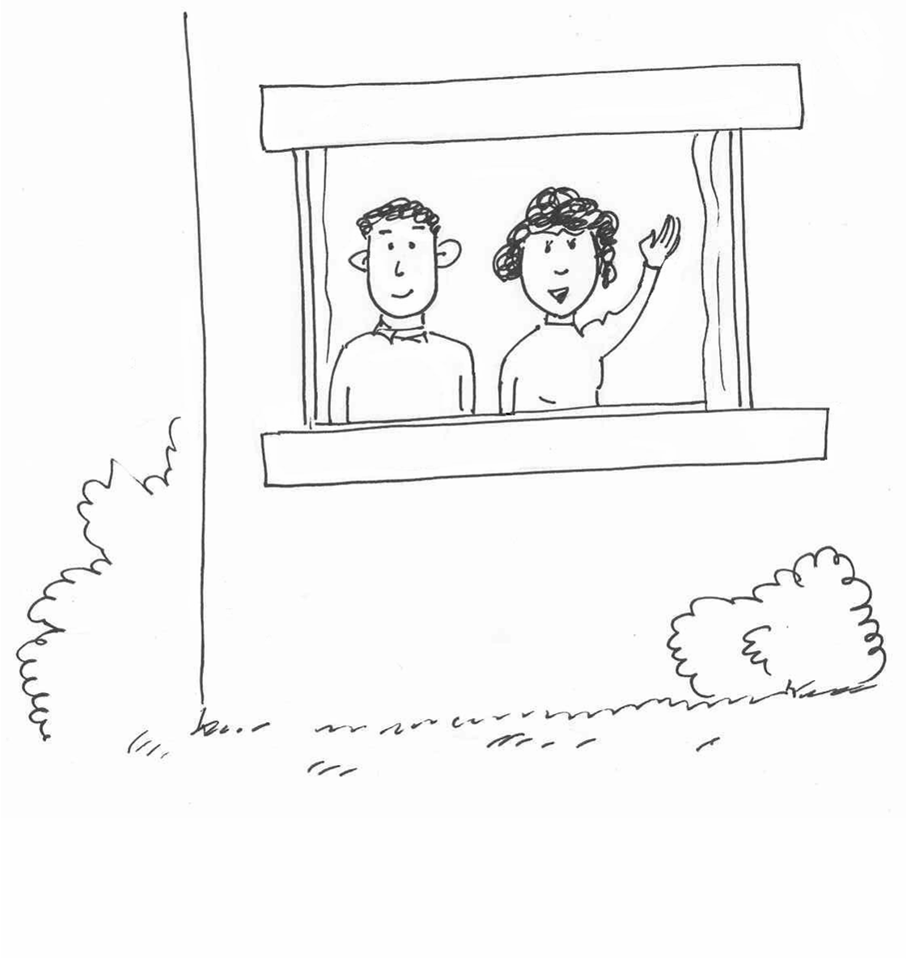
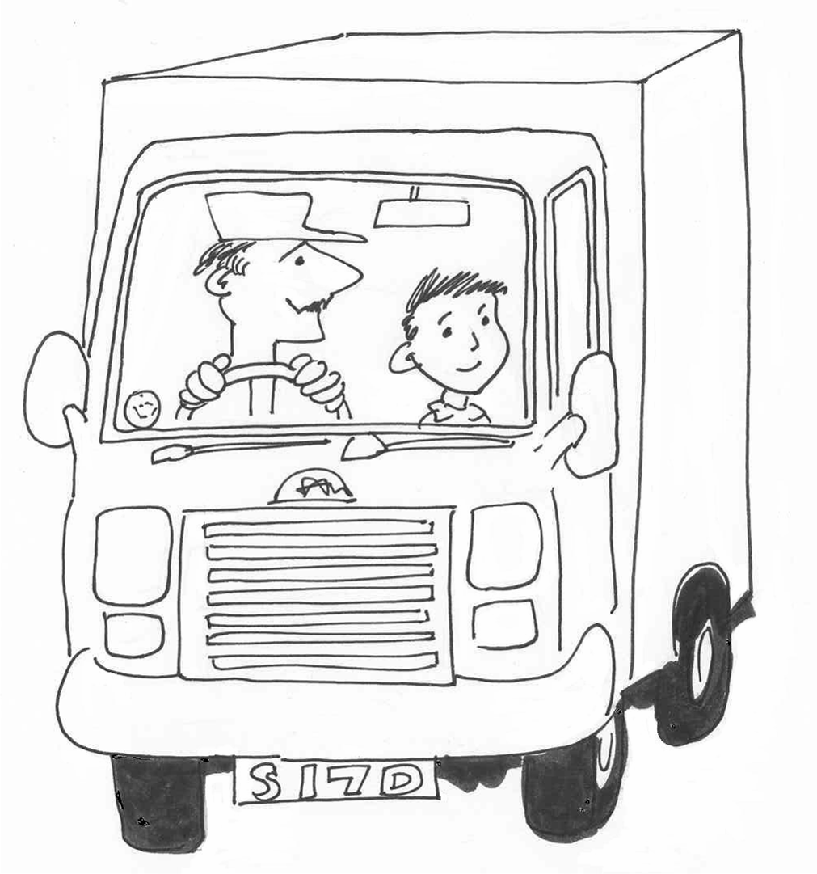
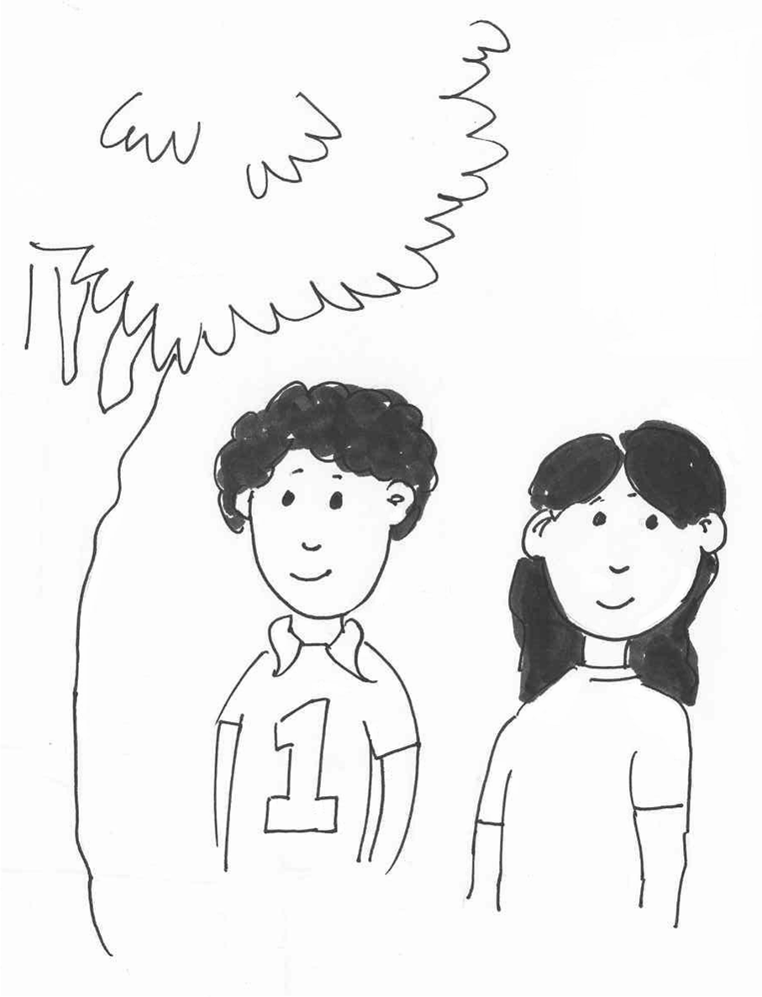

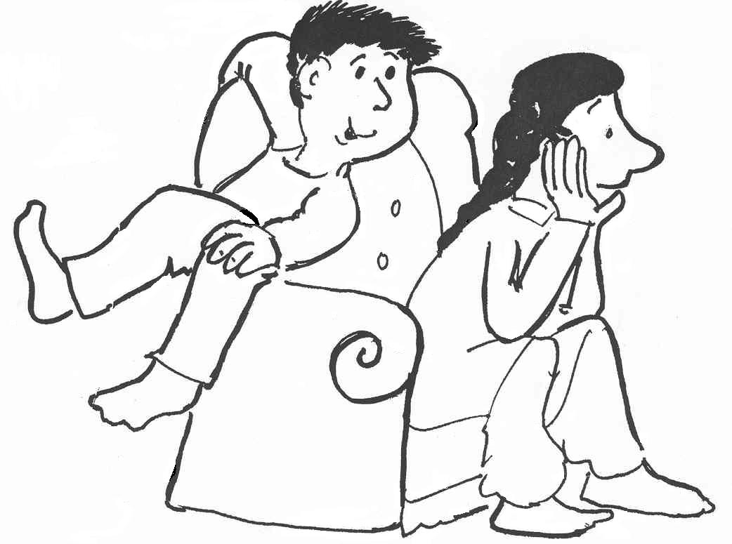
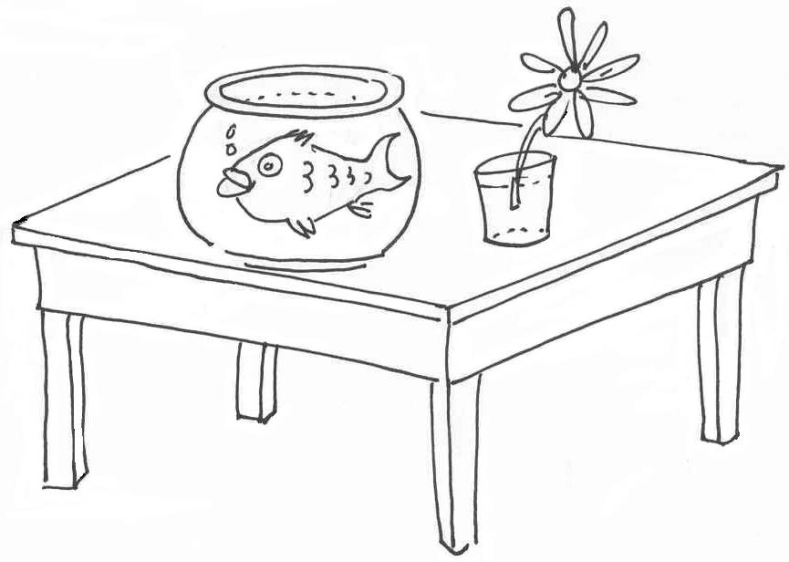

7.4 Sentences: and, are
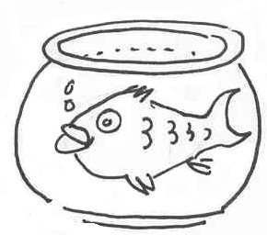
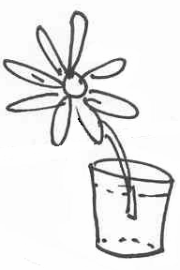
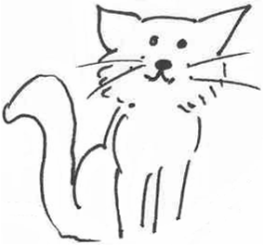

The cat and the girl are on the bus. | The flower and the fish are on the table.
The pencil and the book are under the chair. | The boy and the girl are next to the tree.
The man and the woman are in the house. | The man and the boy are in the lorry.
The woman and the girl are in the lorry. | The boy and the girl are on the chair.
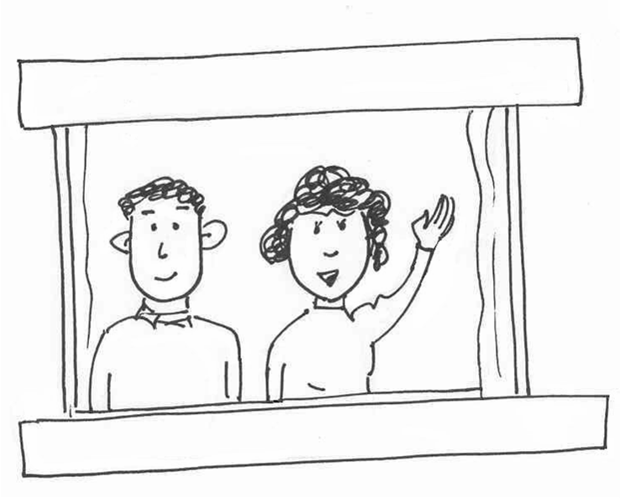
Read and draw sheet 7.4a
The cat and the girl are on the bus. | The flower and the fish are on the table.
The pencil and the book are under the chair. | The boy and the girl are next to the tree.
The man and the woman are in the house. | The man and the boy are in the lorry.
The woman and the girl are in the lorry. | The boy and the cat are on the chair.

Sentence maker 7.5

The | cat | and | the | dog | are | in | the | bus.
 | boy |  |  | man |  | next to |  | house
 | girl |  |  | woman |  | under |  | tree.
 | man |  |  | girl |  | on |  | door.
 | dog |  |  | cat |  |  |  | table.
 | ball |  |  | fish |  |  |  | chair.

The | cat | is | green | and | the | man | is | green.
 | boy |  | blue |  |  | woman |  | blue.
 | girl |  | sad |  |  | boy |  | sad.
 | man |  | happy |  |  | girl |  | happy.
 | dog |  | little |  |  | flower |  | little.
 | ball |  | red |  |  | ball |  | red.

Writing sheet 7.5a

Write about it

……………………………………………………………………………………....................................................................................................................................................................................................................................................................................................................................................................................................................................................

