The dog and the cat
and and are
Seema’s English Book 8

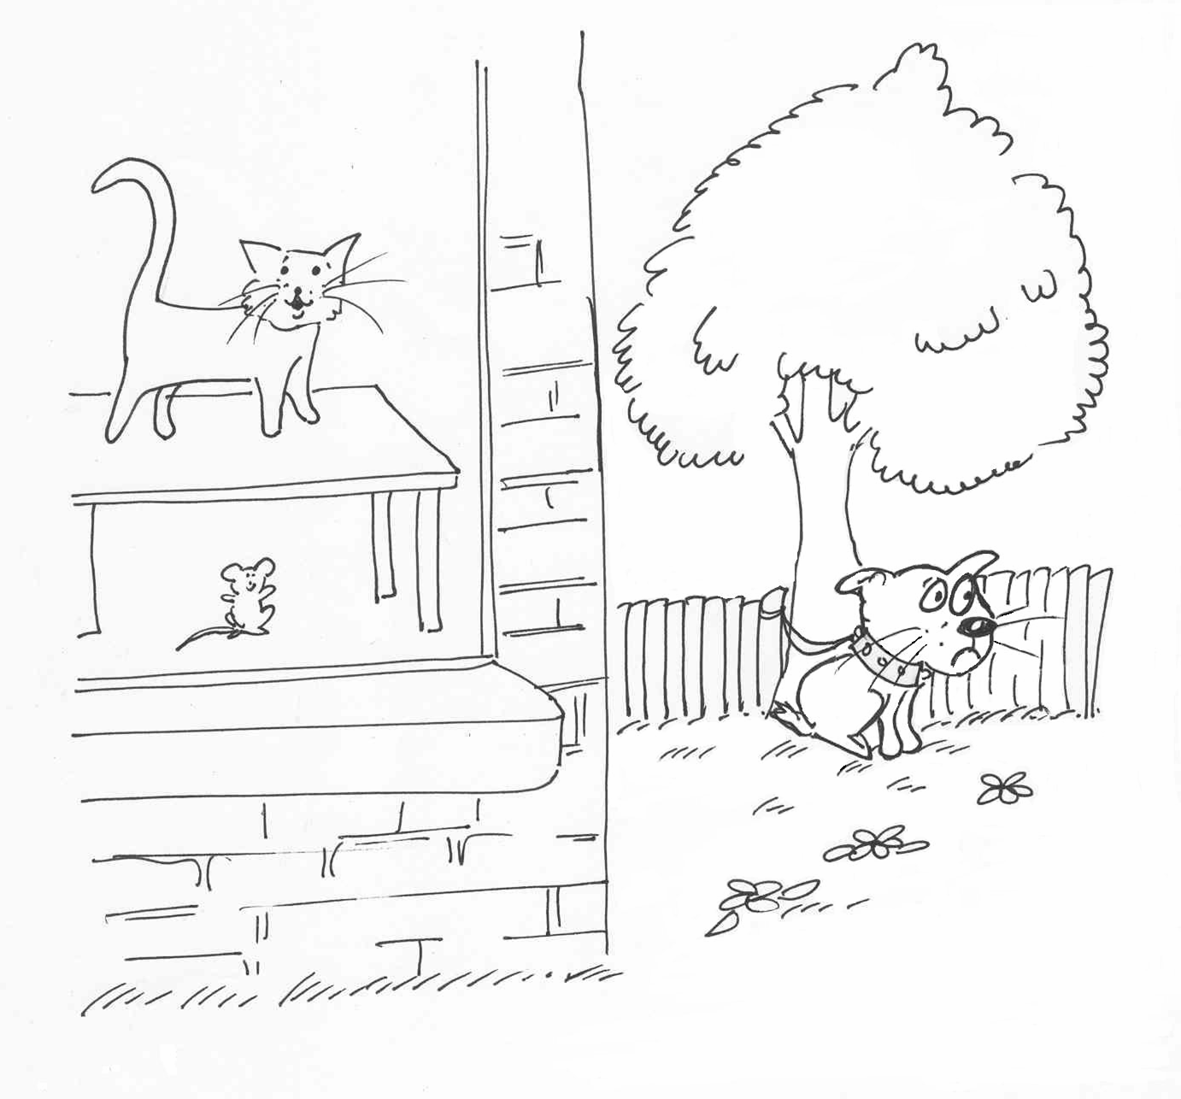

Name ………………………………………………………………

Class …………………………………………………………………

School ………………………………………………………………
Unit 8 Further practice with ‘are’ and ‘and’

Activities:
8.1 Check the sentence and colour work from Unit 7.
8.2 Say the sentence: Choose an object that has two colours. Describe it, e.g., ‘The box is red and yellow’. Ask pupils to copy. Continue with more objects. Practise until secure.
  - Colour and describe. Look at the pictures on sheet 8.3. Ask the question and say a sentence about each one. Ask pupils to copy.
  - Read the sentence: Colour the pictures on sheet 8.3 to match the sentences on sheet 8.4. Set read and draw activity 8.4a.
  - Write a sentence: Colour the picture on sheet 8.5 and make sentences orally. Set pupils the task of writing five or more sentences before the next session.
  - Read the text: Practise reading aloud and answering the questions orally. Set pupil the reading and writing task to complete in class time.
  - Write a page of text: Practise saying sentences about the picture. The emphasis is on prepositions in, on, next to, under, e.g., The woman is next to the door. Task to be completed in pupils’ own time.
Key expectations:
- Pupils speak and write two or more sentences about a picture.
- Pupils read and respond to simple text.
Colour and describe sheet 8.3
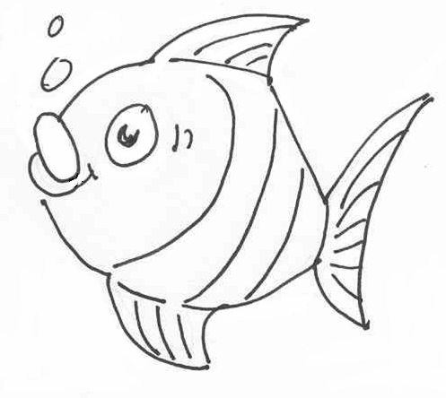 | 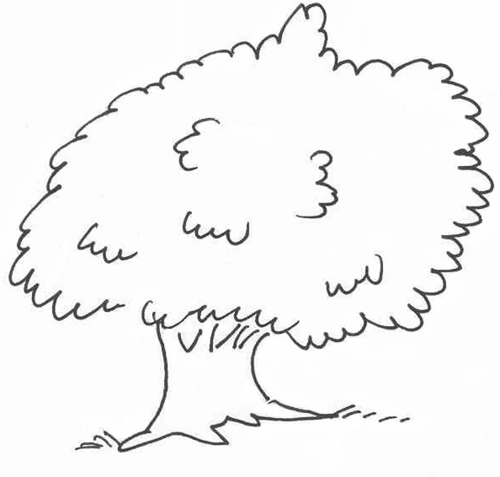
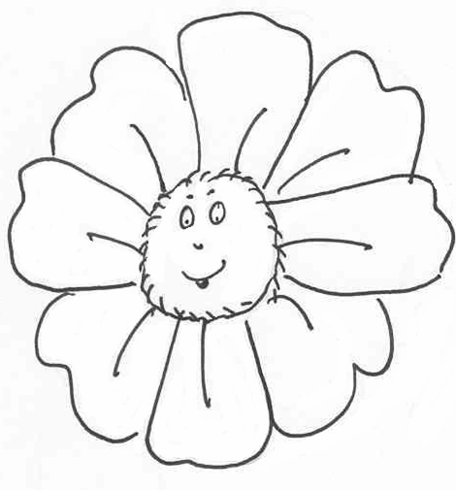 | 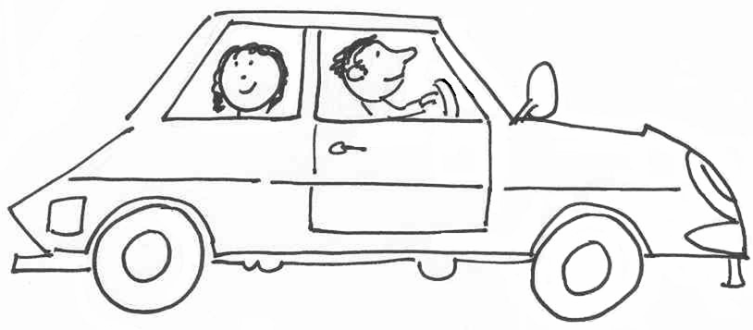
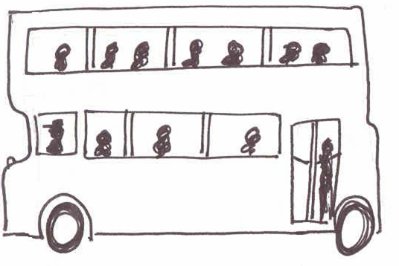 | 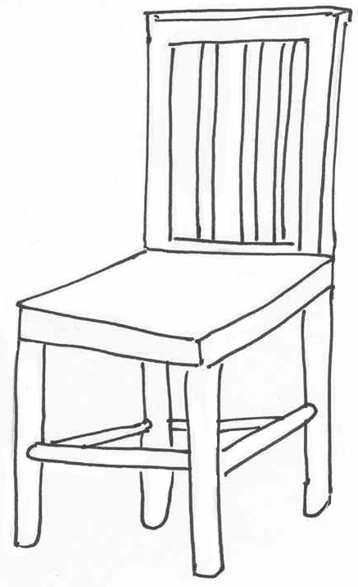
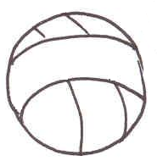 | 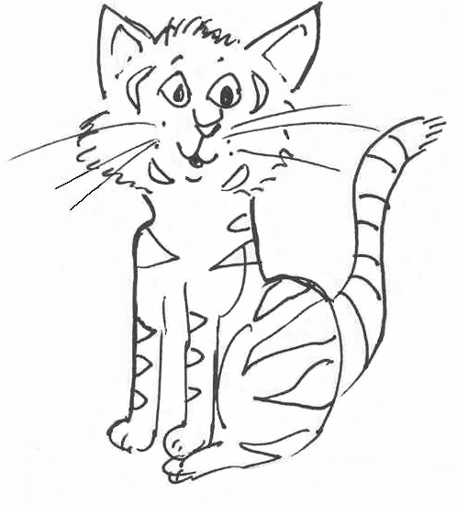

Sentence sheet 8.4

The ball is red and blue. | The cat is black and brown.
The bus us yellow and green. | The car is blue and orange
The fish is pink and blue. | The flower is yellow and purple.
The tree is green and brown. | The chair is red and blue.

Read and draw activity 8.4a
The ball is red and blue. | The cat is black and brown.
The bus is yellow and green. | The car is blue and orange.
The fish is pink and blue. | The flower is yellow and purple.
The tree is green and brown. | The chair is red and blue.
Colour and write sheet 8.5

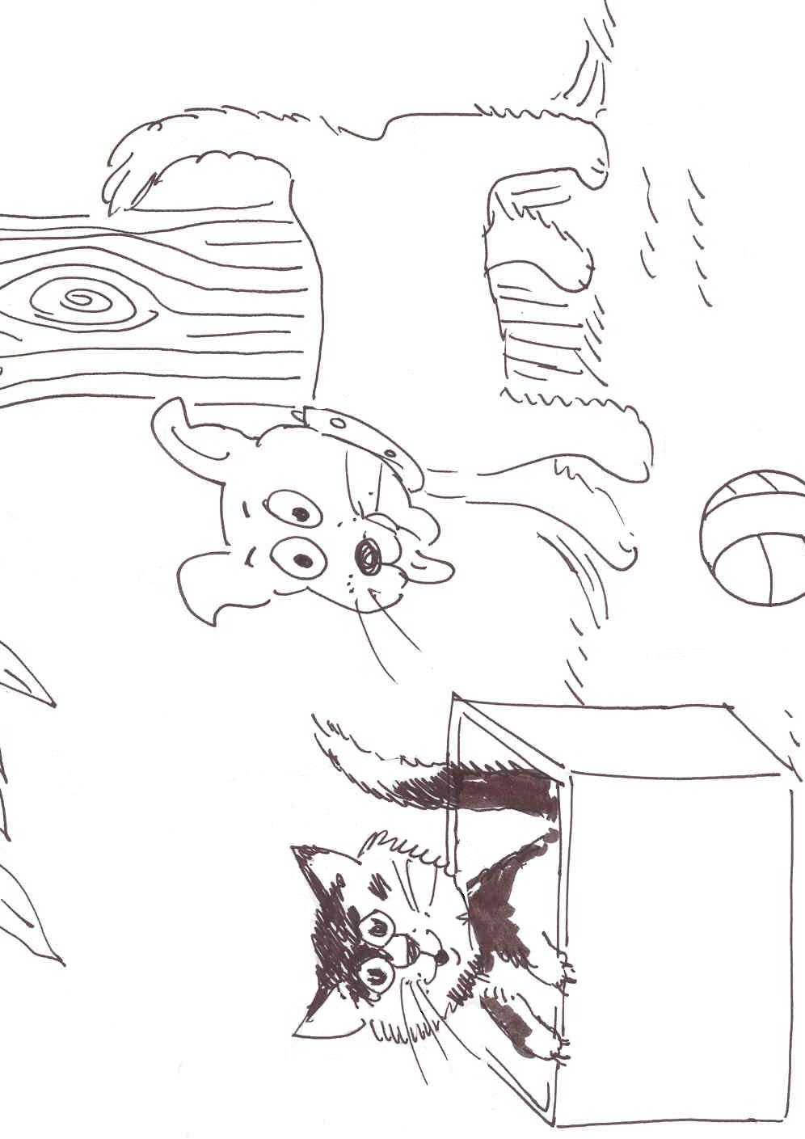
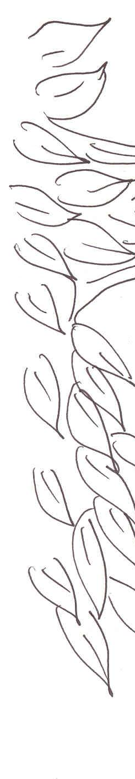
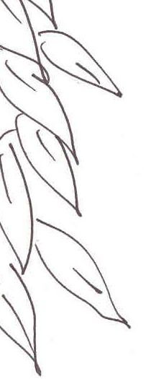

Write about it

…………………………………………………………………………………….................................................................................................................................................................................................................................................................................................................................................................................................................................................................................................................................................................................................................................................................................
Read the text 8.6a The girl and the cat.
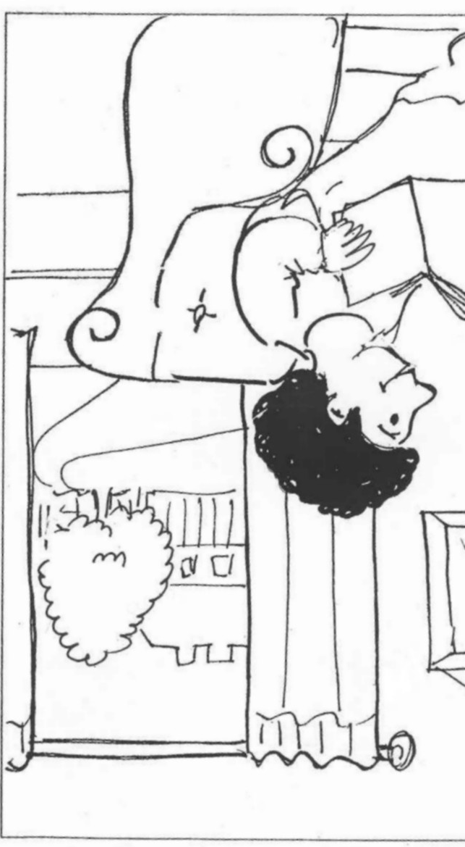
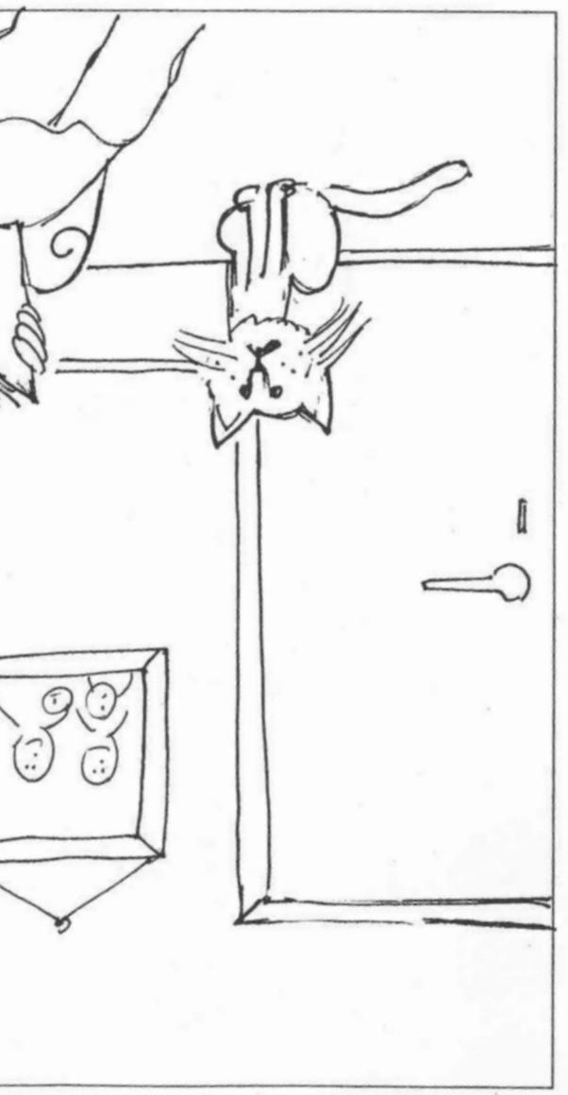

This is a girl and this is a cat.
The girl and the cat are in the house.
The girl is happy. The cat is black and white.
This girl is on the chair.
The black and white cat is next to the door.
The cat is sad.

- Who are in the house?
- Is the cat happy?
- Is the girl sad?
- Where is the cat?
- What colour is the cat?

8.6a The girl and the cat.

1.
2.

3.

4.

5.

Now say and write your own sentence about the picture.
6.

Read the text 8.6b The man and the woman.

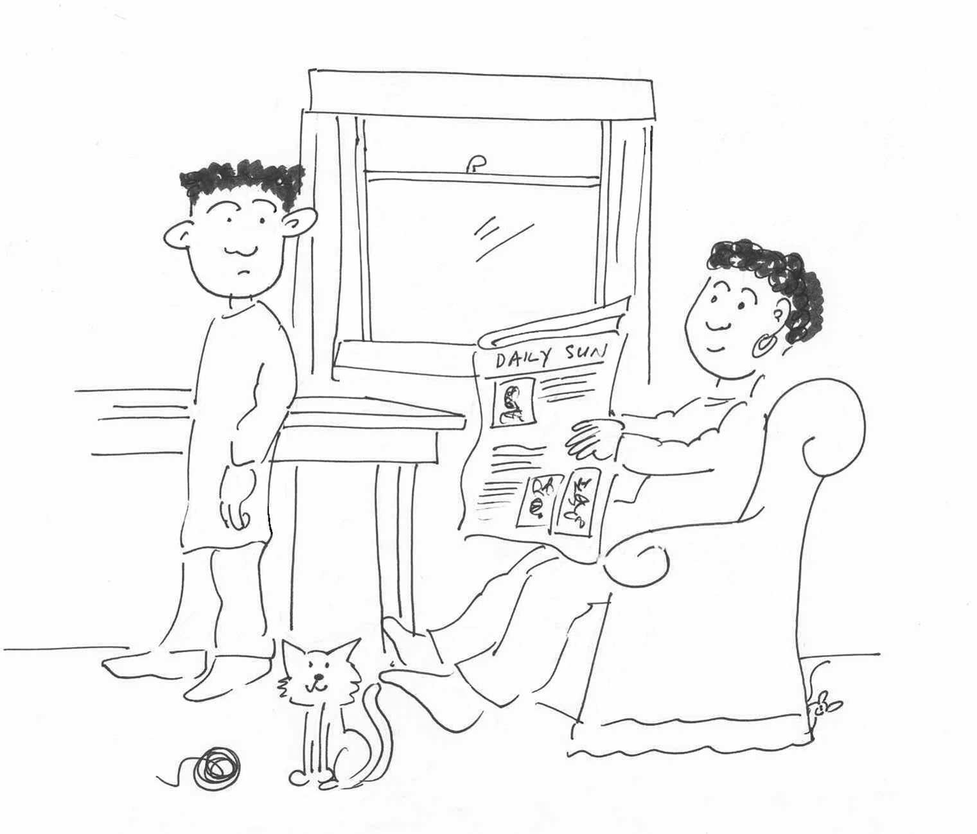

This is a man and this is a woman.
The man and the woman are in the house.
The woman is happy.
The man is next to the table.
The woman is on the chair. The man is sad.

- Who are in the house?
- Is the man happy?
- Is the woman sad?
- Where is the woman?
- Where is the man?

8.6b The man and the woman

1.
2.

3.

4.

5.

Now say and write your own sentence about the picture.
6.

Read the text 8.6c The cat and the dog.

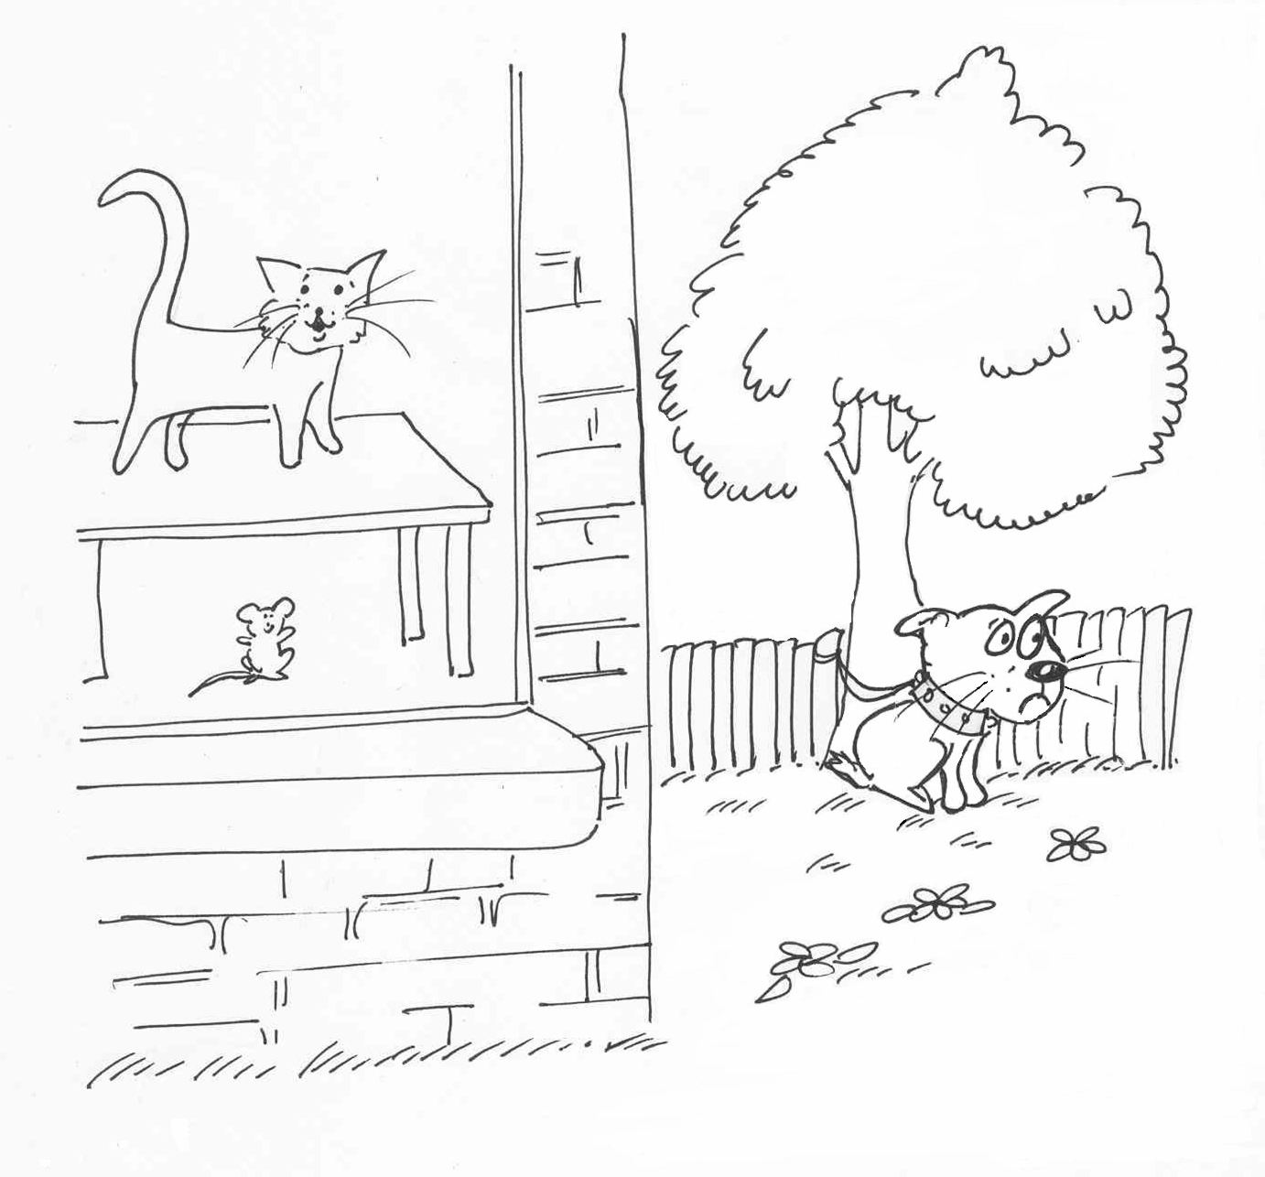

This is a cat and this is a dog.
The cat is in the house.
The cat is happy.
The cat is black and white.
The cat is on the table.
The dog is next to the tree.
The dog is brown and black.
The dog is sad.
- Where is the cat?
- Is the cat sad?
- What colour is the cat?
- Where is the dog?
- What colour is the dog?

8.6c The cat and the dog

1.
2.

3.

4.

5.

Now say and write your own sentence about the picture.
6.

Colour and write sheet 8.7
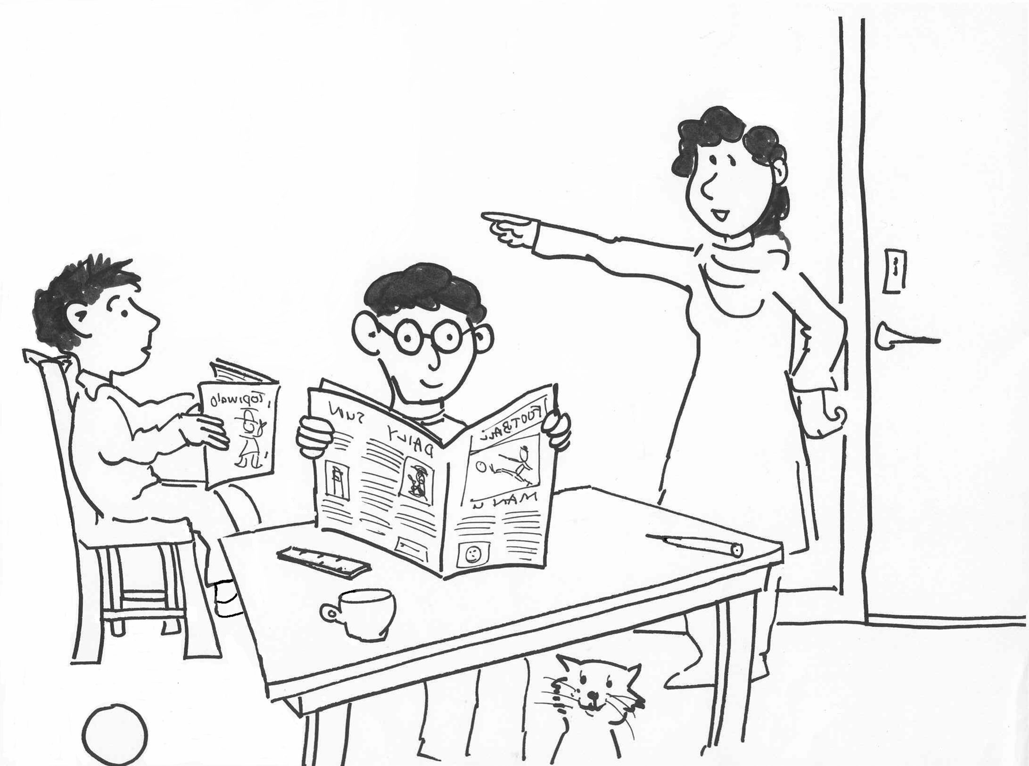

Write about it

…………………………………………………………………………………….......................................................................................................................................................................................................................................................................................................................................................................................................................................................................................
…………………………………………………………………………………………………………………………………………………………………………………………………………………………………………………………………………………………………………………………………………………………………………

